When we first spoke to our customer about this car, he explained to us that there were some major swirl marks in the paint. However on the day that we saw the car, unfortunately it was a pretty typical Scottish day with no sunshine and it was therefore very difficult to see any of the swirl marks.
The car was booked in with us and we allowed ourselves two days to work on the car.
When the customer dropped off the car just before 8am on a Tuesday morning, he informed us that he had washed the car last night. Therefore our first action of the day was to take it inside under our daylight lighting and assess the marks for ourselves, under the lights the marks were very obvious for us to see and we could tell that there was going to be a fair amount of work involved.
Once we had assessed the car, it was then taken outside and pressure washed to remove any loose road grime that had been picked up whilst the customer had driven the car to our premises.
The car was then sprayed and wiped down with Autosmart tardis to remove any tar/oily contaminants that were bonded to the car.
The car was then washed with Autoglym car shampoo using the two bucket method and lambs wool mitt and then pressure washed at 70°c to remove the remaining soap.
The car was then moved inside and dried using a waffle weave towel.
As shown by the pictures, the car is then taped with 3M High Performance Masking Tape (#3434) whilst the front and rear windows are protected with plastic sheeting which is also used to cover the wheels and tyres.

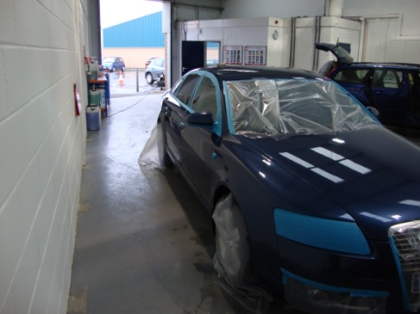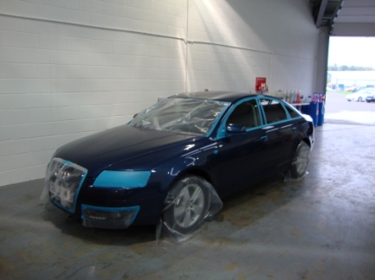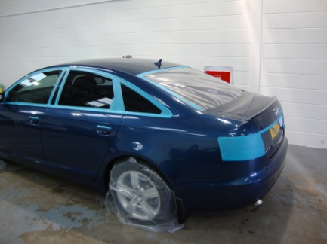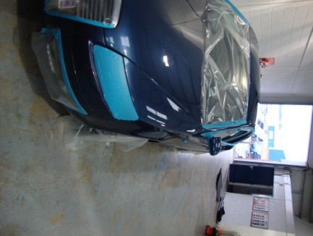

At this stage, an aggressive clay was used to remove any other bonded contaminants, however not many were removed as the customer had previously used a clay bar himself.
Once the car was dried off again, it was now possible to see the swirl marks in the paint under our high output lighting.

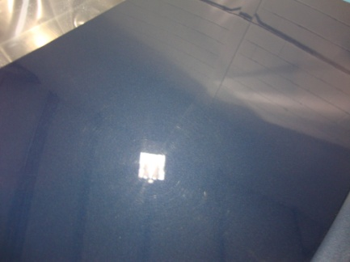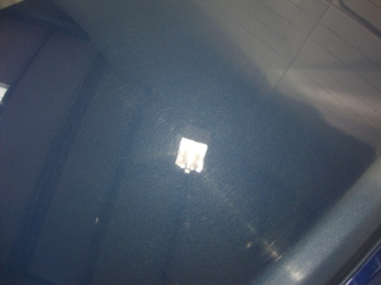

Having taken readings of the paint using a paint depth gauge, it was now time to start the correction process. Using a rotary machine with a Lake Country light cut (orange) constant pressure pad and Farecla G3 products we worked our way round the car.
The next stage of the process was to use an Autoglym soft polish head and Farecla G10 compound, to reduce the marring in the paintwork.
The paint was then sealed with a cleaner wax and another Autoglym soft head, the wax was then hardened by spraying with cold clean water and buffed using a microfiber cloth to increase the depth of shine.

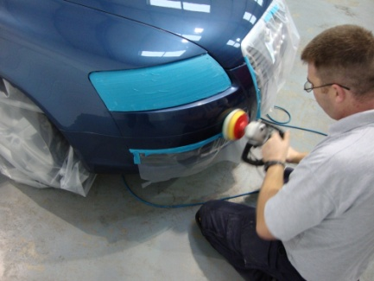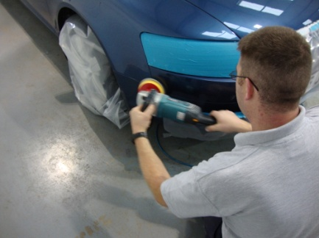

The car was stripped of all the tape and polythene and taken outside and pressure washed at 90°c. Using the two bucket method and a lambs wool mitt the paint was then re-washed using Autoglym car shampoo and rinsed off again.
The car was moved back inside under the daylights, and dried off using a waffle weave towel.
Another coat of cleaner wax was applied before the paint was sealed with a coat of Auotglym HD Wax.
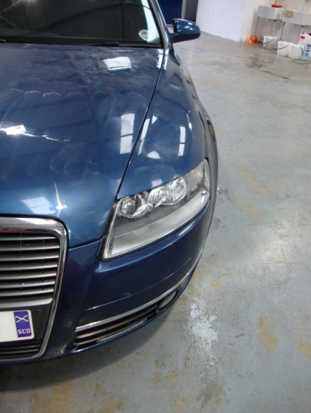

The HD Wax was left to cure for an hour. During this time, the interior of the car was vacuumed (although it was already very clean) and the tyre pressures were checked. The paintwork was then buffed off using a microfiber cloth.
As you can see from the final photos a great result was achieved.

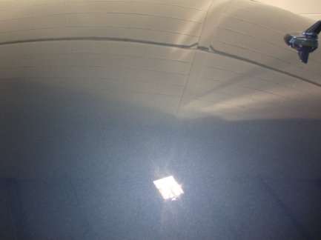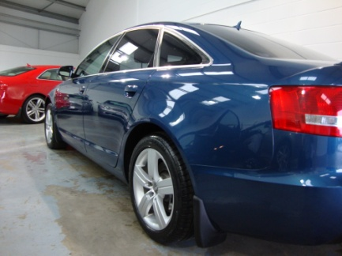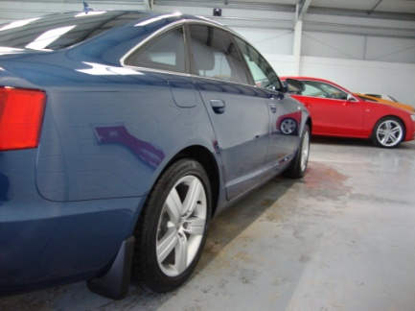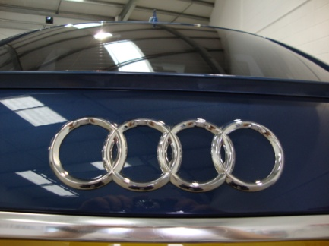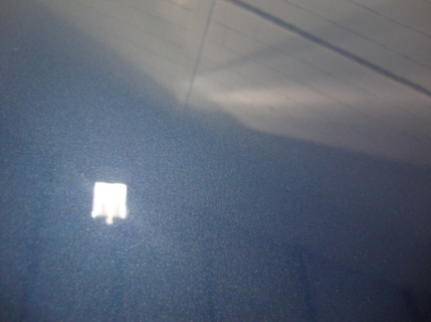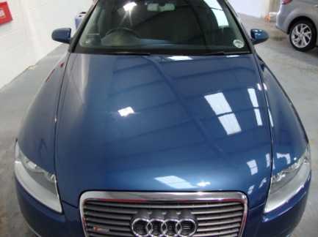

Many thanks to the owner of the car for allowing us to work on his pride and joy.

