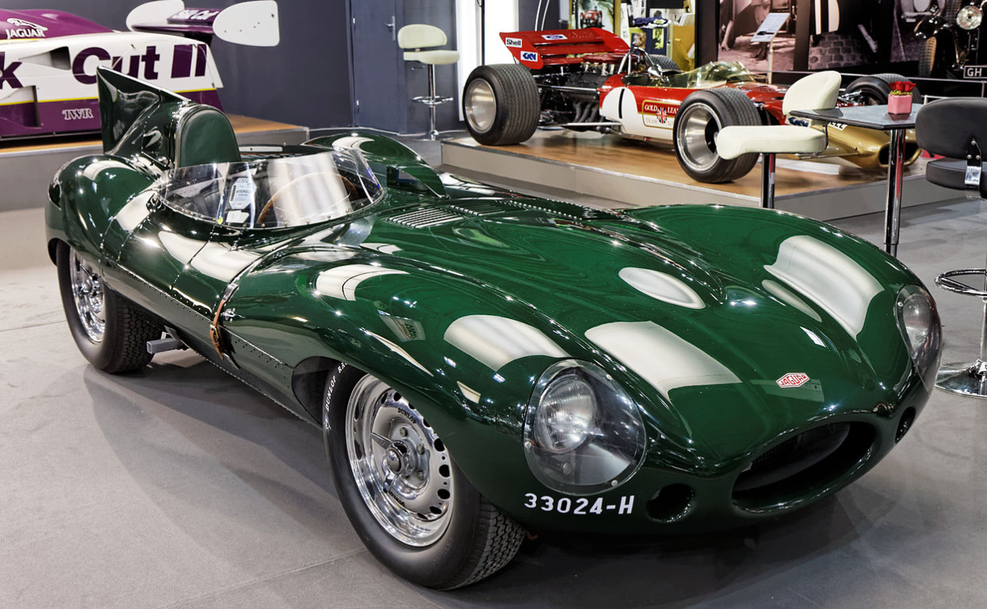
1957 Jaguar D-Type; Walt Hansgen 1956-1959, SCCA National Championship Runoffs

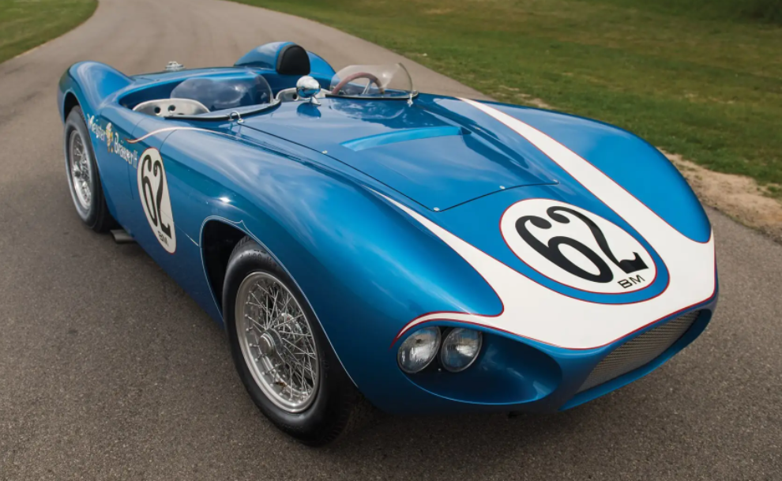
1959 Bocar XP-5 “Meister Brauser III” , SCCA champions Harry Heuer and Augie Pabst

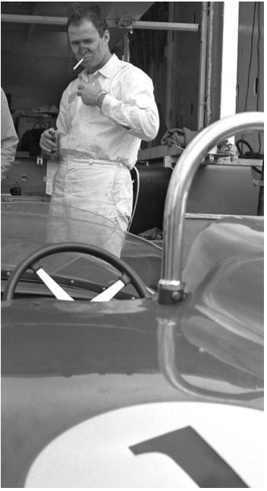
Harry Heuer, winner of the United States Auto Club’s National Road Racing Championship in 1959, winner of the Sports Car Club of America’s B-Modified National Championship in 1961, winner of the C-Modified National title in both ’62 and ’63. Harry raced away from us all on May 25th,2019.
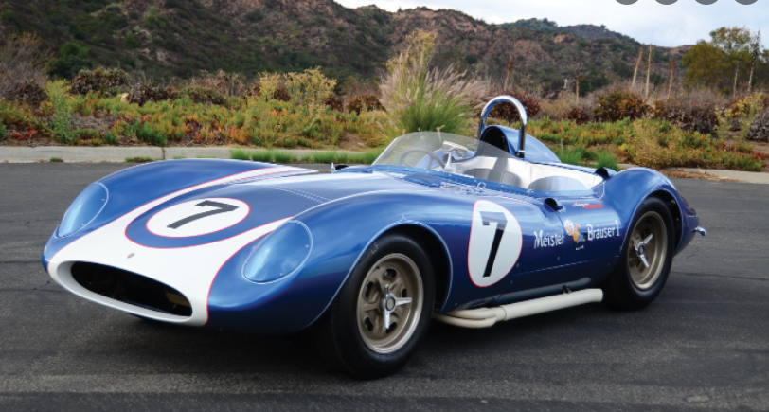
Scarab Meister Brauser Edition MkII

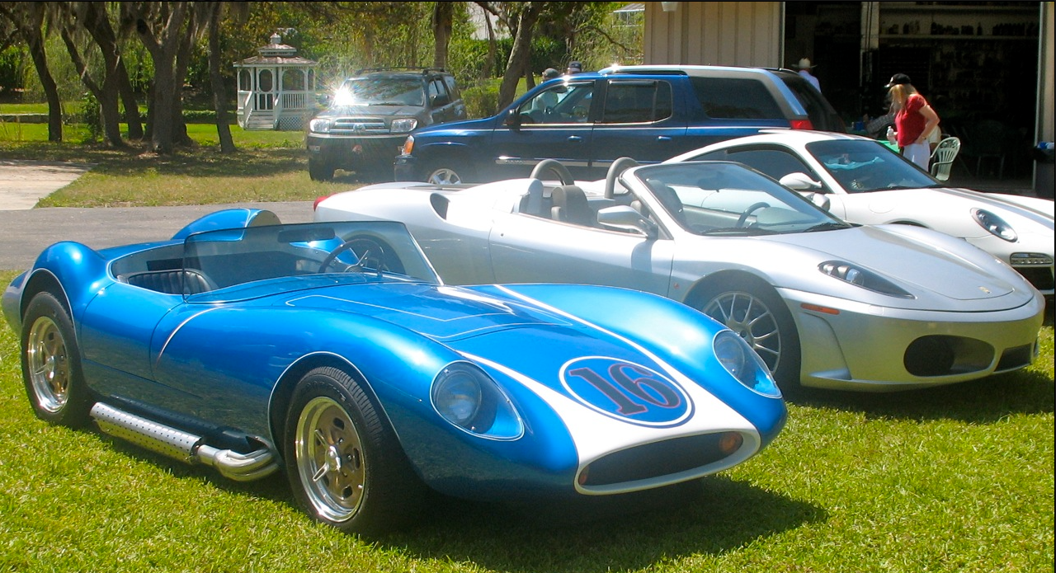
While racing in Europe in 1957, Lance Reventlow visited a number of racecar constructors including Lister where they built the almost unbeatable Lister-Jaguar. He felt that he could do better with an American car powered by a Corvette engine. The result: The incredibly sexy Scarab. The rest is history.
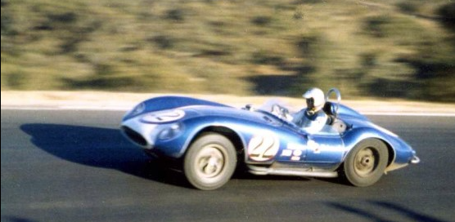
Harry Heuer in his Scarab, Laguna Seca, 1961
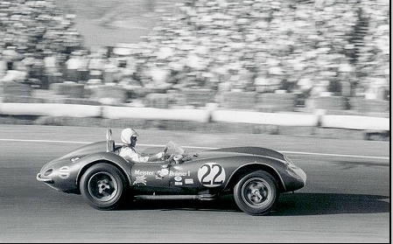
Heuer in the Scarab, Riverside Grand Prix, 1961

