Engine - Drive/Supercharger Belt Chirping Noise

NUMBER JTB00045
(ISSUE 3)
MODEL S-TYPE, XJ, XK, XK8
DATE 29 MAY 2009
ISSUE '3' CHANGES ARE HIGHLIGHTED IN GRAY
SECTION: 303
Drive Belt Noise - Repair Procedure

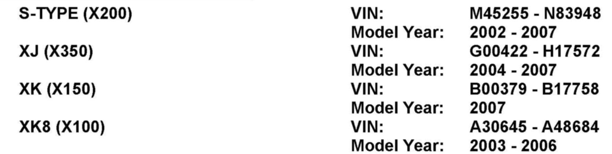
AFFECTED VEHICLE RANGE
CONDITION SUMMARY:
Situation:
A noise or chirp may be heard from Front End Auxiliary Drive (FEAD) belt or Supercharger drive belt on cold start. This may be caused by the installed idler pulleys not controlling belt tracking correctly.
Action:
In the event of a customer concern of the above, refer to the Repair Procedure outlined below to:
^ | Normally Aspirated (NA) vehicles: replace the FEAD belt and idler pulley with new flanged idler pulley and belt.
  ^ | Supercharged (SC) vehicles: replace the FEAD belt and idler pulley with new flanged idler pulley and belt; and / or replace supercharger idler pulley with new grooved idler pulley, tensioner, pulley bracket, and drive belt.
