 | 
If upon start-up you notice a rattling sound from your 1997-2000 Jaguar V8 engine, or unusually rough running, turn off the engine immediately and DO NOT restart it. Have the car towed to a Jaguar specialist service facility for inspection.  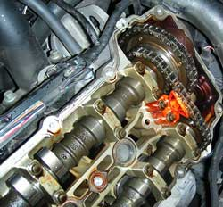  The secondary tensioner (red) for each cylinder bank is visible when the valve cover is removed.  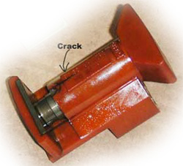  This tensioner is cracked in the typical way first-generation tensioners fail. Cracked tensioners can break apart, causing severe engine damage.  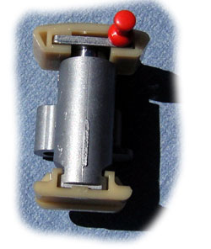  As of April 2005 we use Jaguar's third-generation metal replacement tensioners exclusively.  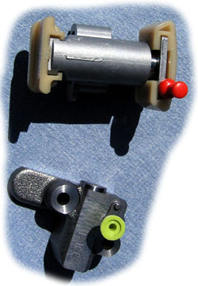  Jaguar's third-generation secondary and primary tensioners are mostly metal, not plastic. Although we have not had problems with the second-generation plastic units, as of April 2005 we are using third-generation tensioners exclusively.  Other preventive maintenance options for your late-90s Jaguar V8  In addition to timing gear replacement, we offer package prices on refurbishment of other potentially problematic areas on late-90s Jaguar V8 cars:  A cooling system overhaul is a good idea for late-90s Jaguars if it has not already been done. The original water pump was a weak design and caused overheating in many early Jaguar V8s. Its replacement (see below) is far more robust and reliable.  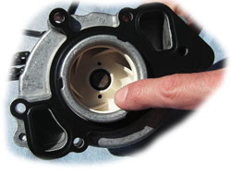  Jaguar's original water pump design was faulty, resulting in broken ceramic impeller blades and engine overheating. The improved unit (above) is far more reliable and highly recommended if your car still has the original.  We recommend the thermostat be replaced every two years at minimum. Often, a worn thermostat manifests itself not by overheating, but via secondary problems such as engine warning light, low coolant indicator, and other symptoms.  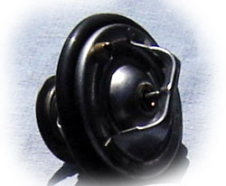  Thermostats should be replaced at least every two years on late-90s Jaguar V8 cars. Worn units can cause secondary problems that are not immediately traceable to the thermostat unless the technician has experience spotting the tell-tale indicators.  Another preventive maintenance item to consider: replacement spark plugs and/or ignition coils. The original units often deteriorate well before the manufacturer's 100K mile recommended replacement interval, and cause rough running and poor starting. At no cost we will inspect your plugs and, if wear indications are visible, point them out to you.  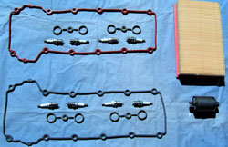  We offer replacement plugs, gaskets and other parts for your late-90s Jaguar V8. All parts are OEM quality and warranteed for 12 months, unlimited mileage.  If you live outside the San Francisco Bay Area, see our Mail Order page or click button below.  MONEY SAVING TIP: If your late-90s Jaguar V8 is approaching the mileage at which the factory recommends a major service -- 60K miles or 90K miles -- it may be advantageous to look into a combined major service and refurbishment of components that often need replacing at higher mileage: tensioners, water pump, thermostat, plugs, valve cover gaskets, oil pan gasket, and so on. | Jaguar’s 4.0-liter V8, known as the AJ-V8, was the first-ever eight-cylinder engine from that manufacturer. Designed in the mid-1990s by an all-Jaguar engineering team (including employees who worked on the previous twin-cam six), it proved to be a superb combination of lightness, torque, power, and fuel efficiency, the equal of anything from BMW or Mercedes.  In their zeal to reduce the weight of the valve train and related components as a way of improving fuel efficiency, the engineers underdesigned the AJ-V8's timing gear: in particular, the cam chain tensioners. These plastic components are part of the AJ-V8's single-chain design, a weight-saving alternative to the more robust double-chain approach Jaguar has used on most of its six-cylinder engines. (The new 4.2L version of the Jaguar AJ-V8 engine has double timing chains.)  As a result of their weak design and other factors like engine overheating or poor maintenance, the plastic cam chain tensioners on 1997 to 2000 V8 Jaguars began to experience stress fractures, and so did some of the plastic guides. While the cars were under warranty, many tensioners were replaced by Jaguar service departments with improved components.  In their Technical Service Bulletin No. X303-68 of February 2005, titled “Rattle From Engine on Start-up and Idle,” Jaguar states:  This Technical Bulletin has been issued to address customer concerns of a rattle emanating from the engine on start-up and idle.  Cause: Failure of a primary or secondary timing chain tensioner.  Should a customer express concern, and the fault has been confirmed as a timing chain tensioner, new primary or secondary timing chain tensioners must be installed.  Engines subject to this problem include XJ8/XJR engines with the last six digits of their VIN numbers between 812256-F41862, and XK8/XKR engines with the last six digits of their VIN numbers between 001001-A24195.  Note that late in the 1999 model year the factory began installing upgraded plastic tensioners. These second-generation units are, to the best of our knowledge, more reliable than the originals.  In 2005, Jaguar introduced a third-generation metal-based tensioner kit. (See the photos at left.) We now use the metal-based third-generation tensioners exclusively when replacing cracked first- and second-generation Jaguar V8 tensioners.  What happens when a tensioner breaks  When a plastic tensioner shatters or wears to the point the cam chain becomes loose, a rattling around can be heard in the cam area at the front of the engine. Usually this happens on start-up, when the engine is cold.  (Note that a rattling sound does not necessarily mean broken tensioners. There can be other causes that are not as drastic but nevertheless indicate trouble.)  On some occasions there is no rattling sound to serve as a warning. As the tensioners wear, the cam chains can become loose and eventually jump one or two teeth on the cam sprockets – usually on a cold start. If the chain jumps one tooth, rough running will be experienced. If it jumps more than one tooth, the valves on one block will contact the pistons, resulting in engine failure.  If upon start-up you notice a rattling sound from your 1997-2000 Jaguar V8 engine, or unusually rough running, turn off the engine immediately and DO NOT restart it. Have the car towed to a Jaguar specialist service facility for inspection.  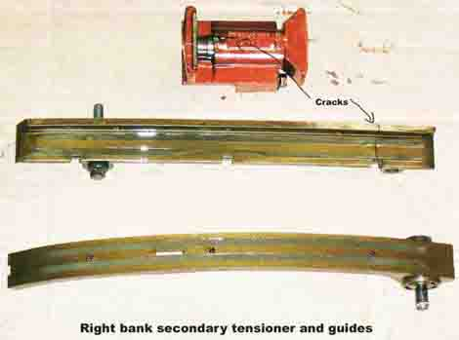  Though the tensioners of this 1998 XJ8 engine with 56,000 miles appeared intact on visual inspection with the valve covers removed, upon disassembly both were discovered to be badly cracked, and so was one of the main tensioner guides. A cracked tensioner can break apart and cause cam chain failure, damaging the engine severely.  History of tensioner failures  The AJ-V8 was first installed in the XK8/XKR starting in 1997, and then in the XJ8/XJR (and Vanden Plas models) starting in 1998. Tensioner failures have been experienced by owners of V8 models through the 2000 model year.  Jaguar Cars has instructed their dealer service shops to listen for the telltale rattling sounds during routine service visits. When the cars were under warranty, rattling tensioners, or failed engines due to tensioner breakage, would be replaced with beefed-up second-generation plastic tensioners at no charge to the owner.  Jaguar Cars will NOT cover repair of the tensioners, or associated engine failures, on cars that are out of warranty -- and of course all those model years are now past their factory warranty expiration.  Some third-party extended warranties cover tensioner replacement and even engine rebuild on tensioner failure. Check with your warranty provider. Continental Imports is certified as a Jaguar repair facility by most third-party warranty providers. If you would like us to do a tensioner replacement under third-party warranty, please supply us with contact information about your warranty provider before we start the job.  What you can do if you own a 1997 - 2000 4.0L Jaguar  We recommend that if your XJ8/XK8 has passed 35,000 miles, you take preventive action and have the tensioners inspected. If they are cracked, have them replaced before they fail.  While many cars make it to higher mileage without failure, a significant number do not. We don't know the exact number because the factory is keeping it confidential, but we are aware of the problem through extensive our service work on Bay Area V8 Jaguars, and from our discussions with parts distributors.  Jaguar dealer service departments will not replace the tensioners before failure under warranty without the engine displaying obvious symptoms (e.g., rattling noises). And if you own a 1997-2000 Jaguar, your factory warranty has expired by now.  As a preventive maintenance operation, your Jaguar service department, or Continental Imports, can replace your timing gear with improved components. At Continental, we use exactly the same parts the Jaguar dealers do, and having done so many V8 timing gear upgrades, we are highly expert and efficient at this procedure. Our parts and labor are guaranteed for one year.  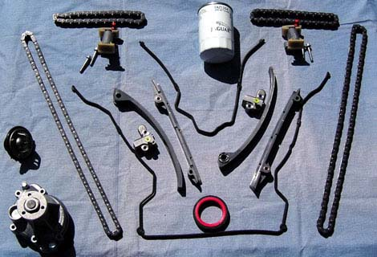  Depending on your needs, we can replace only the secondary tensioners, or as shown above, the primaries, secondaries, chains and guides. At the bottom left are replacement water pump and thermostat, another weak point on early Jaguar V8s. We use the same replacement parts as are used by Jaguar dealership service departments, and we guarantee our parts and labor for one year, unlimited mileage.  Tensioner replacement of the Jaguar V8 is a prudent investment because the cost of inspection and replacement (if required) is reasonable, and the car is in almost all other respects exceptionally reliable. (Early XJ8s and XK8s have a few other, less serious, weak points that can be remedied at the same time as the tensioners. See the sidebar at left.)  Our shop offers a special tensioner-replacement package: an all-inclusive price for replacement of the secondary tensioners alone, or for the complete replacement of secondaries, primaries, guides, all chains, and seals. We now use Jaguar's third-generation metal tensioners.  Should you elect to replace your tensioners, make an appointment and we promise 48-hour turnaround. Our 12-month, unlimited mileage warranty will apply to all parts and labor.  If you live outside the San Francisco Bay Area, or want to do the job yourself, see our Mail Order page for parts kits you can order directly from us.  Could you experience the problem with the new tensioners after replacement is carried out? Jaguar's third-generation replacement tensioners are far more robust in design (see photos at left) and, though it is too soon to ascertain their longevity with complete certainty, we are confident that they will provide a “one-time” solution to the problem. One thing we are certain of is that all parts and labor we provide are covered under our one-year, unlimited mileage warranty.  Precautions you can take  If your V8 Jaguar has low mileage and its original tensioners, follow these precautions to maximize original tensioner life: Avoid letting the car sit for several days if possible. (This can cause stretched chains to “sag” and then jump a tooth or two under the torque of engine start-up.) Instead, drive it daily if you can. Avoid driving short distances on a cold engine – let it warm up before shutoff by driving at least 15 minutes if possible.  Maintain the car faithfully. We recommend oil and filter changes every 5,000 miles (as opposed to the manual’s 10,000 mile recommendation), using 5W30 mineral oil. (You can use synthetic if you like.)  Your original tensioners MAY last longer if the above precautions are taken, but due to the nature of their design, we can make no guarantees.  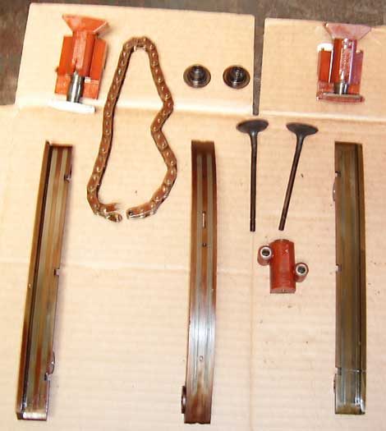  When the worst happens: This 1999 XJ8's tensioners both cracked. When the one at the top left broke, its timing chain (shown) snapped and the valves collided with the pistons. Two of the bent valves are shown in this photo. Though such damage requires significant shop time to repair, engine replacement is usually NOT indicated, and the parts required are reasonable in quantity and cost.  If you hear a rattle in the front of the engine, stop the car immediately and have it towed to a Jaguar service facility. Similarly, if the engine is running very roughly or refuses to start, have it towed. In either case, DO NOT TRY TO RESTART THE ENGINE.  Engine rebuild after tensioner failure is an option  If the worst happens and the valves contact the pistons due to tensioner failure, all is not necessarily lost. Whereas some places recommend engine replacement (at a cost of $10,000 or more), we can repair an engine that has suffered tensioner failure and subsequent valve damage on one bank for less than under half that price.  Investing in preventive replacement of the tensioners will remedy this excellent engine’s only serious flaw. If proper maintenance is carried out and the car is not abused, your V8 Jaguar engine should be as reliable and long-lived as its famously durable 6-cylinder ancestor.

