JAGUAR S-TYPE 4 WHEEL ALLIGNMENT SPECIFICATIONS: - UPDATED TO PREVENT INNER TIRE WEAR.

NOTES TO POINT OUT TO YOUR ALIGNMENT TECH:
- FRONT TOE – SEE SPEC SHEET FOR REVISED SPEC
- SET FRONT NEGATIVE CAMBER AS EVENLY AS POSSIBLE - otherwise the car pay potentially pull.
- Sequence of setting the allignment:
FIRST SET REAR TOE
THEN SET CASTOR AND CAMBER
SET FRONT TOE TO REVISED SPEC LAST, WITH THE STEERING WHEEL LOCKED DEAD CENTER TO PREVENT AN OFF – CENTER WHEEL.

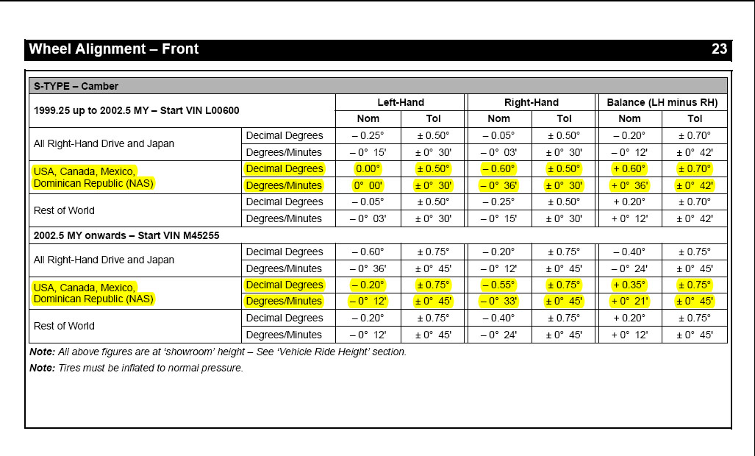

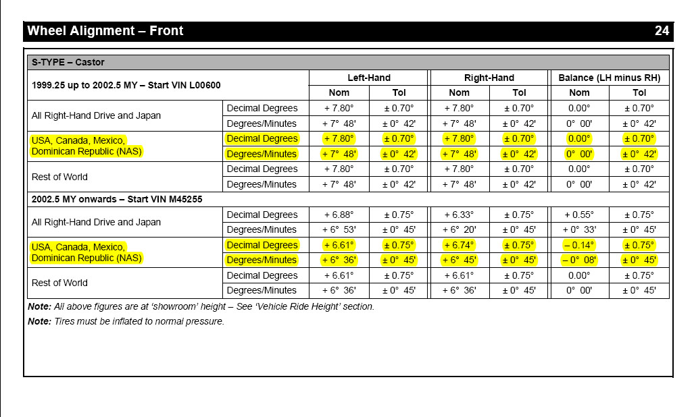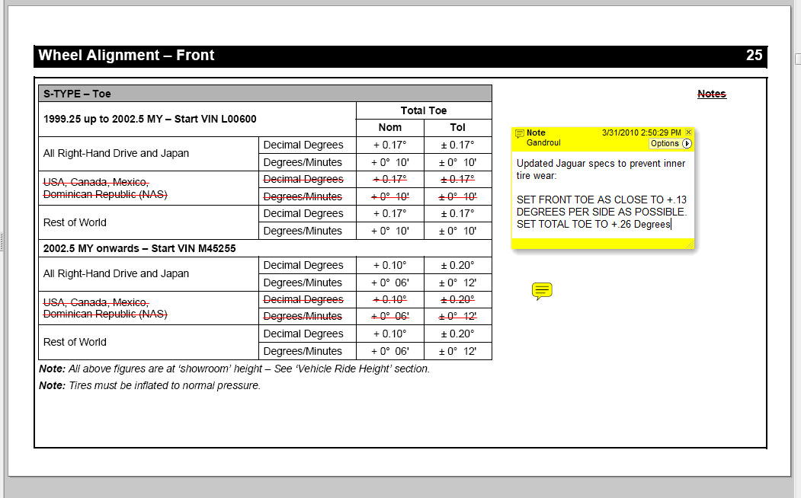
SEE NOTE – IGNORE FACTORY FRONT TOE SPECS – USE SPECS IN YELLOW BOX.

