Drain the cooling system. Remove the wheel and tire assembly. Remove the fender splash shield.

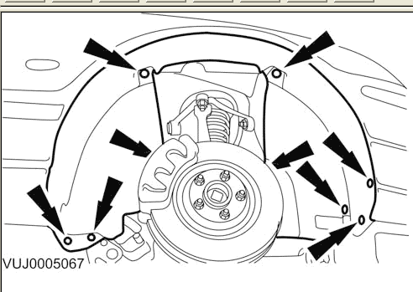

Remove the air deflector.
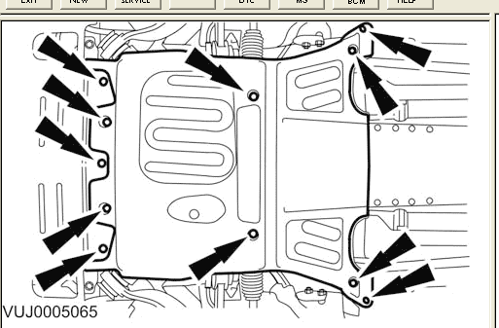

Remove the drive belt splash shield.
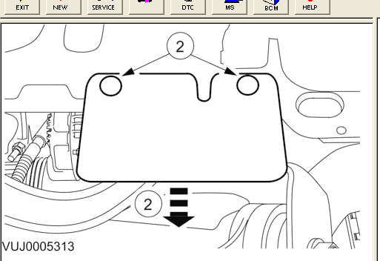

Disconnect the dual coolant flow valve bottom hose.
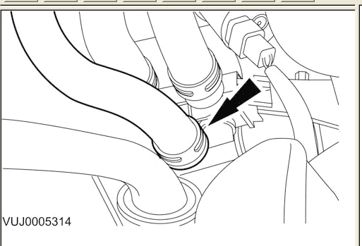

For vehicles fitted with 4.2L engine Remove the radiator upper hose.
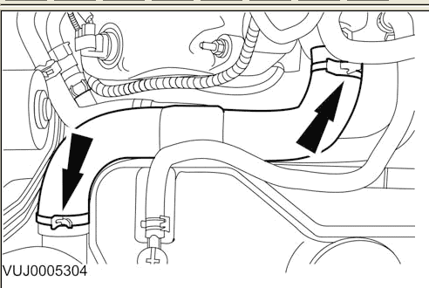

Disconnect the dual coolant flow valve electrical connector.
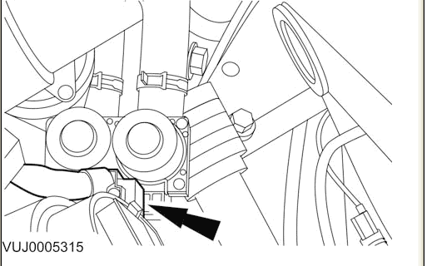

Disconnect the heater hose couplings.
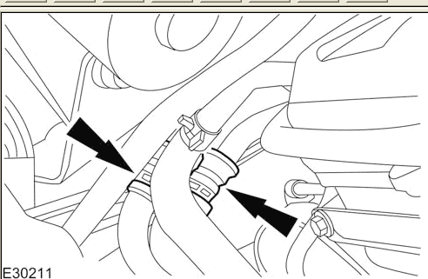

Disconnect the auxillary coolant flow pump electrical connector.
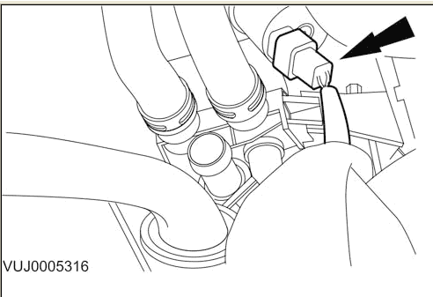

Remove the dual coolant flow valve: 1.) Remove the retaining bolt. 2.) Remove the dual coolant flow valve.
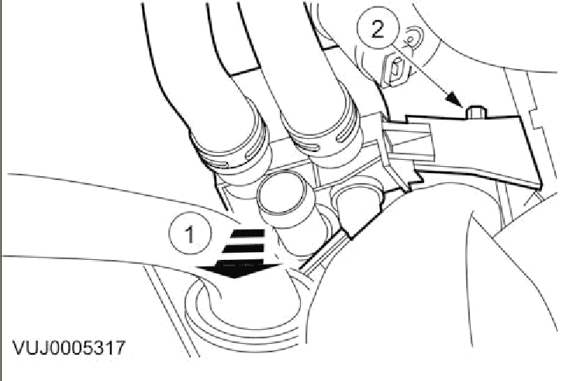

Remove the dual coolant flow valve hoses.
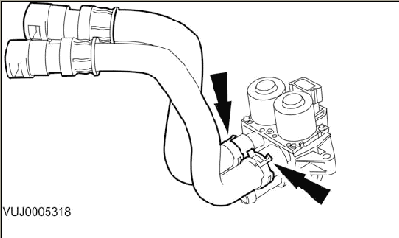

To install, reverse the removal procedure.Tighten to 10 Nm.

Remove the hoses from the metal pipes rather than the heater valve, it's much easier that way. They should be color coded so you can't screw it up. One should have a green band on it which matches a green band on the pipe. Sometimes the band falls off of the hose, if this is the case just mark them before removal. Push the hoses further on to the pipe to take the tension off of the plastic retainer clips. Press in on one side of the clip and start to pull the hose off with a rocking motion. You should be able to feel when it has started to come over the pipe flange, dont pull too hard, then press in on the other side of the clip and the hose should pull off with little effort. There is a feel to it and you can usually easily feel when the clip has released. After you have the 2 outlet hoses removed from the pipes remove the one 8mm screw that holds the valve to the fan shroud, pull the valve free of the shroud, pull up on the red safety lock on the electrical connector to access the actual release for the connector. Press inwards on the release and pull the electrical connector free of the valve. Pull the valve with the remaining hose attached up to where you can get better access to the feed hose. Release tension on the hose clamp and pull the feed hose off of the valve. If the white index mark is worn or missing from the feed hose mark it so you can put it back on in the correct orientation so that the hose doesn't get kinked. Now you can pull the valve with the heater hoses attached out from under the hood. Remove the heater hoses one at a time and transfer to your new valve paying attention to orientation if the index marks are worn off. Reverse procedure to install.

Bleeding the System

Remove the coolant expansion tank bleed screw.

Fill the cooling system up to the MAX mark on the coolant expansion tank using a fifty percent mixture of Jaguar Premium Cooling System Fluid or equivalent, meeting Jaguar specification WSS M97B44-D and fifty percent water.

Do not over tighten the coolant expansion tank bleed screw. Failure to follow this instruction may cause damage to the vehicleInstall the coolant expansion tank bleed screw. Tighten to 1 Nm.

Install the coolant expansion tank pressure cap.

Do not RUN the engine with the coolant expansion tank pressure cap removed. Failure to follow this instruction may cause damage to the vehicleSTART and RUN the engine.

SET the heating system to MAX heat, the blower motor to MAX speed and the air distribution to instrument panel registers.

Observe the engine temperature gauge. If the engine starts to over-heat switch off immediately and allow to cool. Failure to follow this instruction may cause damage to the vehicle. Allow the engine to RUN until hot air is emitted from the instrument panel registers, while observing the engine temperature gauge.

Switch off the engine.

Allow the engine to cool.

Release the cooling system pressure. Remove the coolant expansion tank pressure cap.

Fill the cooling system up to the MAX mark on the coolant expansion tank using a fifty percent mixture of Jaguar Premium Cooling System Fluid or equivalent, meeting Jaguar specification WSS M97B44-D and fifty percent water.

Install the coolant expansion tank pressure cap.

****************

The bleed screw is in the front of the engine on the plastic cooling pipe that's just under the throttle body. It has a flat head slot. Be gentle when you screw/unscrew it. It might be brittle.
There's also a bleed screw coming off of the tube on the expansion tank.
Fill up, start car, turn up heat to max, continue to fill up until coolant leaks from front bleed screw, then close front bleed screw.
Let engine reach operating temp. Rev the RPM's up a few times, check coolant tank and keep filling up as necessary.
Repeat this until coolant tank is a hot mark, close coolant tank bleed screw and cap and you're all set.

****************

****************

Now, the bleed valve. It's on a pipe just to the lower right of
the throttle body at the front of the engine (it is marked). To
open it, turn it a 1/4 turn clockwise. This allows air / water to
run down a pipe at the back of it, back to the expansion tank.
With the valve, open re-fill the system until water starts to come
back to the tank via the pipe off the back of the bleed. Once
that's done, start the car and run it with the heater on 29 degrees
for 5 mins, topping up the tank as necessary.
Once the water level is constant, close the valve and put the lid
back on. Job done.

****************

