Upper Arm RH

Upper Arm RH
Removal
- Remove the shock absorber and spring assembly.
- Remove the cabin air filter.
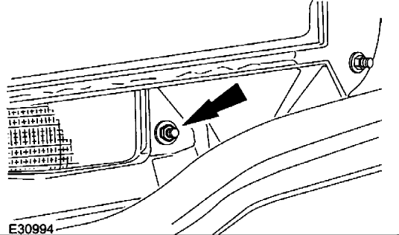

- Remove the cabin air filter housing retaining nut.
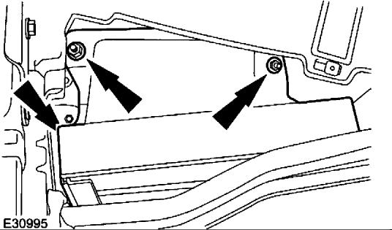

- Remove the cabin air filter housing.
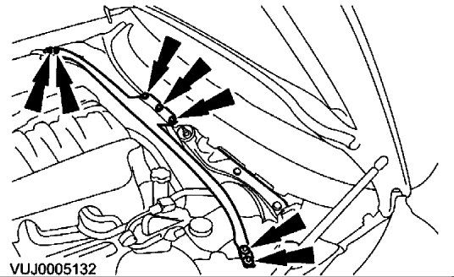

- Remove the engine compartment support.
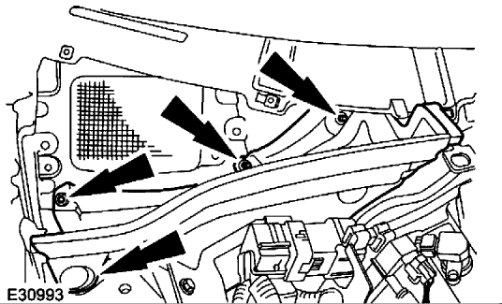

- Remove the engine compartment panel.
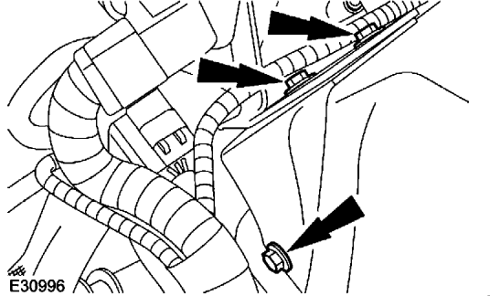

- Detach the wiring harness mounting bracket.
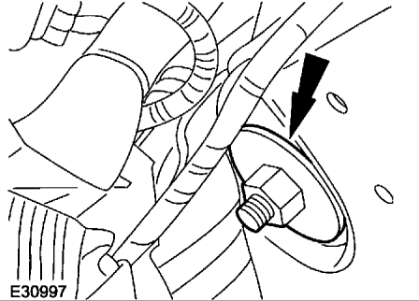

- Remove the upper arm retaining nut.
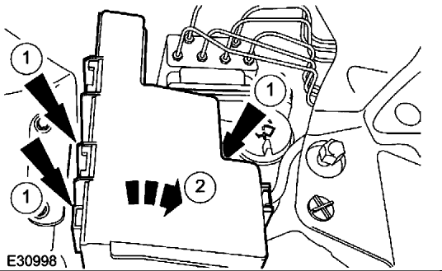

- Detach the engine compartment battery junction box.
- Release the engine compartment battery junction box retaining clips.
- Detach the engine compartment battery junction box.
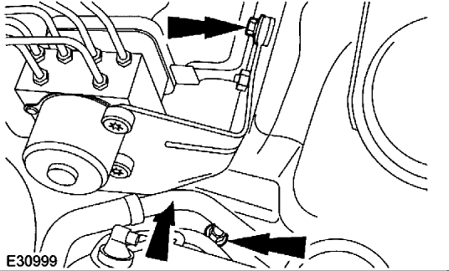

- Detach the hydraulic control unit.
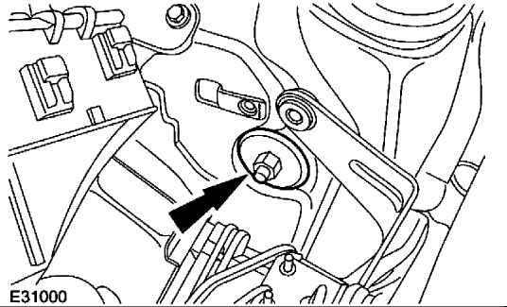

- Remove the upper arm retaining nut.
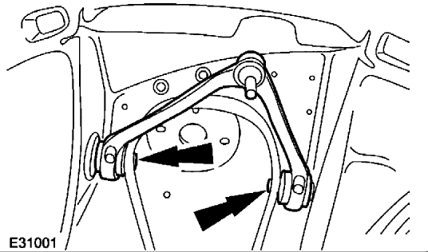

- Remove the upper arm.
Installation
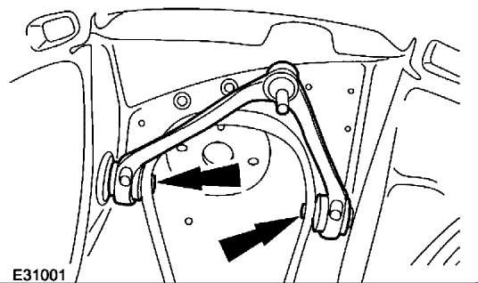

- Install the upper arm.
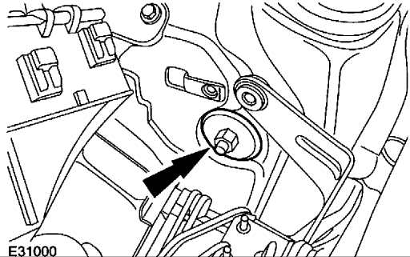

- Install the upper arm retaining nut.
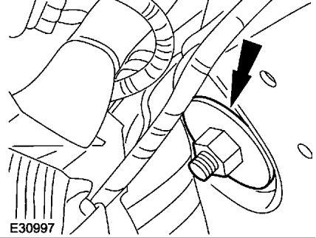

- Install the upper arm retaining nut.
- Install the shock absorber and spring assembly.
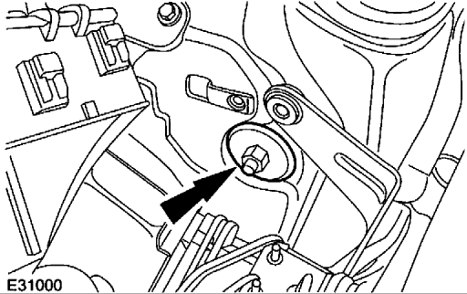

- CAUTION: The final tightening of the Upper arm retaining nut must be carried out with the vehicle on its wheels.
Tighten to 47 Nm .
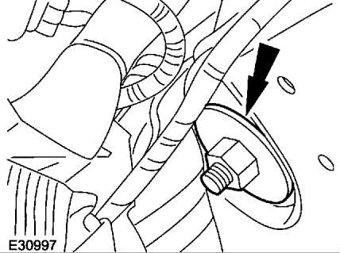

- CAUTION: The final tightening of the Upper arm retaining nut must be carried out with the vehicle on its wheels.
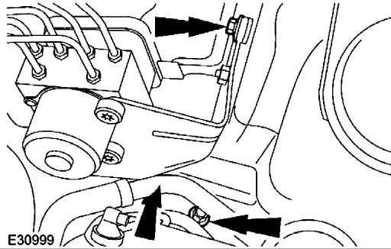
Tighten to 47 Nm .
- Attach the hydraulic control unit.
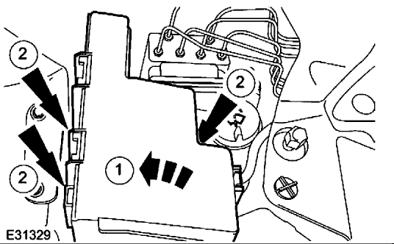

- Attach the engine compartment battery junction box.
- reposition the engine compartment battery junction box .
- Attach the engine compartment battery junction box.
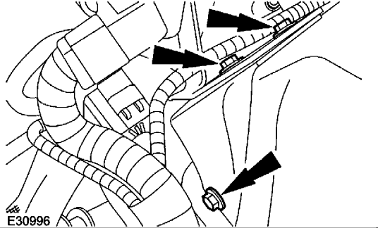

- Attach the wiring harness mounting bracket.
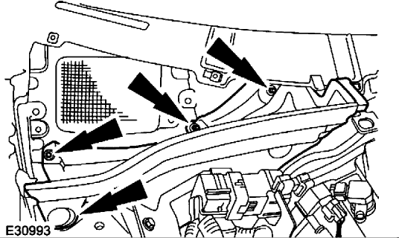

- Install the engine compartment panel.
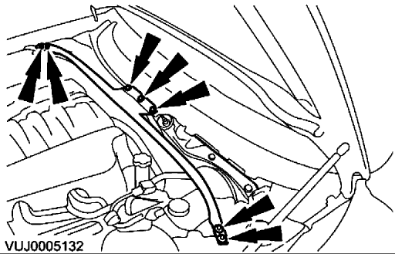

- Install the engine compartment support.
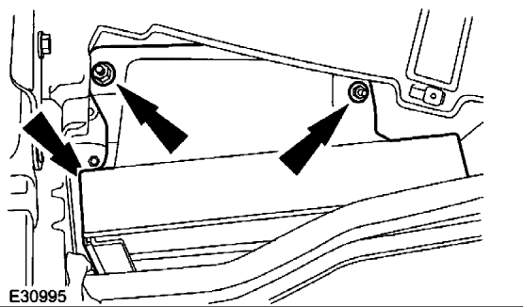

- Install the cabin air filter housing.
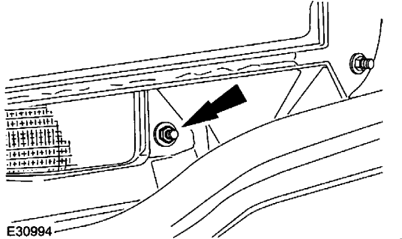

- Install the cabin air filter housing retaining nut.
- Install the cabin air filter.

