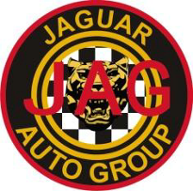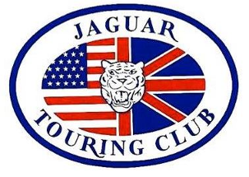

Annual JAGUAR Picnic

Sunday, August 26th, 2018

All British Marques welcome
Car Tour through local countryside

Popular vote car show
50/50 Raffle Drawing

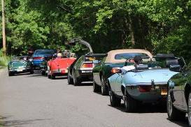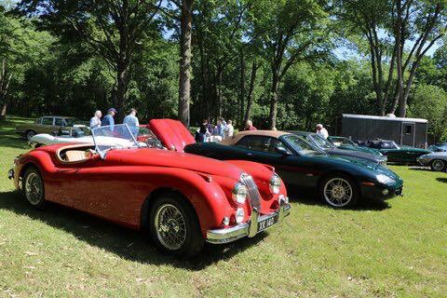

Held on the lovely, shaded grounds of the Dawn Patrol Motorcycle Club,
who will cater the event with a tasty selection of BBQ food and soft drinks.

Please bring an appetizer, salad or dessert for sharing, homemade or not.
A Prize will be awarded for the best Homemade Appetizer, Salad or Dessert

$20 per person
Kids under 16 are welcome & free!

Located at 106 Robert St, Bridgewater, NJ 08807

Registration starts @ 10:00 AM
Car Tour BEGINS @ 10:30 AM
PICNIC @ 12:30 PM
In case of Bad weather Cancellation will be posted on www.jcna.com/users/ne52

Please RSVP by August 19th to:
Jeremy Dale at Email: jdale1066@optimum.net

DIRECTIONS TO DAWN PATROL MOTORCYCLE CLUB
106 Robert Street, Bridgewater, NJ 08807

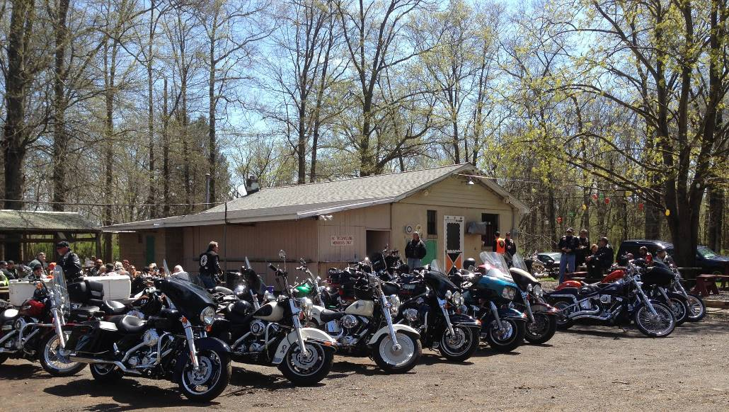

The Clubhouse is 2.4 miles from the Somerville Circle in Bridgewater, where Route 202-206 & 28 come together near Route 22.

From the circle take Route 202 South.

Make a Left turn (from the Right lane) onto First Avenue at 0.4 miles.

Turn Right onto Somerset Street at 1.0 mile.

Turn Left at the corner of Robert Street at 2.1 miles.

Turn Left into the Clubhouse parking lot at 2.4 miles.

Car parking will be on the Grassy Area past the parking lot.

