A/C - Does Not Cool Sufficiently

No: JTB00183
Issue: 1
Date: 07 JAN 2010
SECTION: 412
Air Conditioning System Not Cooling Sufficiently
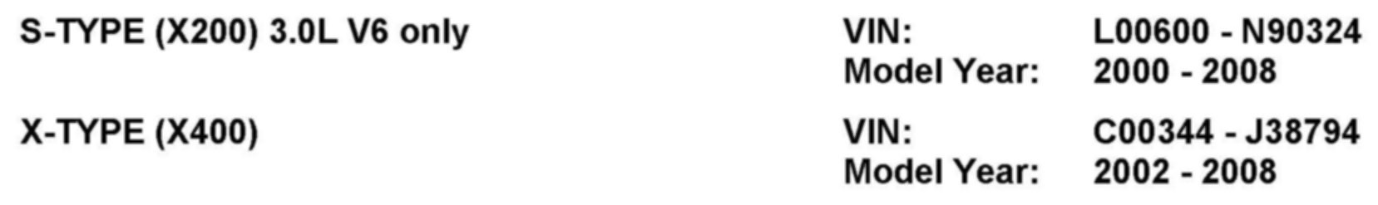

AFFECTED VEHICLE RANGE
CONDITION SUMMARY:
Situation:
The air conditioning (A/C) system may exhibit insufficient cooling. This may be due to the degradation of control valve operation, preventing the system from delivering full functional potential.
Action:
In the event of a customer concern of the above, refer to the Repair Procedure outlined below, after confirming correct refrigerant level, to modify the compressor valve spring.

PARTS
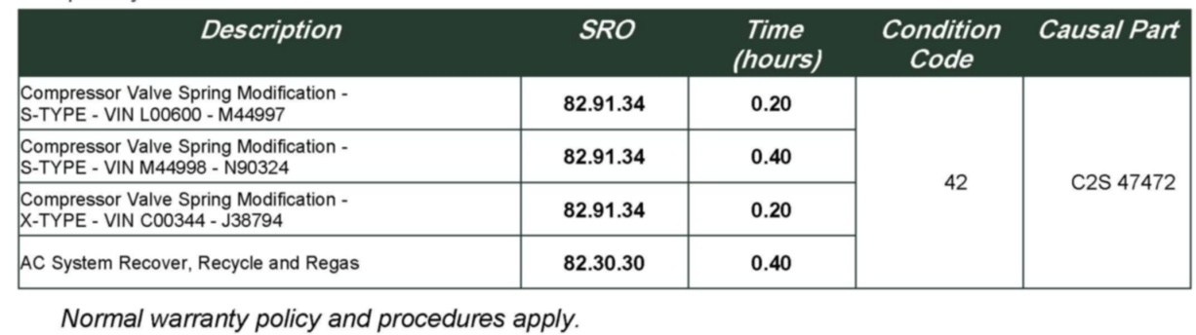

WARRANTY:
NOTE:
Repair procedures are under constant review, and therefore times are subject to change; those quoted here must be taken as guidance only. Always refer to DDW to obtain the latest repair time.
DDW requires the use of causal part numbers. Labor only claims must show the causal part number with a quantity of zero.
REPAIR PROCEDURE
MODIFY AIR CONDITIONING COMPRESSOR VALVE SPRING
NOTE:
Global Technical Reference (GTR) lookup sequence is as follows: GTR Home > NAS > Model > Service Information > Model Year > Workshop Manual
1. Refer to Workshop Manual (GTR) section 412-00 and recover the Air Conditioning (A/C) system.
2. Refer to Workshop Manual (GTR) section 100-02 and raise and support the vehicle.
NOTE:
S-TYPE vehicles from VIN M44998 only.
3. For S-TYPE vehicles from VIN M44998 only, refer to Workshop Manual (GTR) section 501-02 and remove the front air deflector.
CAUTION:
Ensure the area around the A/C compressor is clean and free of foreign material.
NOTE:
Position a cloth to collect possible fluid spill.
NOTE:
A/C compressor shown removed for clarity.
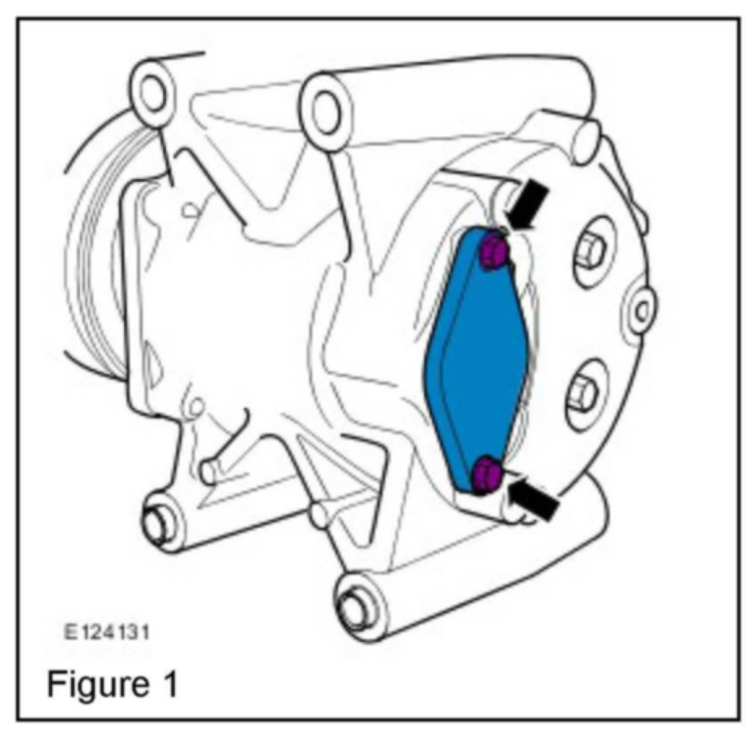

Note the position of the cover. (Figure 1)
4. Remove the A/C compressor valve cover:
^ | Remove the two bolts.  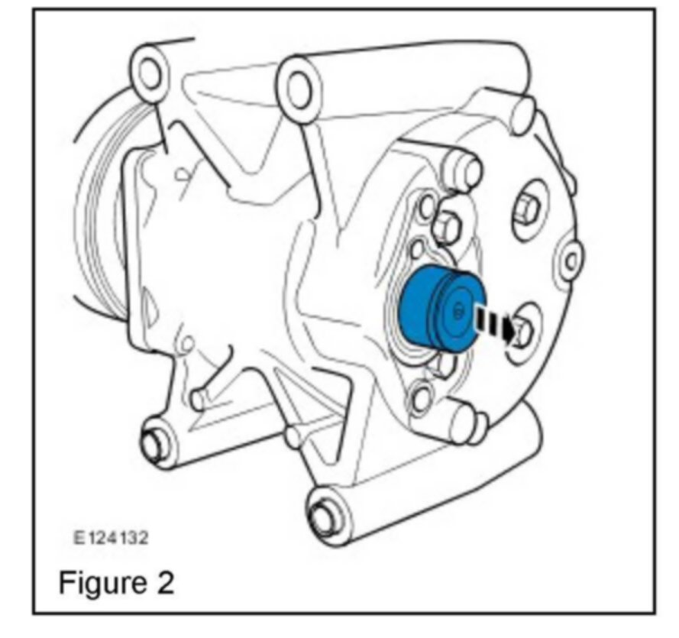  NOTE: Note position of the A/C compressor valve. (Figure 2)  5. Remove the A/C compressor valve. (Figure 2)  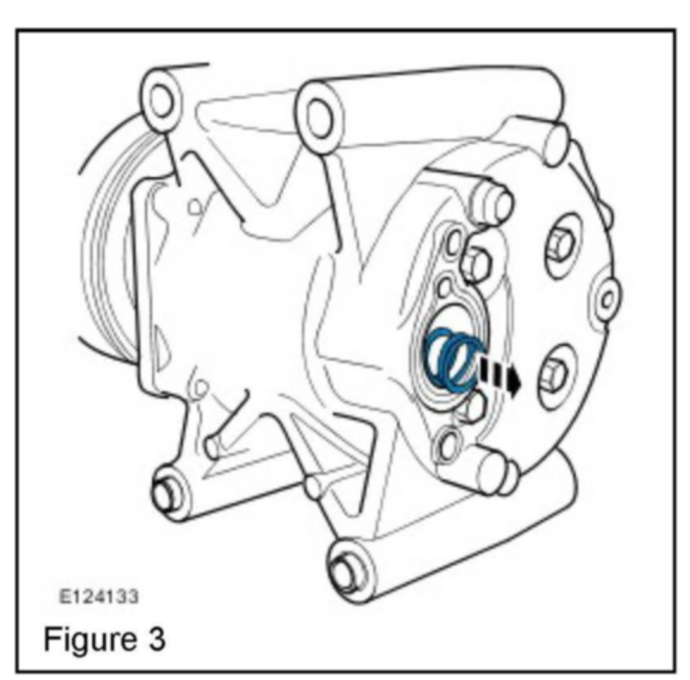  6. Remove the A/C compressor valve spring. (Figure 3)  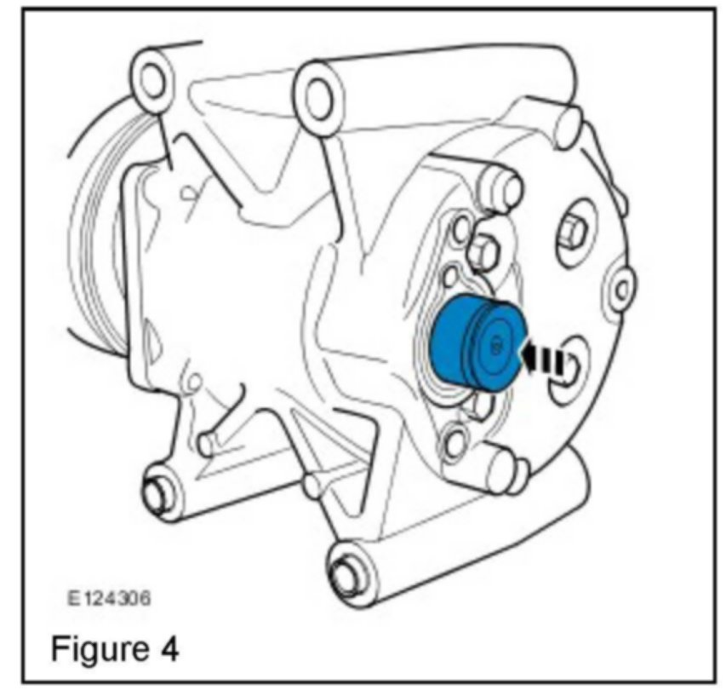  7. Install the A/C compressor valve. (Figure 4)  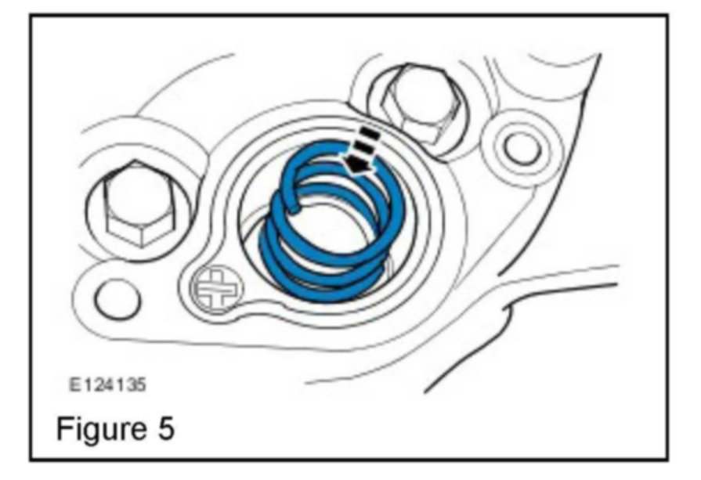  8. Install the A/C compressor valve spring. (Figure 5)  9. Inspect the A/C compressor O-ring seal; replace if necessary.  CAUTION:  Ensure the mating faces are clean and free of foreign material.  NOTE:  Ensure A/C compressor valve cover is correctly positioned.  10. Install the A/C compressor valve spring cover:
  ^ | Evenly and progressively tighten the bolts to 15Nm (11 lbf ft). (Figure 1)  NOTE  S-TYPE vehicles from VIN M44998 only.  11. For S-TYPE vehicles from VIN M44998 only, refer to Workshop Manual (GTR) section 501-02 and install the front air deflector.  12. Refer to Workshop Manual (GTR) section 100-02 and lower the vehicle.  13. Refer to Workshop Manual (GTR) section 412-00 and evacuate and charge the A/C system.

