Service and Repair

Drain
- Raise and support the vehicle.
- Place a suitable container under the transmission drain plug.
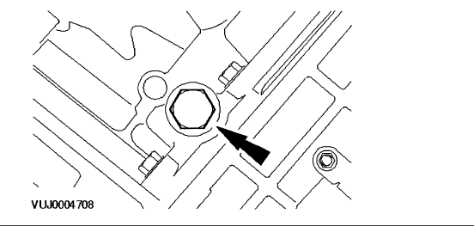

- Remove the transmission drain plug. NOTE: If an integral problem is suspected, drain the transmission fluid through a paper filter. A small amount of metal or friction particles may be found from normal wear. However, if excessive metal and friction particles are present, internal examination may be required.
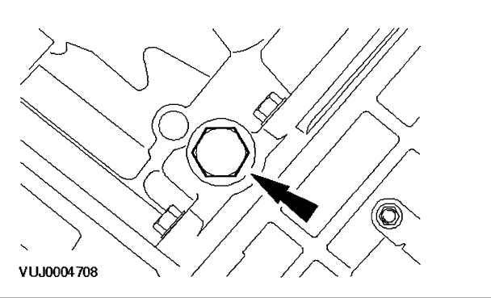

- Install the transmission drain plug. Tighten to 45 Nm.
Refill
- Lower the vehicle.
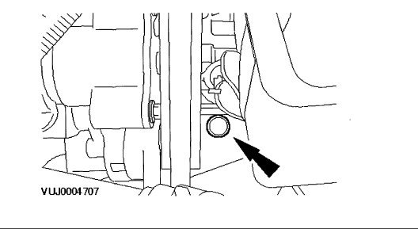

- Remove the automatic transmission fluid charging pipe cap.
- Fill the automatic transmission with 8 liters of automatic transmission fluid through the automatic transmission fluid charging pipe. NOTE: Use automatic transmission fluid WSS-M2C922-A1 or equivalent meeting Jaguar specification.
- Carry out a fluid level check and adjustment. See: Testing and Inspection
Capacity Specifications

Transmission Fluid Capacity | 8.8 liters (9.3 quarts)

Fluid Type Specifications

Automatic Transmission Fluid | ATF IDEMITSU K17 (Jatco 3100 PLO85)

