Recall - R935 Turn Signal Indicator

All
7-21
DATE 03/03
MODEL
2002-03 MY
X-TYPE
VIN
C00294-D17471
Turn Signal Indicator - Replace GECM - RECALL R935
This recall supersedes Service Action S920 (Technical Bulletin XT419-S920).
Issue:
Jaguar has investigated a concern with the external indicators on X-TYPE Vehicles. When power is lost to the external indicators, the internal 'tell tales' flash as if there is no fault. Investigations have determined that the General Electronic Control Module (GECM) design includes feedback to the driver via a 'tell tale' function for bulb failure but does not include feedback in the event of power loss to the direction indicator system as required by law.
Corrective action was introduced into production at the end of October 2002, by implementing a software change within the GECM.
Jaguar Cars has made the decision to recall all X-TYPE vehicles in the above VIN range that have yet to have the correct level of GECM installed.
Jaguar Cars will be writing to all owners of affected vehicles requesting them to contact their nearest dealer as soon as possible to arrange for the GECM to be replaced at the earliest opportunity.
To ensure that this repair can be fully completed, the owners of affected vehicles must make available all remote locking handsets.
In conjunction with this Recall Action, Service Action S934 Restraints Control Module Re-program will be released which is an owner notification program and affects all X-TYPE vehicles within the VIN range of C00294 to C90822. You should ensure that all repairs are completed at one visit.
Action:
This is an ideal opportunity to ensure that all outstanding Service Actions are completed on X-TYPE vehicles included within this Recall Action.
Note: All vehicle keys/transmitters must be present during GECM reconfiguration. Any key/transmitter not present will no longer function.
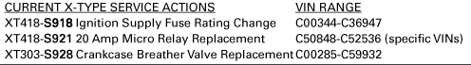

A list of the current X-TYPE campaigns is shown. Please ensure that you check that the vehicle is applicable to the campaign prior to confirming the booking with your customers so that suitable time and parts are made available prior to the repair visit. This can be done by using the outstanding campaign function within DDW, using your own internal records and by check-in the original campaign bulletin. It is also important that you ensure that the repair has not already been completed as NO repeat campaign claims will be accepted.
Note: Always review a Vehicle's Claim History within DDW first to determine whether this recall has been previously performed on a specific vehicle. The "Review Claim History" function will display a list of claims against the vehicle. If this recall appears in the program code field, do not perform this recall.
Refer to technical Bulletin XT413-R935 for the modification procedure.
Note: Refer to Administration Bulletin 6-94, for information on obtaining additional Authorized Modification labels.
Warranty Information:
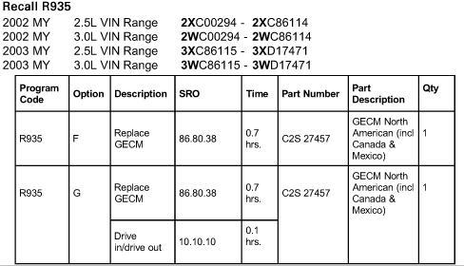

Warranty claims should be submitted quoting the information found in the table shown. This will result in payment of the stated time and, where applicable, parts/ miscellaneous expense codes.
The options that allow for drive in/drive out may only be claimed when the vehicle has been brought in to the workshop for this action alone to be undertaken.

Owner Letter

Recall - Turn Signals Defect Replace GECM
Notes
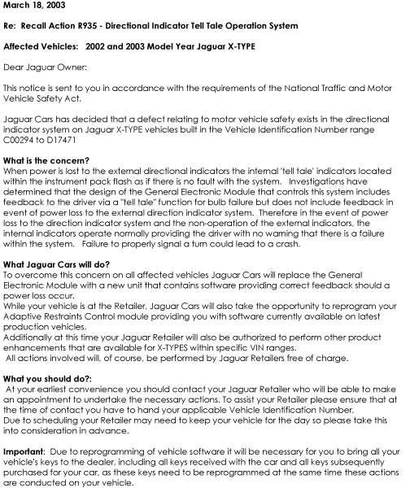

Notes
