Additional Information

^ | Passive Anti-Theft System Overview
^ | Engine Control Module (ECM) PATS functionality
^ | Fault code reading (from PATS LED)
^ | DTC Descriptions
^ | Generic Connector Inspection
^ | Generic Harness Check
Passive Anti-Theft System Overview
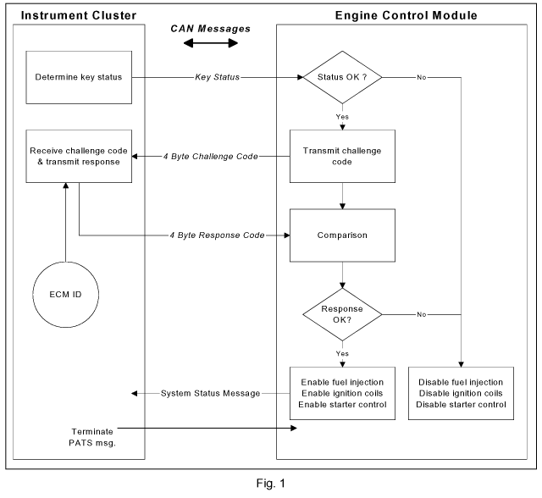

The Passive Anti-Theft System (PATS) function is split between the instrument cluster and the Engine Control Module (ECM). In order for the vehicle engine to crank and start the instrument cluster must have read a valid key and the correct information flow must have occurred between the instrument cluster and the ECM: (see Fig. 1)
ECM PATS Functionality
When a key is inserted in the ignition barrel, a hardwired input is supplied to the instrument cluster. This triggers the instrument cluster to read the PATS key code stored in the key and compare it with one that has been previously stored. If the ignition key is subsequently turned to the 'RUN/START' position the result of this comparison is transmitted to the ECM via the Controller Area Network (CAN).
Assuming the key status message received from the instrument cluster is OK, the ECM will respond with a challenge code. The instrument cluster will after encryption send a response code, if this response code matches one that the ECM has calculated the fuel injectors, ignition coils, fuel pump drive and starter will be enabled.
The ECM will disable the fuel injectors, ignition coils, fuel pump drive and starter if any of the following conditions apply:
1. | A theft signal has been received from the instrument cluster, i.e. the key code has not been authenticated.
2. | A challenge code has been transmitted to the instrument cluster but no response code has been received.
3. | A challenge code has been transmitted to the instrument cluster and an incorrect response received.
The ECM will log DTC P1260 for any of the following reasons:
1. | PATS Sequence Time Out. This means that the PATS exchange has started but the two second timer has expired prior to receiving the Enable/Disable Engine status.
2. | Identification transfer challenge error. This occurs following an ID transfer (Part replacement), if the result of the challenge is incorrect.
3. | Challenge response errors. This occurs if the result of the challenge is incorrect. The challenge is performed on every key 'ON' cycle.
4. | Invalid key data received. This occurs if the ECM receives incorrect Key Status data.
System Diagnostics
The best method to confirm the correct operation of PATS is to check the light emitting diode (LED). The LED should illuminate constantly for 3 seconds when the key is turned to Ignition 'RUN/START' position and then extinguish. This validates all PATS functions (PATS Prove-out) i.e. the key transponder matches a key code stored, the challenge/response sequence between the instrument cluster and ECM was successful resulting in the ECM being enabled.
Engine cranks but will not start
If the engine is cranking it means that the ECM is enabled with respect to PATS.
If PATS was disabled the ECM would not engage the starter.
This could be confirmed by verifying the PATS LED prove-out (illuminated solid for 3 seconds) or by reading Diagnostic Trouble Codes (DTCs) from the instrument cluster and ECM.
Fault Code Reading (from PATS LED)
When a PATS fault is apparent, the instrument cluster will store a DTC and indicate this to the customer by illuminating the LED in the following manner. The LED will be illuminated for 60 seconds (flashing for customer fault codes, continuous for non-customer fault codes); the LED will then be extinguished for 2.5 seconds. The first digit of the fault code will then be flashed. The total LED 'on/off' time per single flash will be one second, this being repeated for the relevant number of times to count the first digit. The LED is then off for a further 1.5 seconds before the second digit of the fault code is flashed, again the total 'on/off' time per single flash will be one second with the number of repeats being the second digit (see Fig. 2). The fault code flash routine will be repeated up to 10 times. The indication will stop immediately if the ignition is turned to 'OFF' at any time during the fault indication sequence. (Note: Only the highest priority fault code will be flashed)
Normal PATS operations are complete within 400 milliseconds of the ignition switch transition from 'OFF' to 'RUN/START'; worst case for ECM communication problems will be less than two seconds.
If PATS is not complete during the two seconds, the ECM will terminate PATS and await the next Ignition 'RUN/START' event.
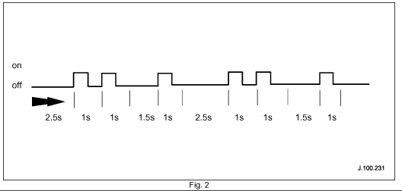

^ | Example (see Fig. 2); fault code 21 (all times in seconds from left hand side 2.5s, 1s, 1s, 1.5s, 1s, 2.5s, 1s, 1s, 1.5s and 1s)
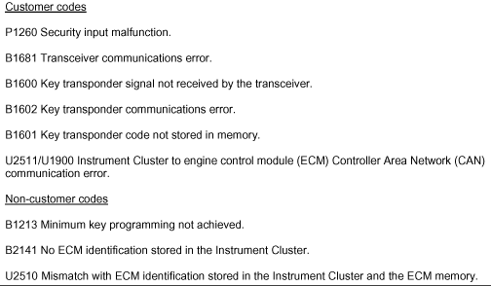

DTC Descriptions
Generic Connector Inspection
Electrical failures can be caused by problems with the connectors and their pins. Below are a number of points that may aid in investigation.
Backed-out Pins
Inspection of the connector; look for signs that the pin has backed-out. If a seal is fitted to the pin it may be protruding further out the back of the connector. If a pin has backed-out of the cavity in the connector, there is a possibility that it has been forced out when the connector was mated. Make sure that the pins are in line when the two halves of the connector are mated.
Bent Pins
Disconnect the two halves of the connector and visually inspect the pins. If a pin is bent over there is a possibility of a short from pin to pin. Pins can easily be bent over when the connector is mated. Check to ensure the pins within the connector are not knocked out of alignment before the two halves of the connector are mated.
Water ingress/fluid ingress
Disconnect the connector and inspect for signs of water ingress, corrosion may have occurred. If water or any other fluid is visible this may cause a bad connection or even short circuit to the other pins within the connector. Examine the connector seals for any damage and to ensure that the seals are fitted correctly. Ensure that the two halves of the connector latch together securely.
Probing
Ensure when probing a pin that the correct probe is used and excessive force is not used as this may weaken the locating clip and allow the pin to work loose. Care must be taken when probing female pins as the pin can easily be splayed if probed with the incorrect adaptor or the wrong tool. This would then have the potential to cause a bad connection between the two mating halves. Always use the Worldwide Diagnostic System probe kit when probing pins within a connector. (Jaguar probe adaptor kit part number. 3548-1358-00.)
Insertion force
Insertion force is imperative to ensure a good connection is made between the two mating pins. If the female pin is splayed, the connection will be poor. To check the insertion force of the female connector, identify the correct male pin within WDS probe adaptor kit. Gently insert the adaptor into the female pin and then repeat with the other pins within the connector. If the pin in question feels loose in comparison replace both male and female pins.
Chafing
Inspect the harness when in close contact to other objects (i.e. sharp steel brackets). Engine vibration will cause the outer protection to quickly chafe through if the harness is not routed correctly. When performing a repair, ensure that heat resistant tape is used where relevant. Before repairing or replacing any harness, always refer to the electrical wiring harness repair guide, reference publication number JTP 586. When repairing a harness ensure the Jaguar harness repair kit is used. (Part number. 418-5065 and 418-5411.)
Always refer to the Technical Hotline if problems are encountered.
Generic Harness Check
^ | When carrying out any of the tests in the generic harness check, it is imperative that any other sources that share the harness are taken into consideration when a measurement is taken.
^ | The X-TYPE electrical guide (publication part number - JJM 10 38 20/20) will show all other sources sharing that harness i.e. splices and sensors. This electrical guide is in JTIS.
^ | Always ensure the digital voltmeter is operating correctly before proceeding.
^ | Always use the WDS probe kit when probing pins within a connector.
Note: Do not insert the Digital Multi Meter (DMM) leads into the connector pins. (Probe adaptor kit part number: 3548-1358-00.)
Continuity test
Using a DMM, connect the DMM to the pins at both ends of the circuit that you are testing. Ensure you connect to the correct pin when a large number of pins are used in a connector. (Use WDS Probe adapter kit).
Set the DMM to the resistance test or the continuity beeper. The resistance should be between 0 - 10 ohms. If a high resistance or open circuit is found investigate harness for damage.
Short circuit high fault
The DMM can be connected to any ground source on the vehicle, but it is preferable to use the battery negative pole.
Set the DMM to Volts DC; connect the DMM red probe to the suspect pin of the circuit and the DMM black probe to the battery negative pole. No voltage should be seen, if 4 - 13 volts is seen suspect short circuit high and investigate harness for damage.
Always test the circuit with the ignition 'ON' and 'OFF' when trying to identify this fault condition.
Short circuit low fault (to ground)
The DMM can be connected to any ground source on the vehicle, but it is preferable to use the battery negative pole.
Set the DMM to the resistance test; connect the DMM to the suspect pin of the circuit and the battery negative pole, an infinity reading/open circuit (0/C) should be seen.
If a resistance is seen, suspect short circuit low and investigate harness for damage.
Always refer to the Technical Hotline if problems are encountered.

