Description and Operation

Wheel Alignment Angles
Toe is adjustable on the front and rear suspension system. The front toe is adjusted by use of the front tie-rod. The rear toe is adjusted by the use of cam bolts in the lower control arm to the rear crossmember.
Toe
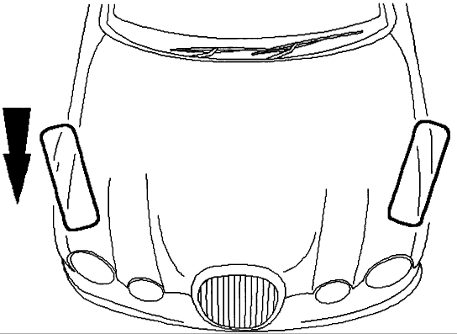
Positive Toe (Toe-In)
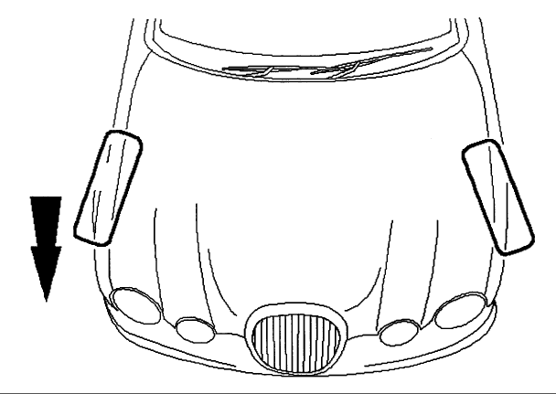
Negative Toe (Toe-Out)
The vehicle toe setting:
- Affects tire wear and directional stability.
Ride Height
NOTE: All ride height measurements are carried out with vehicle empty and 9 Liters of fuel in the tank (showroom condition).
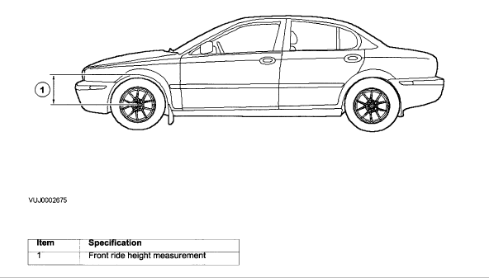
Front Ride Height Measurement
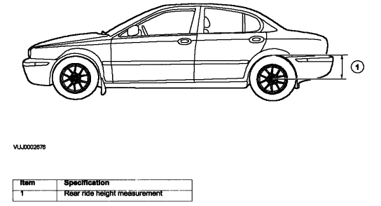
Rear Ride Height Measurement
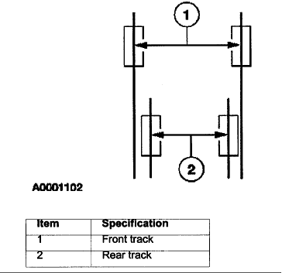
Wheel Track
Crabbing
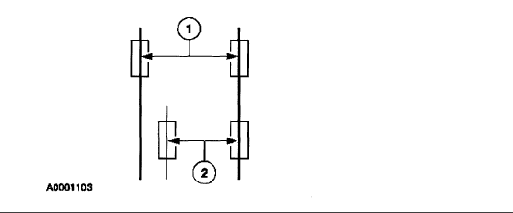

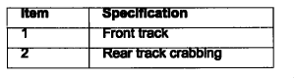
Crabbing is the condition in which the independent rear suspension (IRS) system is not square to the chassis. Heavily crowned roads can give the illusion of crabbing.
Wander
Wander is the tendency of the vehicle to require frequent, random left and right steering wheel corrections to maintain a straight path down a level road.
Shimmy
Shimmy, as observed by the driver, is large, consistent, rotational oscillations of the steering wheel resulting from large, side-to-side (lateral) tire/wheel movements.
Shimmy is usually experienced near 40 miles/hour (64 km/h) , and can start or be amplified when the tire contacts pot holes or irregularities in the road surface.
Nibble
Sometimes confused with shimmy, nibble is a condition resulting from tire interaction with various road surfaces and observed by the driver as small rotational oscillations of the steering wheel.
Poor Returnability of the Steering
Poor returnability of the steering is used to describe the poor return of the steering wheel to center after a turn or the steering correction is completed.
Drift/Pull
Pull is a tugging sensation, felt by the hands on the steering wheel, that must be overcome to keep the vehicle going straight.
Drift describes what a vehicle with this condition does with hands off the steering wheel.
- A vehicle-related drift/pull, on a flat road, will cause a consistent deviation from the straight-ahead path and require constant steering input in the opposite direction to counteract the effect.
- Drift/pull may be induced by conditions external to the vehicle (i.e., wind, road crown).
Vague On-Center Feel
Vague on-center feel is characterized by little or no build up of turning effort felt in the steering wheel as the wheel is rocked slowly left and right within very small turns around center or straight-ahead (under 20 degrees of steering wheel turn). Efforts may be said to be "flat on center."
- In the diagnosis of a road ability problem, it is important to understand the difference between wander and vague on-center feel.
Toe Adjustment-Front

Front Toe Adjustment
NOTE:
The checking and subsequent adjustment of the front toe setting should be carried out on a flat surface and in accordance with the manufactures instructions for the wheel alignment equipment used.
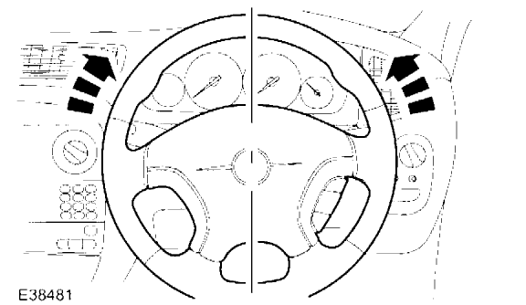

- Start the engine and centralize the steering wheel.
- Turn the engine off, and hold the steering wheel in the 'straight ahead' position by attaching a rigid link from the steering wheel to the brake pedal.
- Using suitable four wheel alignment equipment, check the toe setting.
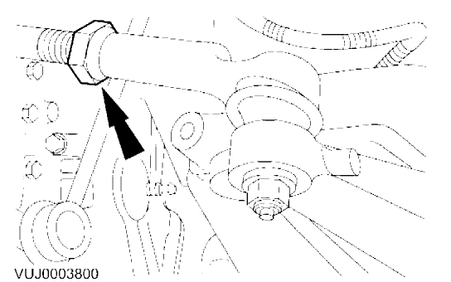

- NOTE: Right-hand shown, left-hand similar. Loosen the tie rod end locknuts.
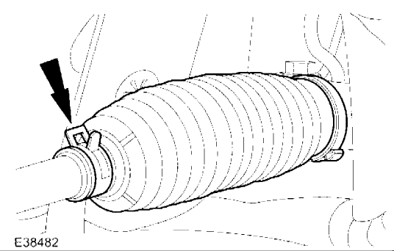

- NOTE: Right-hand shown, left-hand similar. Reposition the steering gear boot outer clamps.
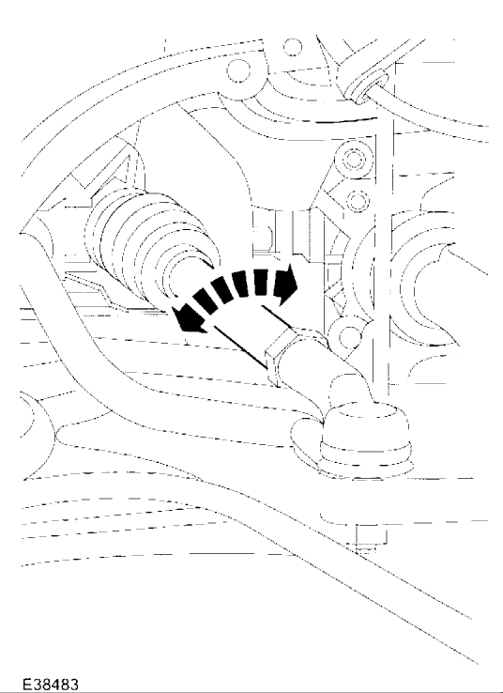

- NOTE: Right-hand shown, left-hand similar. Rotate the tie-rods an equal amount in either a clockwise or a counterclockwise direction to adjust the toe setting.

- NOTE: Right-hand shown, left-hand similar. Tighten tie-rod end locknuts.
  - Tighten to 40 Nm.

- NOTE: Right-hand shown, left-hand similar. Reposition the steering boot outer clamps.
- Check the toe setting.
Toe Adjustment-Rear

Rear Toe Adjustment
NOTE:
The checking and subsequent adjustment of the front toe setting should be carried out on a flat surface and in accordance with the manufactures instructions for the wheel alignment equipment used.
- NOTE: Final tightening of the rear suspension components should be carried out when the vehicle weight is on the road wheels. Using suitable four wheel alignment equipment, check the toe setting.
- Raise and support the vehicle.
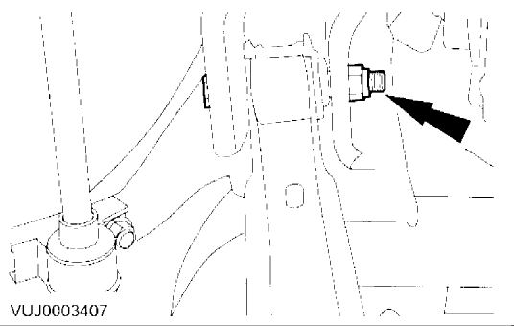

- NOTE: Left-hand shown, right-hand similar. Loosen the rear lower arm cam bolt nuts.
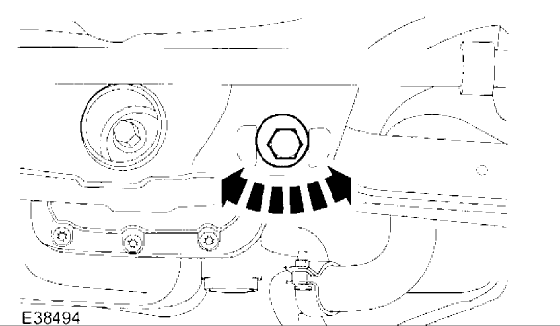

- Rotate the the cam bolts equal amounts, in either a clockwise or a counterclockwise direction, to adjust the toe setting.

- CAUTION: The final tightening of the suspension components should be carried out with the vehicle on its wheels. Failure to follow this instruction may result in damage to the vehicle. NOTE: Left-hand shown, right-hand similar. Tighten the rear lower arm cam bolt nuts.
- Lower the vehicle. Bounce the vehicle to make sure that the suspension is in its normal resting position.

- NOTE: Left-hand shown, right-hand similar. Tighten the rear lower arm cam bolt nuts.
  - Tighten to 115 Nm.
Alignment

Alignment Specifications
Note: | Settings must be checked with the vehicle at 'curb' height (unladen, with full tank of fuel).
Front Suspension
Camber
Left Hand | -1.04°to -0.04°
Right Hand | -1.04°to -0.04°
Balance (RH minus LH) | -0.70°to +0.70°
Caster
Left Hand | +1.98°to +2.98°
Right Hand | +1.98°to +2.98°
Balance (RH minus LH) | -0.50°to +0.50°
Toe | -0.27°to +0.07°
Rear Suspension
Camber
Left Hand | -1.20°to -0.20°
Right Hand | -1.20°to -0.20°
Balance (RH minus LH) | -0.50°to +0.50°
Toe
Left Hand | +0.03°to +0.23°
Right Hand | +0.03°to +0.23°
Total Toe | +0.08°to +0.42°
Thrust Angle | -0.10°to +0.10°

Notes
Ride height
Front | 376 mm
Rear | 379 mm

