Service and Repair

Draining and Filling
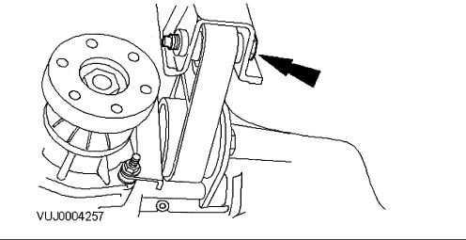

- Remove the engine roll restrictor mount retaining bolt.
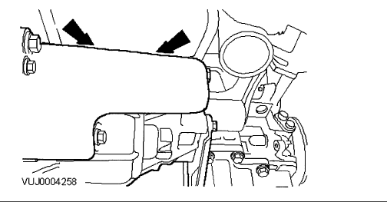

- Remove the transfer case mounting top retaining bolts.
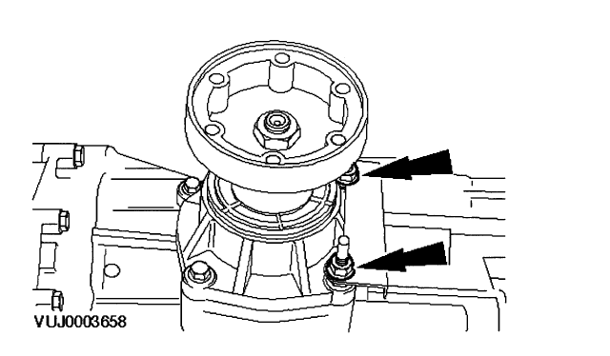

- Remove the transfer case mounting bottom retaining nuts.
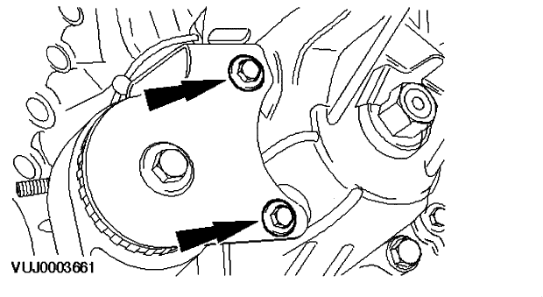

- Remove the transfer case mounting side retaining bolts.
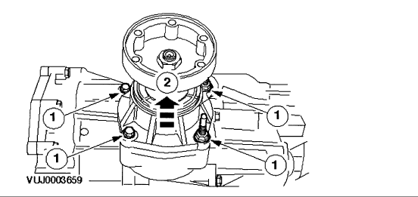

- Drain the transfer case oil.
- Remove the transfer case pinion housing retaining bolts.
- Remove the transfer case pinion housing. CAUTION: Transfer case oil will drain from the transfer case during this operation. NOTE: Observe the position of the shims between the pinion housing and the transfer case. Remove and discard the O-ring seal.
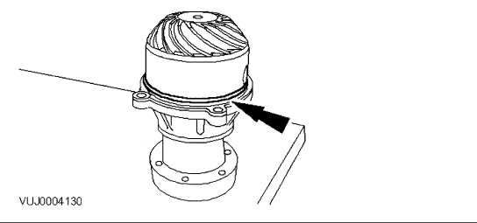

- Install a new O-ring seal.
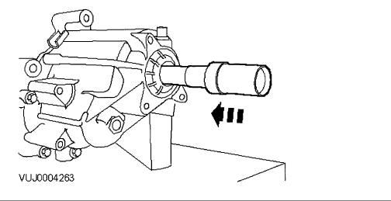

- Install the pinion housing in the transfer case.
- Install the pinion housing retaining bolts.
- Install the pinion housing retaining bolts.
  - Tighten M8 studs to 35 Nm.
CAUTION: Make sure the shims between the transfer case housing and pinion housing are correctly aligned.
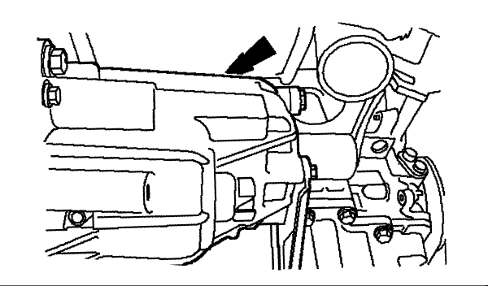

- Remove the transfer case fill plug.
  - Using a suitable syringe, add 550 Ml of SAE 75W 140 to the transfer case.
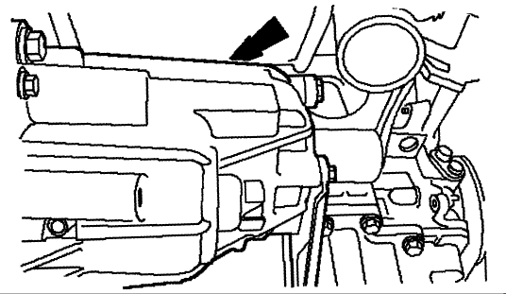

- Install the transfer case fill plug.
  - Tighten to 20 Nm.
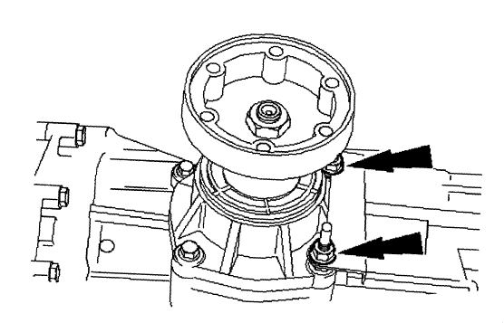

- Install the engine roll restrictor bracket.
  - Tighten to 35 Nm.

- Install the engine anti-roll restrictor bracket side retaining bolts.
  - Tighten to 35 Nm.
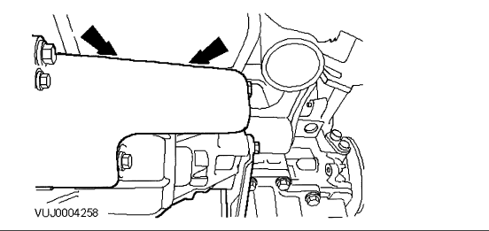

- Install the engine anti-roll restrictor bracket top retaining bolts.
  - Tighten to 55 Nm.
- Install right-hand catalyst.

Capacity Specifications

Transfer Case Capacity | 0.6 liters (0.6 quarts)

Fluid Type Specifications

Transfer Case Fluid | M2C 192A Synthetic

