Component Locations

Relay and Fuse Location
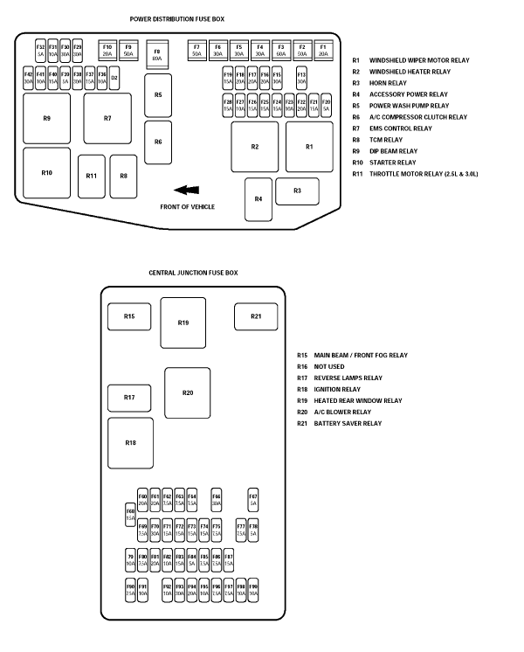

Connector Locations

Fuse Box Connectors
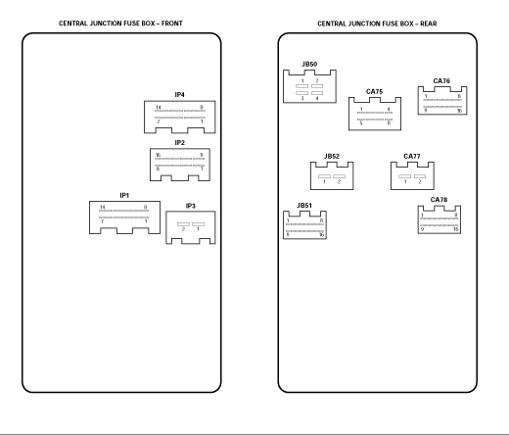

Fuse and Fusible Link Locations

Fuse Details
Engine compartment fuse box - fuses
Fuse | Fuse | Rating | Colour | Circuit

No. | Type | (amps)

F1 | Cartridge | 20 | Blue | Dip beam, High Intensity Discharge (HID) light relay.
F2 | Cartridge | 50 | Red | Ignition relay feed.
F3 | Cartridge | 60 | Yellow | ABS.
F4 | Cartridge | 30 | Pink | Rear window heater/heated mirrors relay.
F5 | Cartridge | 30 | Pink | Automatic transmission control module relay.
F6 | Cartridge | 30 | Pink | Heater blower relay.
F7 | Cartridge | 50 | Red | Power supply to passenger compartment fuse box.
F8 | Cartridge | 80 | Black | Blower module.
F9 | Cartridge | 50 | Red | Engine management system power relay.
F10 | Cartridge | 20 | Blue | Headlight power wash pump relay.
F11 | Mini |  |  | Not used.
F12 | Mini |  |  | Not used.
F13 | Mini | 30 | Green | Heated front screen right-hand side.
F14 | Mini |  |  | Not used.
F15 | Mini | 30 | Green | Heated front screen left-hand side.
F16 | Mini | 20 | Yellow | Left-hand dip beam, day time running lights, autolights.
F17 | Mini | 20 | Yellow | Right-hand dip beam, HID lights.
F18 | Mini | 20 | Yellow | Throttle motor supply.
F19 | Mini | 15 | Blue | Screenwash pump, rain sensing system.
F20 | Mini | 5 | Tan | Navigation display.
F21 | Mini | 15 | Blue | Side (Parking) lights.
F22 | Mini | 20 | Yellow | Accessories relay.
F23 | Mini | 10 | Red | Air conditioning compressor clutch.
F24 | Mini | 15 | Blue | Door lock power.
F25 | Mini | 15 | Blue | Direction indicators (GEM).
F26 | Mini | 15 | Blue | Horns.
F27 | Mini | 10 | Red | Automatic transmission control module, transit relay.
F28 | Mini | 15 | Blue | Ignition switch.
F29 | Mini | 30 | Green | Starter motor solenoid.
F30 | Mini | 30 | Green | Accessory sockets.
F31 | Mini | 10 | Red | Engine management relay coil.
F32 | Mini | 5 | Tan | Engine management control.
F33 |  |  |  | Not used.
F34 | Diode D3 |  |  | Not used.
F35 | Diode D2 |  |  | Engine management control relay diode.
F36 | Mini | 10 | Red | Canister purge valve, airflow meter, throttle motor relay, power wash relay, air conditioning relay.
F37 | Mini | 15 | Blue | Engine management system, blower speed controller, road speed sensor (if fitted).
F38 | Mini | 30 | Green | Oxygen sensor heaters A.
F39 | Mini | 5 | Tan | Variable intake valves.
F40 | Mini | 15 | Blue | Automatic transmission control module.
F41 | Mini | 10 | Red | Injectors.
F42 | Mini | 30 | Green | Oxygen sensor heaters B.
Passenger compartment fuse box - fuses
Fuse | Fuse | Rating | Colour | Circuit

No. | Type | (amps)

F60 | Mini | 20 | Yellow | Power windows left-hand.
F61 | Mini | 20 | Yellow | Power windows right-hand.
F62 | Mini | 7.5 | Brown | Rear fog lights.
F63 | Mini | 7.5 | Brown | Right-hand - front side light, side markers, rear tail lights.
F64 | Mini | 7.5 | Brown | Left-hand - front side light, side markers, rear tail lights.
F65 | Mini |  |  | Not used.
F66 | Mini | 30 | Green | Left-hand power seat switches, heater module, lumbar pump.
F67 | Mini | 5 | Tan | Battery back-up sounder, transit relay, HID/dip relay, automatic transmission control module.
F68 | Mini | 15 | Blue | Cigar lighter.
F69 | Mini | 7.5 | Brown | Telematics display, In-car entertainment head unit, antenna module, navigation module, VICS (Japan), parking aid, amplifier premium 1 system, phone handset, phone power supply module, instrument cluster, PATS module.
F70 | Mini | 30 | Green | Right-hand power seat switches, heater module, lumbar pump.
F71 | Mini | 15 | Blue | VICS (Japan), telephone transceiver, telephone handset.
F72 | Mini | 15 | Blue | Radio head unit, CD player, navigation electronic control module, Jaguar diagnostic connector/OBDII connector.
F73 | Mini | 15 | Blue | Sunroof unit/module.
F74 | Mini | 15 | Blue | Instrument cluster, Premium ICE amplifier unit.
F75 | Mini | 7.5 | Brown | Mirror fold back module, battery back-up sounder, air conditioning ECU.
F76 | Mini |  |  | Not used.
F77 | Mini | 7.5 | Brown | Left-hand and right-hand heated seats modules.
F78 | Mini | 5 | Tan | Phone power supply.
F79 | Mini | 10 | Red | Automatic transmission only: Reverse lights, reverse light switch, reverse park aid, electrochromic mirror, instrument cluster.
F80 | Mini | 7.5 | Brown | Park interlock, heater switch, OBDII, blower relay.
F81 | Mini | 20 | Yellow | Fuel pump control module.
F82 | Mini | 10 | Red | Variable power steering, alternator.  Manual transmission only: Reverse lights, reverse light switch reverse park aid, electrochromic mirror, instrument cluster.
F83 | Mini | 15 | Blue | Not used.
F84 | Mini | 5 | Tan | Instrument cluster, passenger airbag fascia light, seat weight sensor.
F85 | Mini | 7.5 | Brown | Right-hand high beam light.
F86 | Mini | 7.5 | Brown | Left-hand high beam light.
F87 | Mini | 15 | Blue | Front fog lights, master light switch.
F88 | Mini |  |  | Not used.
F89 | Mini |  |  | Not used.
F90 | Mini | 7.5 | Brown | Stop lights, cruise control.
F91 | Mini | 10 | Red | Sunroof, electrochromic mirror, power windows, power mirrors.
F92 | Mini | 10 | Red | Manual transmission cruise control clutch switch, ignition coils, automatic transmission rotary switch.
F93 | Mini | 30 | Green | Windscreen wipers.
F94 | Mini | 20 | Yellow | HID module.
F95 | Mini | 10 | Red | Airbag restraints module.
F96 | Mini | 7.5 | Brown | ABS module.
F97 | Mini | 7.5 | Brown | Glove compartment light, instrument cluster lights, licence plate lights.
F98 | Mini | 10 | Red | Mirror heaters.
F99 | Mini | 10 | Red | Luggage compartment light, footwell lights, puddle lights, vanity mirror lights, interior lights, aircon control unit, roof console unit.

