Identification Codes

Identification Codes
Vehicle Identification Number (VIN)
The official VIN is located on the right hand side of the boot compartment floor and is stamped in a dot matrix format. An additional quick reference and anti forgery identification number is stamped onto a metal plate and fastened to the instrument panel. It is positioned close to the left-hand side of the vehicle and is visible from the outside.
The vehicle identification number is also located on a vehicle certification label which is mounted on the bottom of the 'B' Post.
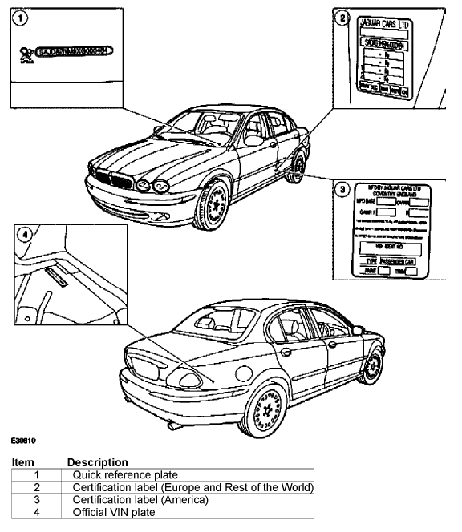
Vehicle Identification Number (Example)
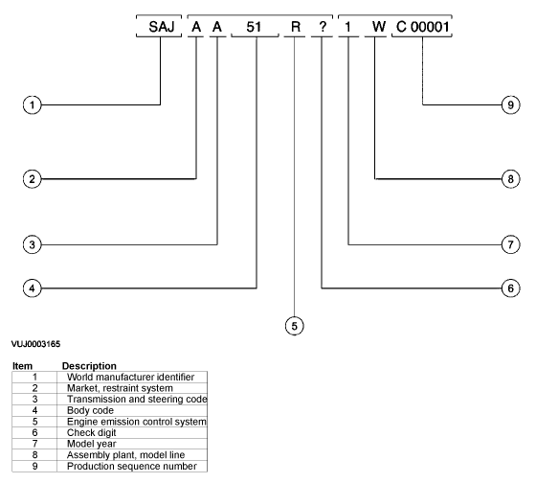
World Manufacturer Identifier
VIN Positions 1
Market, Restraint system
VIN position 2
VIN Code | Description
A | Rest of the world with twin air bags, side air bags and curtain airbags
Transmission, Steering Code
VIN Position 3
VIN Code | Description
A | Automatic LHS
B | Manual LHS
C | Automatic RHS
D | Manual RHS
E | FWD Automatic LHS
F | FWD Manual LHS
G | FWD Automatic RHS
H | FWD Manual RHS
Body Code
VIN Position 4
VIN Code | Description
51 | 4-Door, 5 seat saloon (High)
52 | 4-Door, 5 seat saloon (Entry)
53 | 4-Door, 5 seat saloon (Sports)
Engine Emission Control System
VIN Position 5
VIN Code | Description
L | Emission control system 3.0L
M | Emission control system 2.5L
S | Emission control system 2.0L
Check Digit
VIN Position 6
VIN Code | Description
0 - 9 or X | Calculated in accordance with American Standard CFR part 565
Model Year
VIN Position 7
VIN Code | Description
1 | 2001 Model Year
2 | 2002 Model Year
3 | 2003 Model Year
Assembly Plant and Model Line
VIN Position 8
VIN Code | Description
W | Halewood 3.0L
X | Halewood 2.5L
Y | Halewood 2.0L
Production Sequence Number
VIN Position 9
Sequence Number
C00001 - C99999
D00001 - D99999
E00001 - E99999
J00001 - J99999
K00001 - K99999
S00001 - S99999
T00001 - T99999
V00001 - V99999
Vehicle Certification Label
The vehicle certification label also contains the 17 character vehicle identification number. This number is used for warranty identification of the vehicle.
Vehicle Identification Label (North America)
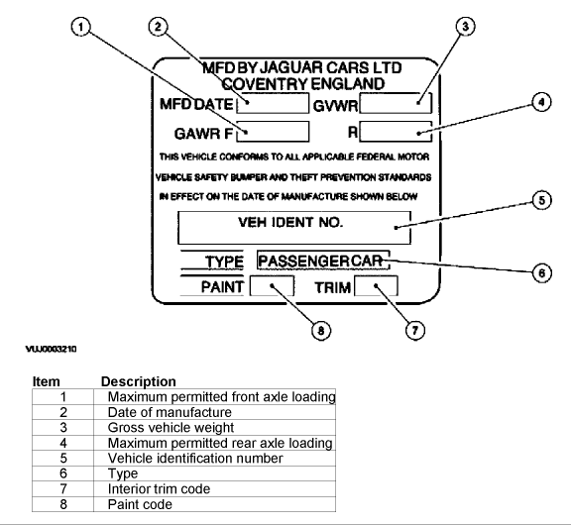
Vehicle Identification Label (Canada)
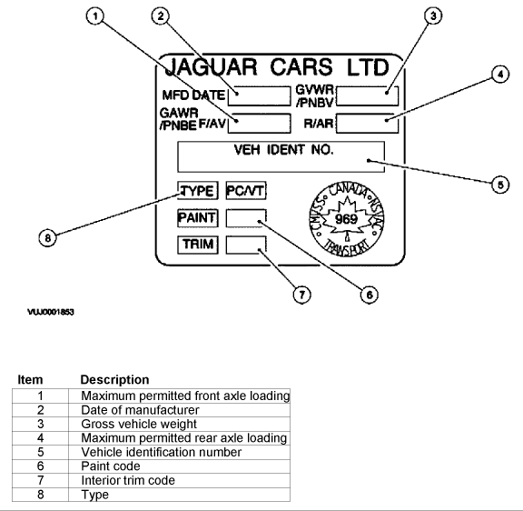
Automatic Transmission Number
The serial number of the transmission unit is displayed on a metal label or bar code (where equipped) attached to the transmission casing.
Engine Number (2.0L, 2.5L and 3.0L)
The engine number is contained on a bar code label on the front cover and is also stamped in the cylinder block casting.

