Body - Windshield Damage Diagnostic Guide
NUMBER:
JAGA501-001
MODEL:
ALL
DATE:
June 22, 2006
SECTION: 501-11
Windshield Damage Diagnostic Aid
AFFECTED VEHICLE RANGE:
All Jaguar Vehicles
CONDITION SUMMARY:
INTERPRETATION OF GLASS DAMAGE SYMPTOMS
Situation:
This information only bulletin has been issued to aid dealers to determine whether windshield damage has been caused by an outside influence, or a manufacturing concern.
Action:
Follow the steps outlined in the Repair Procedure to determine whether windshield damage has been the result of outside damage.
PARTS:
Information only
WARRANTY:
NOTE: The following offer illustrations of common windshield damage conditions and how to determine if the damage is a result of outside influences (not warrantable) or of manufacturing problems (warrantable)
Normal warranty policy and procedures apply.
Service Information
Diagnosis
1. | Clean damaged windshield area.
2. | Perform visual inspection for signs of impact. Low impact damage will appear as a small point along a single crack and can be confirmed by the pen test (see step 6). Moderate impact damage will appear as multiple cracks radiating from a point. High impact damage appears as many cracks radiating from the impact area.
3. | If visual inspection and pen test do not show surface damage point a flashlight at a 45 degree angle along the cracks in the black painted area of the windshield (see illustration E80543 in step 7).
4. | Look for radial cracks similar to illustration E80544 (step 8).
5. | If radial cracks are present then cracks are caused by a stone impact and are not warrantable.
6. | Slowly run the tip of a ballpoint pen along the crack. If there is an impact present the tip will catch in the depression caused by the impact.  Examples of Damaged Windshields Caused by Stone Impact
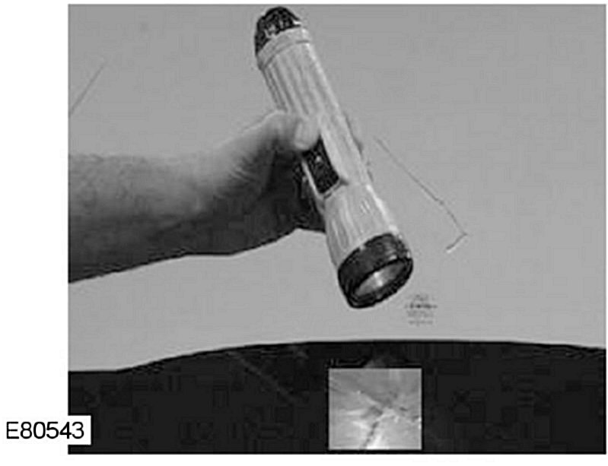

7. | Flashlight test.
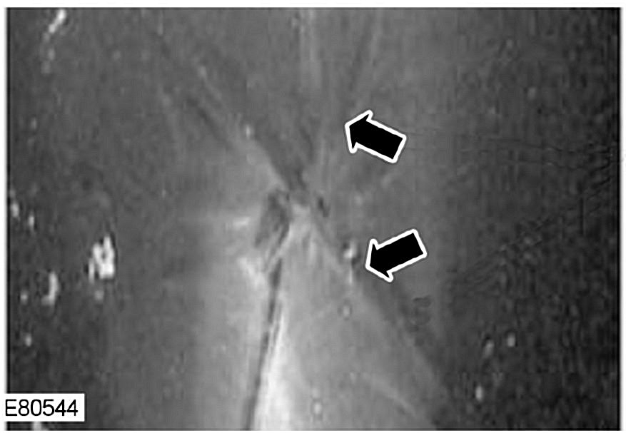

8. | View from outside using flashlight (radial cracks). Several radial cracks emanate from origin point.
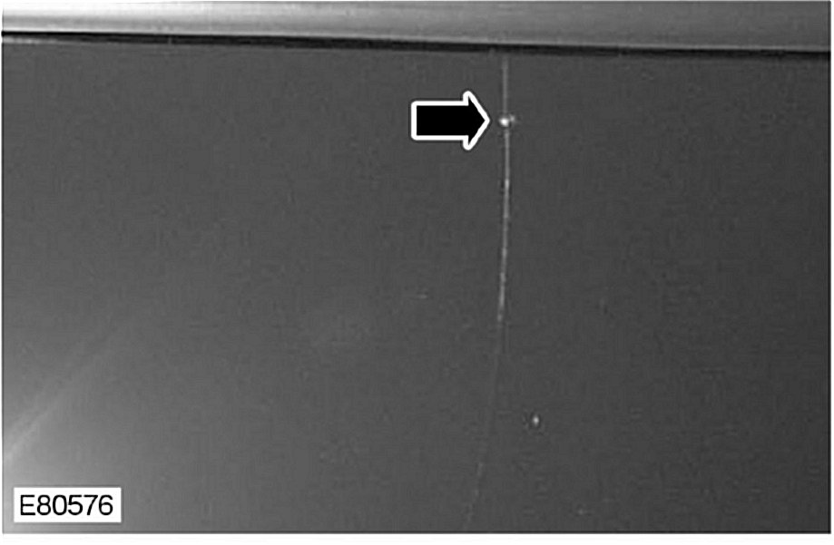

9. | Low impact resulting in single crack.
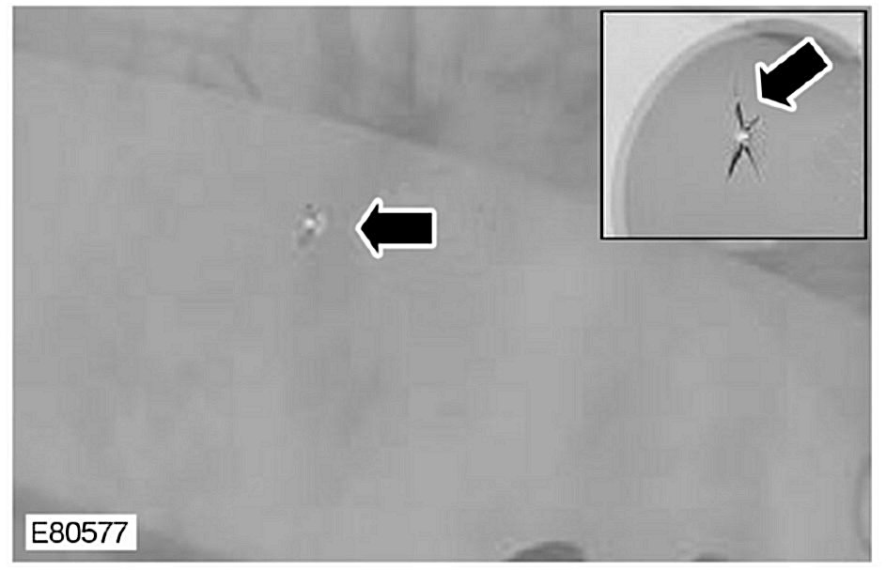

10. | Moderate impact resulting in several cracks.
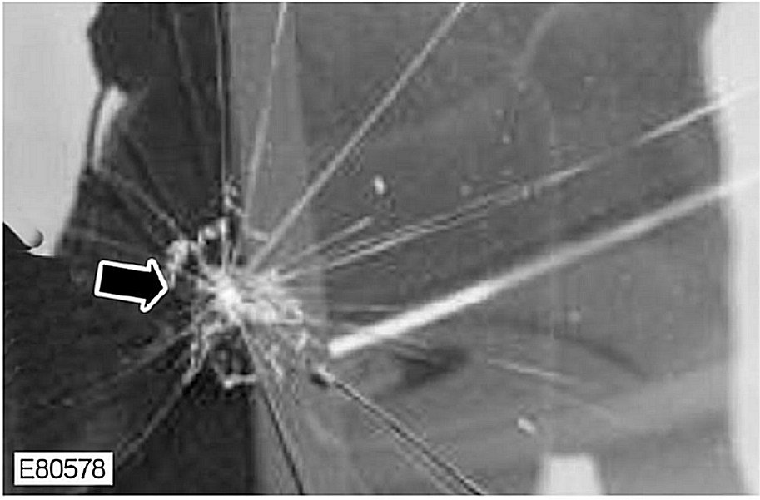

11. | High impact resulting in many cracks.  Examples of Damaged Windshields Caused by Stone Impact at the Black Paint Area  NOTE: The three examples below all show evidence liking to stress cracking. This must be confirmed using the ballpoint pen test previously described (in step 6) before any claim is made. Claims subsequently found to be caused by small stone damage will be rejected.
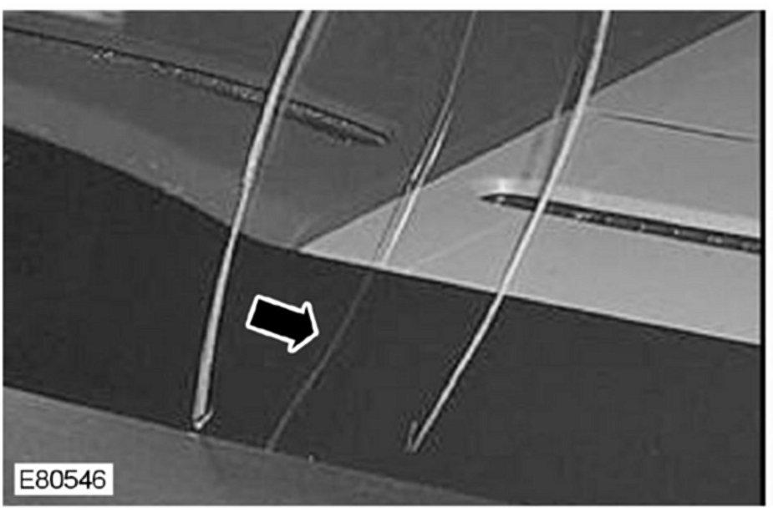

12. | Crack along cowl.
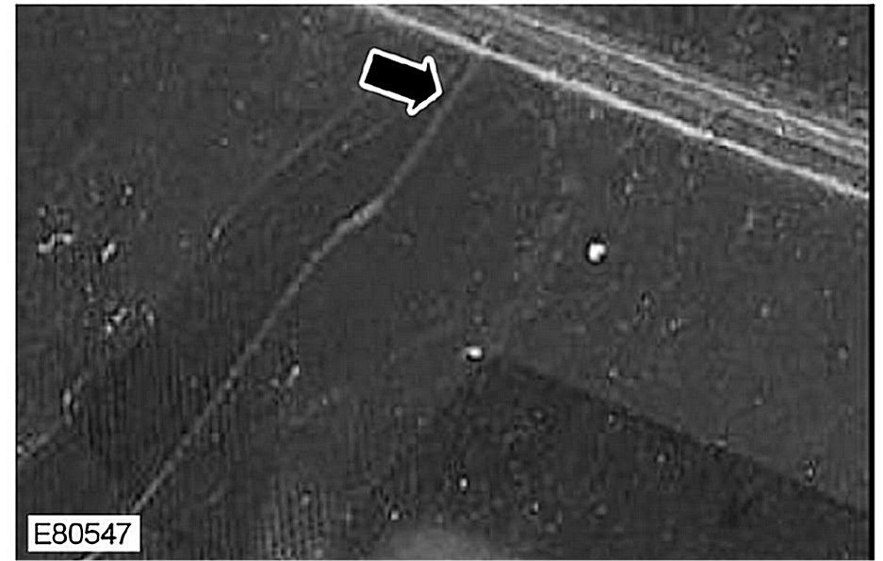

13. | Crack along roof line.
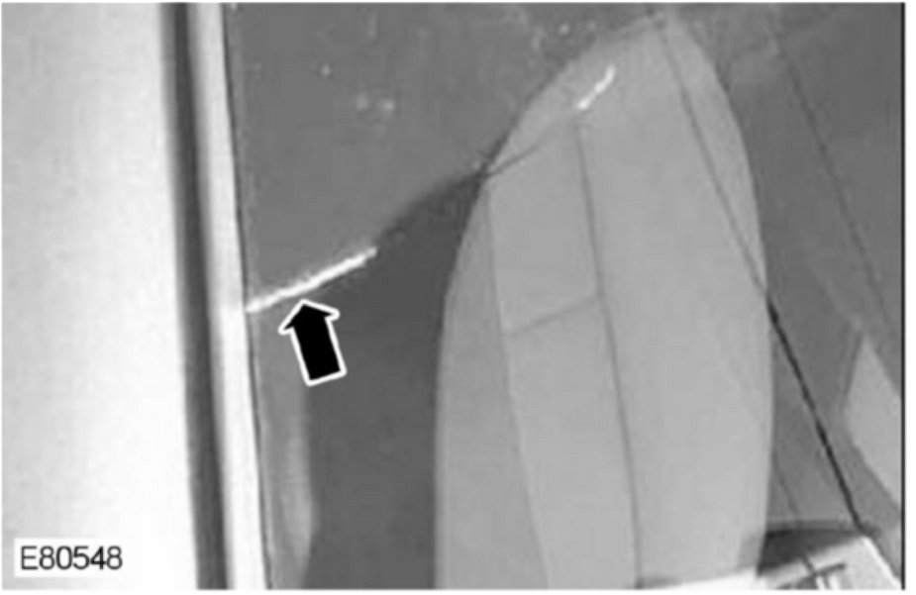

14. | Crack along A-pillar.  Examples of Windshield Defect Covered by Warranty  NOTE: Warrantable items include imperfections in glass manufacturing and factory assembly such as: distortion delamination spalling bubbles visual flaws between windshield layers and stress cracks.
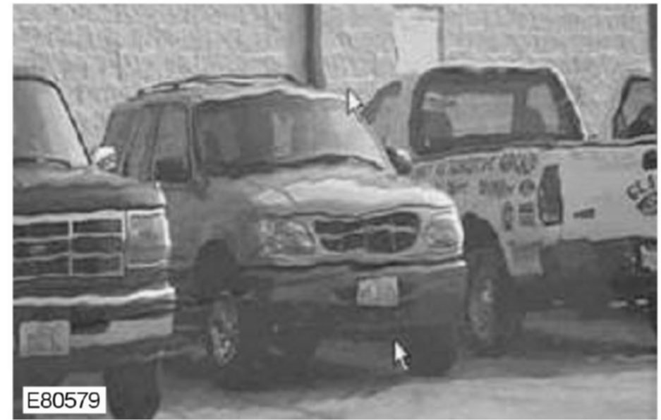

15. | Distorted glass.
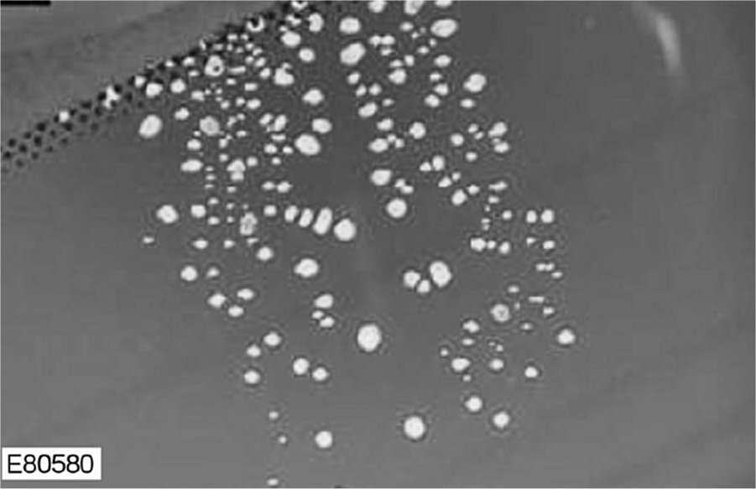

16. | Bubbles (Delamination).
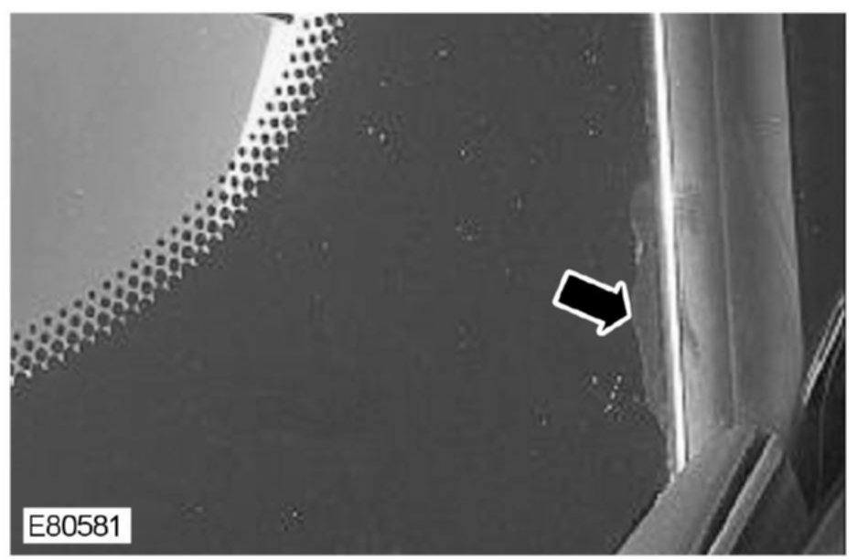

17. | Edge delamination (Spalling).
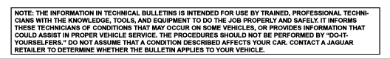

Disclaimer

