Procedure to replace a 2006 Jaguar S Type Coolant Recovery Tank
Jaguar Coolant Recovery tanks are prone to failure of the plastic nipple on the top of the tank which secures the secondary overflow line. However, it is also possible that the connection has just worked loose over time. Before buying a new tank, you might want to first try re-installing the secondary overflow line and/or spring clip, or replacing the spring clip with a screw type hose clip. A free repair or a repair that costs $1-2 is much better than a full replacement costing $95 or more.

If you do have a tank that is cracked or has a cracked fitting as I did, here is the procedure I used to replace my tank. I don’t have the official Jaguar process, but this one seems to have worked, as the tank replacement is a relatively simple repair.

- Place a drip pan underneath the car beneath the coolant tank to catch any antifreeze spillage.
- Remove the Phillips head screw which secures the tank at the right hand side of the tank's top. Set the screw aside for re-use, as the new tank doesn't come with one.
- Use a pair of pliers to open the spring clip on the small overflow tube on top of the tank and remove the line from the plastic nipple.

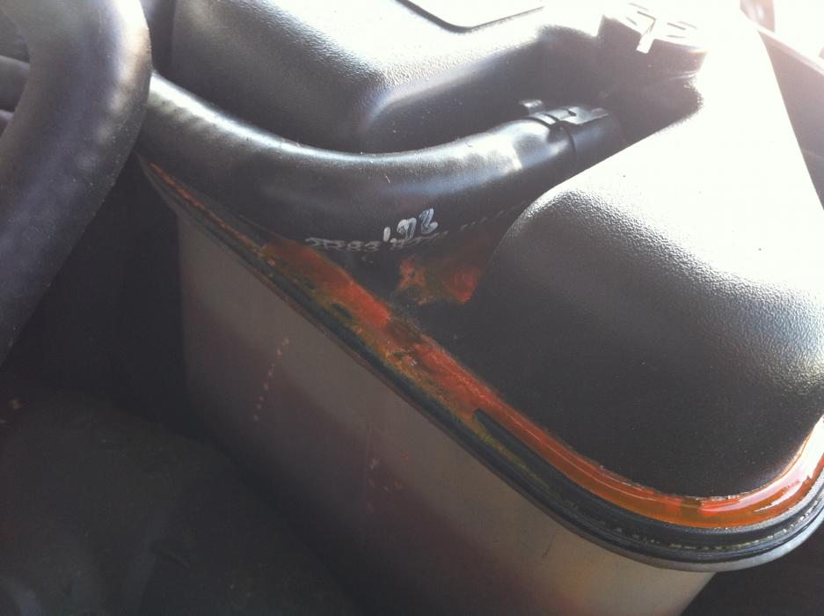
Figure 1 Top overflow line attached to plastic nipple on top of tank

- Pivot the tank upward, raising the right side of the tank as you face the car. You will be able to see the remaining two connections to the tank. One is a 90 degree fitting with a wire. This is the level sensor. The other is a large tube also with a 90 degree fitting, which is the primary overflow.

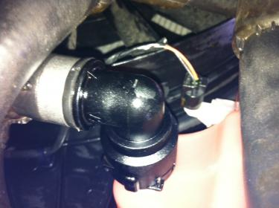
Figure 2 Level Sensor (Left) and Primary Overflow Line (Right) attached to bottom of tank

- Locate the level sensor wire/fitting on the bottom of the tank. Grab the black and white 90 degree plastic fitting and rotate counterclockwise (as viewed from above) until the locking tab dis-engages. Then pull the level sensor straight downward to remove it from the tank. The pictures below show the 90 degree fitting with the sensor wire removed for illustrative purposes. You do not need to remove the wire.

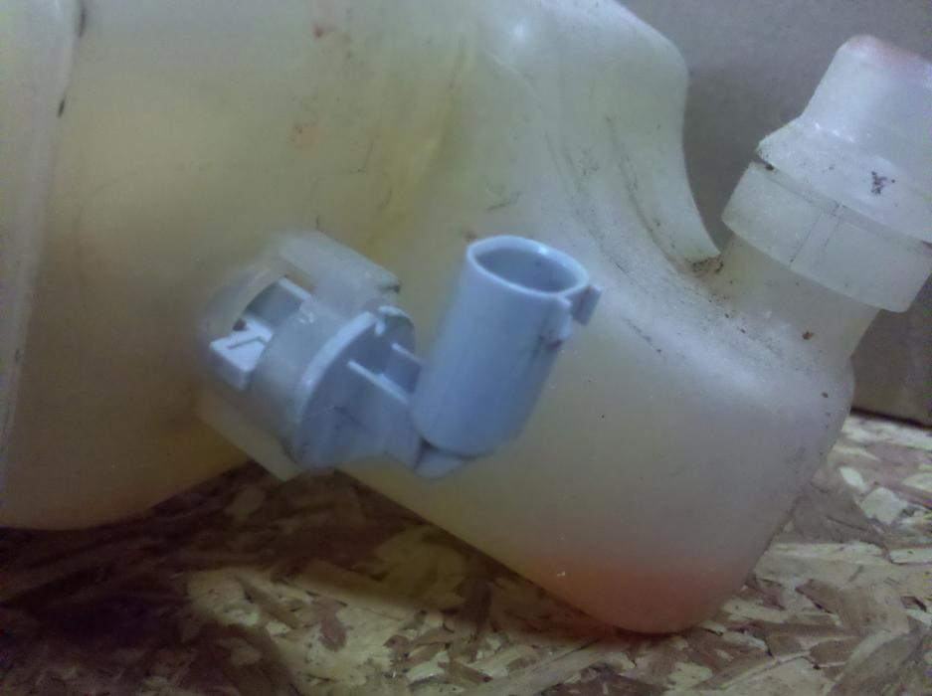
Figure 3 Level Sensor Fitting in locked position

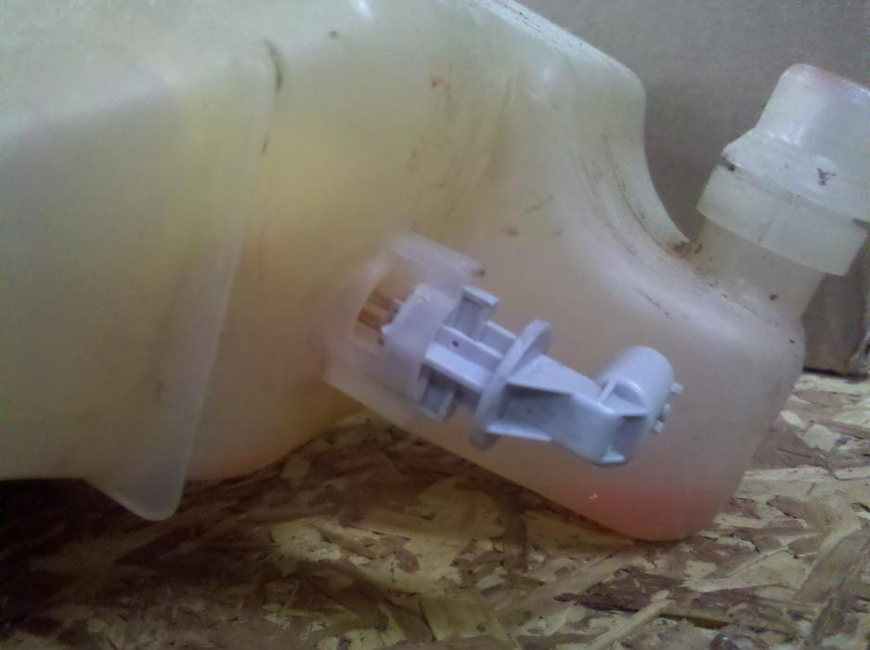
Figure 4 Level Sensor Fitting after it is rotated to allow removal

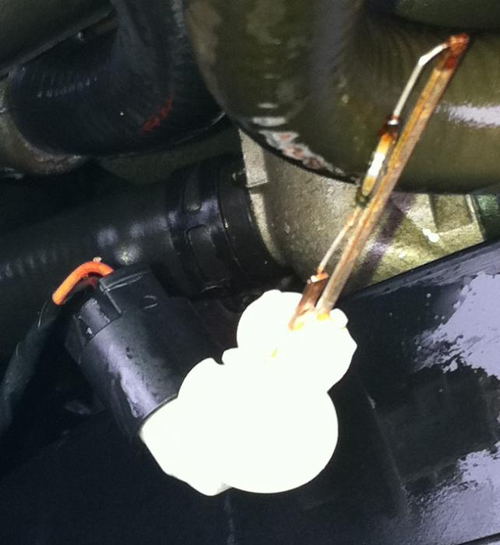
Figure 5 Level sensor after removal from tank

- The only remaining connection to the tan is the primary overflow line going into the bottom of the tank. This is secured with a wire C Clip. Use a straight blade screwdriver to push the top of the C Clip to the disengaged position (push the end of the clip toward the Driver’s side of the car until it clicks into the notch on the fitting). The end of the clip is visible in the closed position the picture below and only needs to be pushed to the slot shown just to its right in order to unlock the fitting. The clip has to be re-engaged when the new tank is hooked up. It is under tension and I didn’t want it to go springing totally off and disappear into the innards of the engine compartment, so I played it safe and removed it totally, setting it aside for re-use.

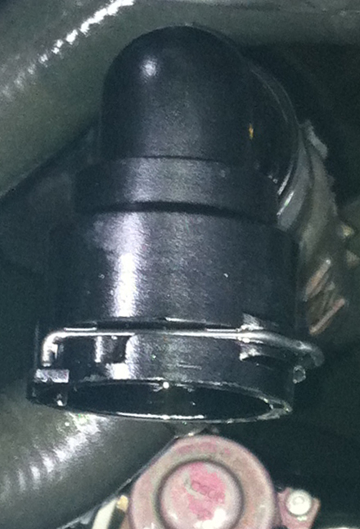
Figure 6 Primary Overflow fitting, showing wire C Clip in Locked Position

- Grab the 90 degree fitting and wiggle, pulling it straight back to remove it from the tank. As it comes off, antifreeze will start leaking from both the line and the tank. Use your thumb to plug the flow from the tank. You will still have a small amount of leakage from the line, but that’s what the drip pan is for.

- Remove the tank by lifting upward and rotating as needed to clear the radiator hose. Set the tank aside with the bottom fitting elevated to keep coolant from leaking out. The area occupied by the tank will now look like this:

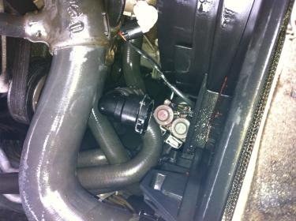
Figure 7 Opening After Removal of Tank

- If you removed the wire C Clip as I did, re-install it onto the 90 degree connector. Slide it into the channel in the connector from the right side to the left (as viewed from the top while facing the car) until the upper and lower ends of the clip both slip into the notches on the channel.
- Position the new tank into the opening. As the level sensor has the most play, it is easiest to attach it first. Insert the level sensor into the new tank, insuring the locking tab slide fully and easily into the fitting. Once fully inserted, rotate the 90 degree fitting clockwise (as viewed from the top until the locking tab locks into position.
- Slide the 90 degree connector on the primary overflow line onto the fitting on the bottom of the tank. Once fully inserted, insure the wire C Clip is engaged by sliding it toward the left until it clicks into the locked position. Pull back on the 90 degree connector (as if trying to remove it) to insure that the fitting and connector are fully engaged.
- Position the new tank properly into its intalled position. Insure the tabs on the end of the tank (left side as you face the car) are engaged in the slots in the radiator. Then secure the entire assembly with the screw first removed in step #2.
- Using pliers to hold the spring clip open, attach the secondary overflow line to the plastic nipple on the top of the tank. Give it a bit of a tug after it is installed to insure the spring clip if fully engaged.
- Use a screwdriver to open the air bleed fitting located just above the secondary line.
- Use a funnel to pour the fluid from the original tank into the new tank (or use new coolant if desired) until the fluid level is full. You may need to add additional coolant if your tank wasn’t full when you started or if you lost coolant during the replacement process.
- Close the air bleed fitting with a screwdriver.
- Use a hose to spray down the area to wash off any coolant spilled.
- Start the engine and inspect the fittings for any signs of leakage. Allow the engine to run for a couple minutes, then shut it down and re-top the tank.
- You should be good to go, but take the car for a test drive, checking the coolant levels and re-inspecting for any signs of leakage after the test drive.

