Exterior Front Door Handle
This is a "Trustmark Authoring Standards (TAS) Repair Procedure"
- TAS style procedures can be identified by steps that have no accompanying step text and the magenta color of the electrical connectors and fasteners such as nuts, bolts, clamps or clips.
- TAS removal and installation procedures use a sequence of color illustrations to indicate the order to be followed when removing/disassembling or installing/assembling a component.
- Many of the TAS procedures will have the installation information within the removal steps.
- The TAS color illustrations use a variety of symbols to indicate important details of the procedures. It is important to understand these symbols in order to properly used the TAS procedures. Refer to How to Use TAS Procedures and TAS Symbol Glossary at Vehicle | Description and Operation for additional information on these TAS procedures.
For additional information, refer to How to Use TAS Procedures See: Description and Operation\How to Use TAS Procedures
For additional information, refer to TAS Symbol Glossary See: Description and Operation\TAS Symbols Glossary
Removal
NOTE:
Removal steps in this procedure may contain installation details.
NOTE:
Some variation in the illustrations may occur, but the essential information is always correct.
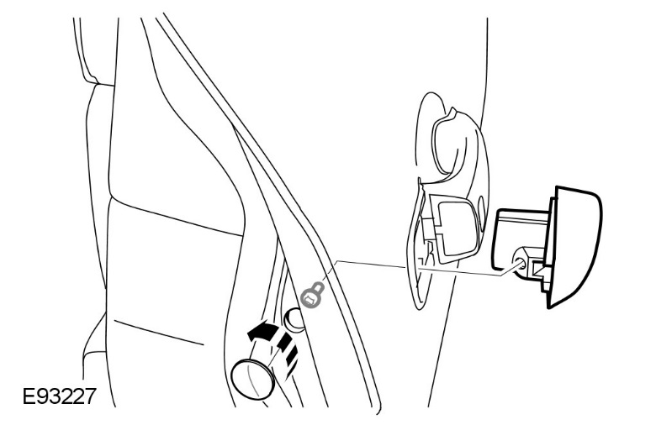
NOTE:
Remove the screw sufficiently, only to release the component.
Torque to: 4 Nm
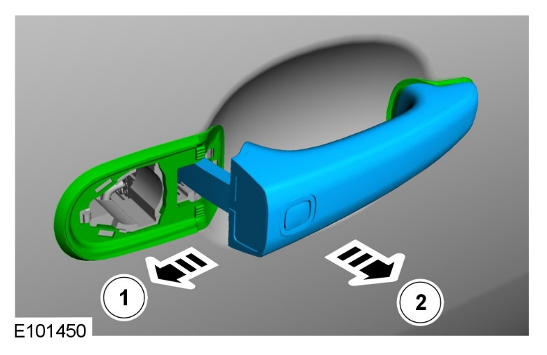

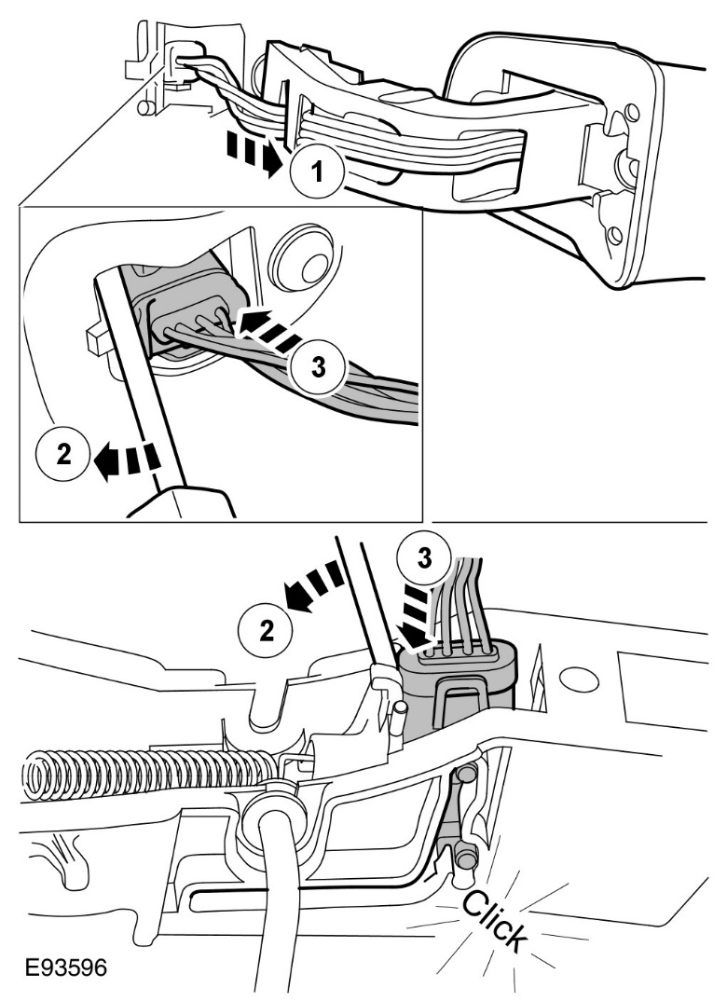
CAUTION: Take extra care not to damage the wiring harnesses.
NOTE:
Secure the connection in the service position.
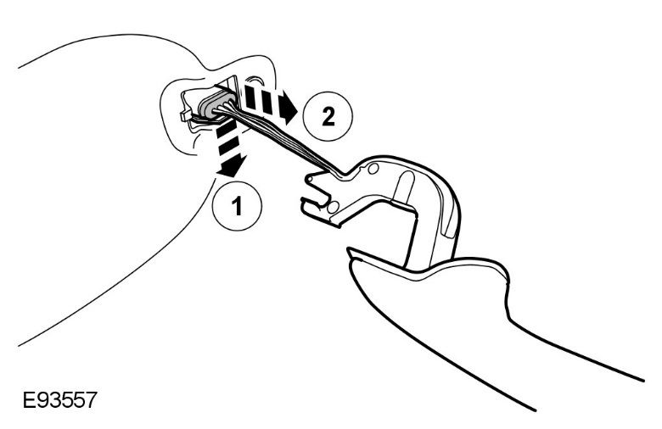
Installation
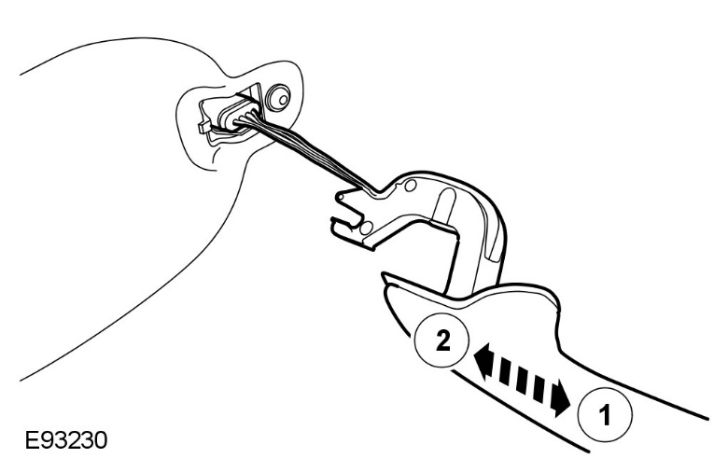
CAUTION: Make sure that the wiring harnesses are correctly located.
1 | To install, reverse the removal procedure.

