Hello,
finally I got around to post the LED headlight hack.
Description:
The relay installed will be activated by the 12V ACC when ignition is turned on. This switches the 12V power source of the LED strip in the head light to the same 12V ACC source which will cause the LED strip to be on when the ignition is turned on. It will go out a few seconds after the ignition is turned off.
When the relay is deactivated the LED strip will receive its 12V power from the headlight harness, just like before the rewiring. That way they work with the parking lights.
The relay was necessary to a) make sure the parking lights work and b) so the tail lights don't come on with the LED strips when the ignition is turned on.
Cut wire for LED strip (see pictures of plug) about 2" from plug. Connect to relay contact. Connect the wire from the harness to the normally closed (N/C) contact on the relay. Connect the 12V ACC power from fuse box in passenger side of engine compartment to relay coil AND the normally open (N/O) contact on the relay.
Please make sure to get a relay with 2 sets of contacts as you want each headlight has its own wiring. It is a very easy hack, assuming you are comfortable with basic vehicle wiring jobs. I ran the wires in a OEM like slitted flex tube and used cable ties to make it a professional and almost invisible job. The relay I attached with double sided tape in the engine compartment.
Pictures below:

Driver side headlight plug Pin #2 (Gray/OR)
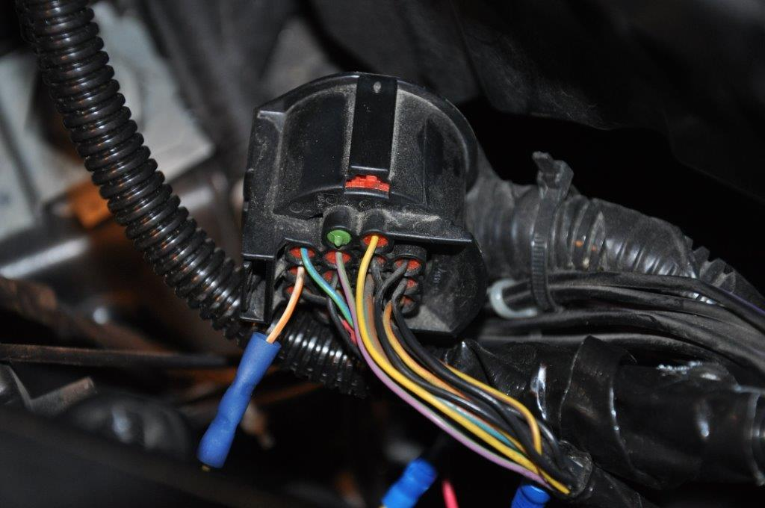
Passenger side headlight plug Pin 2 (Pre 2014 Gray/OR, 2014 on Purple)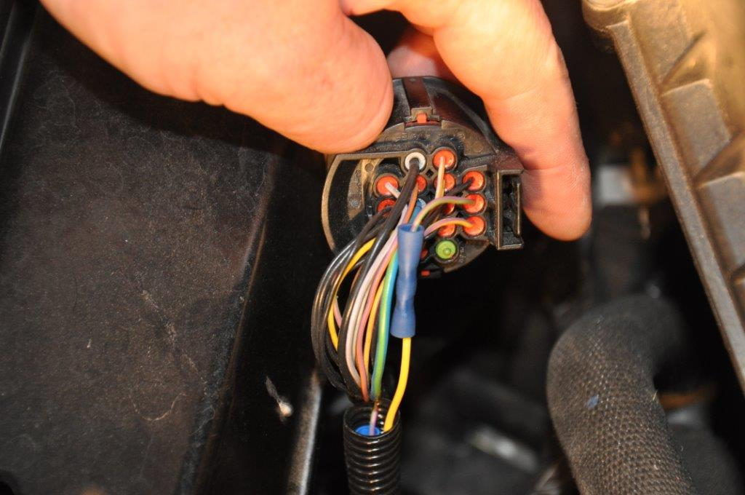
Relay
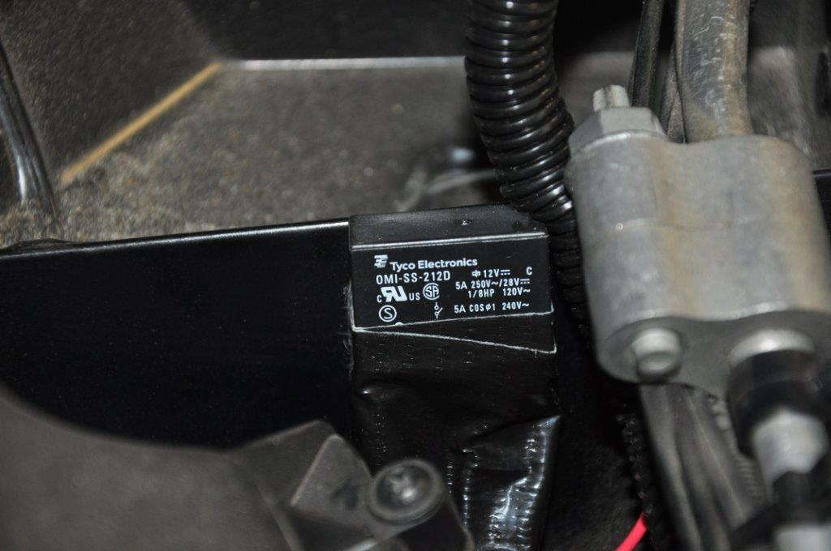
Tap in fuse box
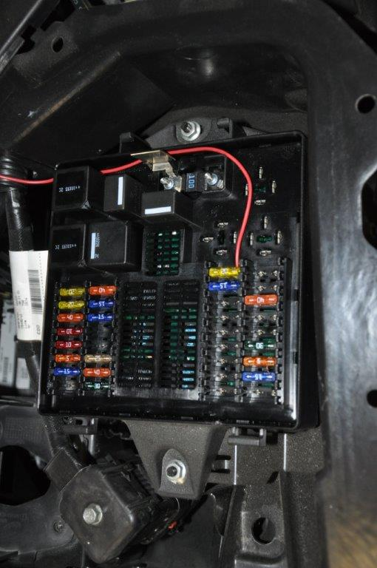
Some misc. pics
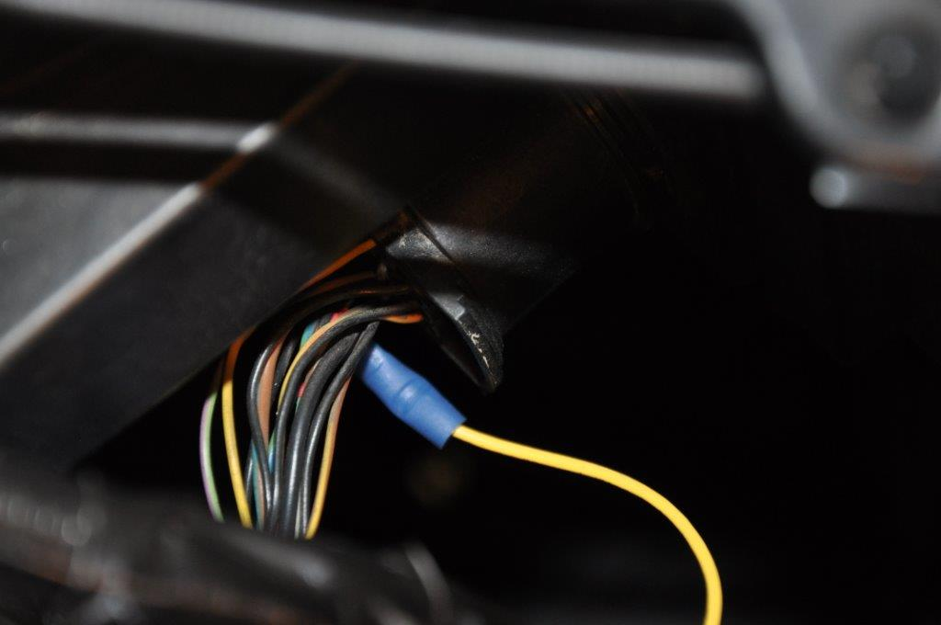
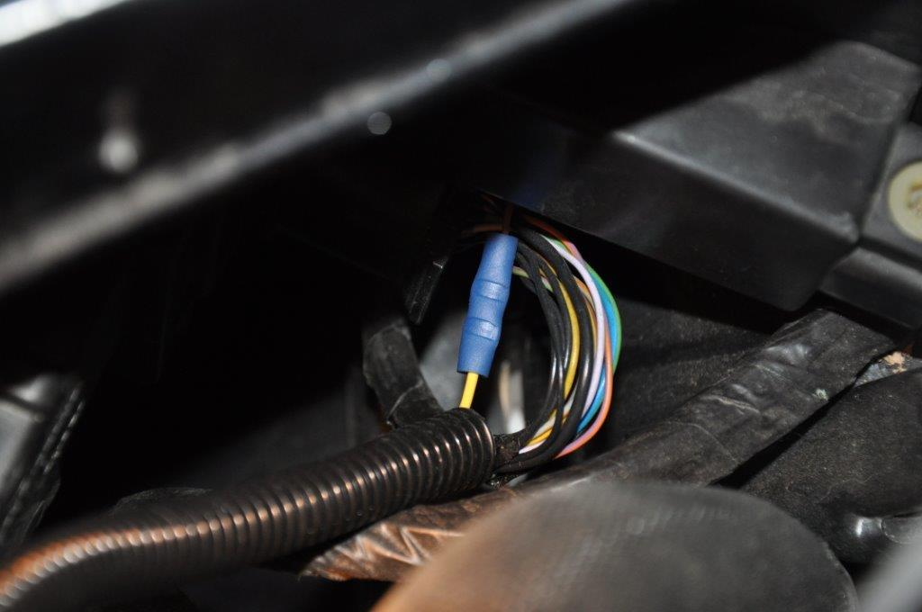
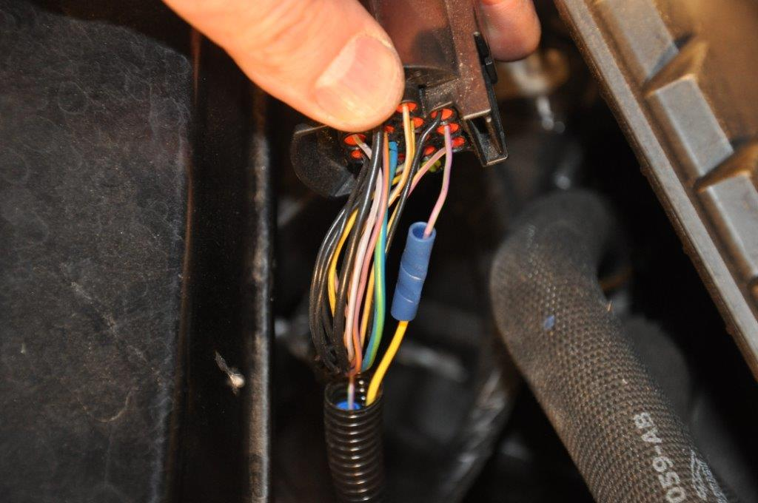
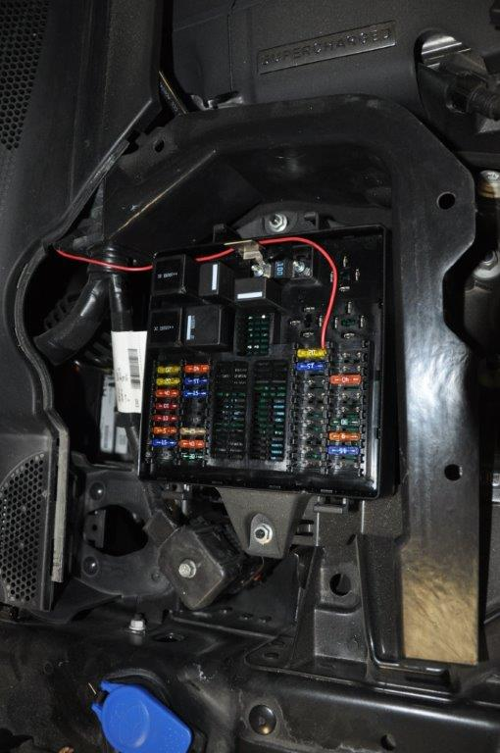
Wiring Diagram
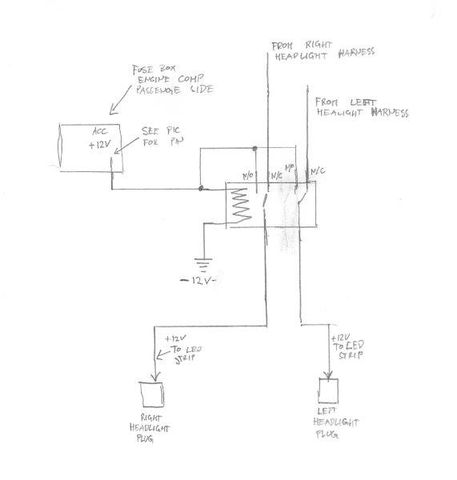
H2)boy’s clearer diagram: