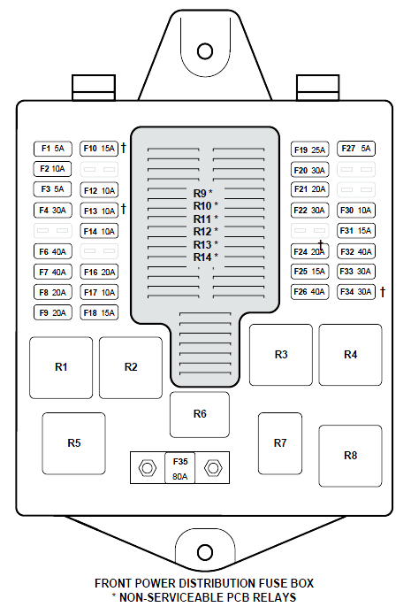
Front of Car

F10 HORN

F16 HIGH
BEAMS

F8 & F9
HEADLIGHT
MAIN BEAMS

WINDSCREEN WIPERS
AIR HEADLIGHT HEATER ? ON/OFF
SUSPENSION HIGH BEAMS
(NOT USED)
COMPRESSOR INNER
HEADLIGHTS
FRONT FOG

HEADLIGHT IGNITION
MAIN BEAMS COIL WIPERS
FAST/SLOW
OUTER
HEADLIGHTS

Rear of Car

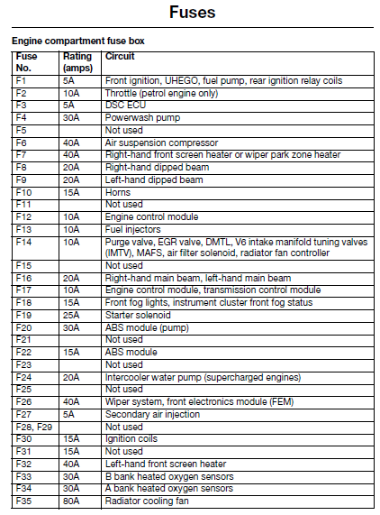

RELAYS
