2005 MY Left HID Headlamp Unit with DIP Bulb (Headlamp Leveling Module/Ballast) part of Fig. 08-2
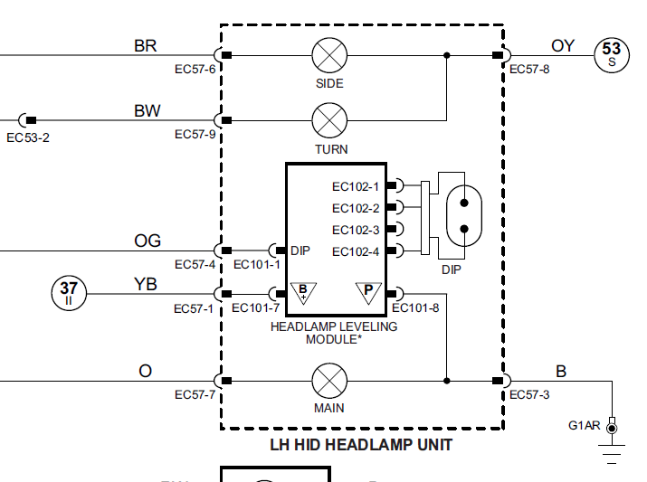

2005 MY Left HID Headlamp Unit with Stepper Motor (Headlamp Leveling Module/Ballast) part of Fig. 08-6

