







DATE 06/97
Amended 09/01
V8 XJ Series/XK
303-11
TECHNICAL BULLETIN
SERVICE
Poor Heater Performance –
Coolant Specification Change –
Repair Procedure
MODEL
1997-99 MY XK Range
1998-99 MY V8 XJ Series
VIN
001001-042635
812256-878274
Remove and destroy Bulletin 303-11, dated 6/97.
Replace with this Bulletin which supersedes
Service Action S813. The procedure has been
rewritten to include V8 XJ Series vehicles.
This Technical Bulletin supersedes Service Action S813 and no further claims will be accepted
under S813. All Warranty Claims must now be made under this Technical Bulletin.
Issue:
On some vehicles within the above VIN ranges, the antifreeze solution in the cooling system may
deteriorate, causing reduced circulation through the heater core, resulting in poor heater
performance. The following procedure has been produced to eliminate this problem:
Action:
In case of a customer complaint of lack of heat from the heating system on a vehicle within the
above VIN ranges, a Workshop Procedure has been produced to eliminate the problem.
Workshop Procedure
STEP 1: HEATER CORE COOLANT CIRCULATION TEST
Note: This procedure is required for all vehicles produced prior to the
introduction of XLC Extended Life Coolant (introduced after VIN 042635
XK Range vehicles and VIN 878274 for V8 XJ Series vehicles), and have
experienced low heater performance and where heater blocking is suspected.
1.
2.
Start and run the engine at approximately 2000 rpm until normal coolant temperature is
reached.
Press heater auto switch to ‘HI’ setting and press the A/C switch, thus selecting maximum
heater output temperature and maximum fan speed.
Date of issue 06/97 Amended 09/01
Bulletin Number 303-11 Page 1 of 9

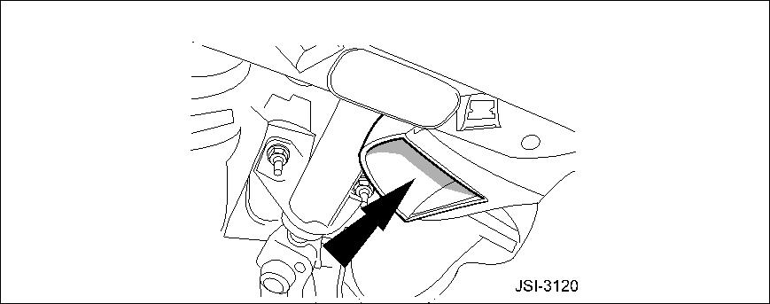
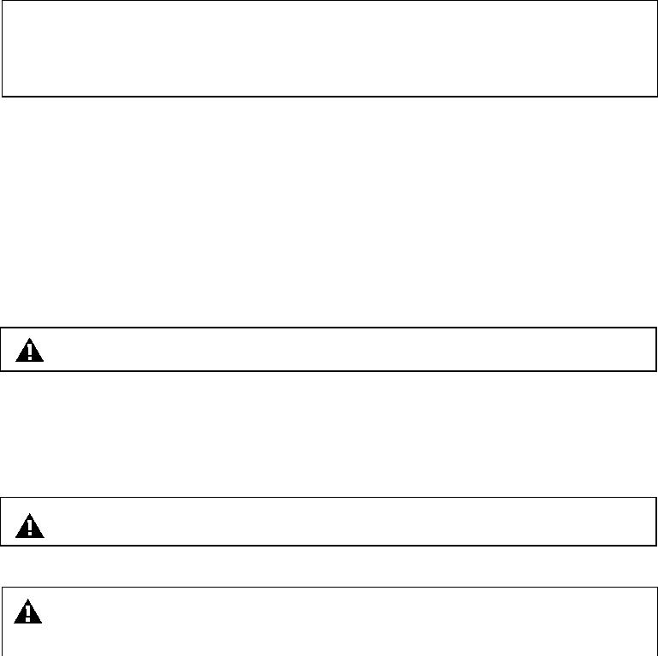
LEFT SIDE FOOTWELL DUCT
ILLUSTRATION 1
3.
4.
Power the left side seat fully rearward and place the probe of an electronic thermometer in
the left side foot well outlet duct, ensuring the probe is in the hot air stream and not in
contact with the duct (Illustration 1). Maintain the engine speed at 2000 rpm and allow the
temperature reading to stabilize.
Switch off the engine and return the seat to its normal position.
Note: If a temperature reading of LESS than 40 °C (104 °F) is indicated, the
coolant circulation rate through the heater core is unsatisfactory. In this
event, proceed to Step 2 Chemical flushing procedure.
If a temperature reading of MORE than 40 °C (104 °F) has been indicated, the coolant
circulation rate through the heater core is satisfactory. In this event, the heater system is working
correctly and no further action is required.
STEP 2: CHEMICAL FLUSHING PROCEDURE
1.
2.
3.
Release and open hood.
Place covers over the fenders.
Remove the pressure cap from the coolant header tank.
Warning: The cooling system may be pressurized and hot.
4.
5.
6.
Raise the vehicle on lift.
On XK series vehicles only, remove the generator-cooling duct.
On all vehicles, position a suitable container under the radiator and remove the radiator
drain plug.
Warning: Coolant will be hot!
7.
Allow the cooling system to drain as much as possible.
Caution: Immediately wash away any coolant spilled on the vehicle
bodywork.
8.
In place of the radiator drain plug, install and tighten the radiator flushing adaptor tool. (XK
Page 2 of 9
Bulletin Number 303-11
Date of issue 06/97 Amended 09/01

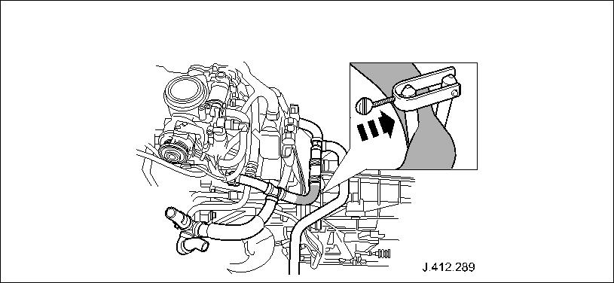

Series vehicles Part Number 100-020, V8 XJ Series vehicles Part Number 100-022).
Connect a suitable hose to the adaptor using a worm drive clip to retain the hose.
9.
Note: The hose must be long enough to enable coolant subsequently flushed
from the system to be drained without any possibility of the flushing solution
coming into contact with the vehicle bodywork.
Note: Suitably clamp the hose to prevent water flowing during the following
operations:
10. Remove the container from under the vehicle and lower the lift.
11. Place a cloth below the coolant header tank.
12. Remove the clip on the hose from the header tank to recovery bottle and disconnect the
hose.
13. For access on XK series vehicles, release and remove the air cleaner cover, mass air flow
sensor and air intake hose assembly. For access on V8 XJ series vehicles, remove the
engine compartment rear cover.
CLAMP INSTALLED ON BYPASS HOSE
ILLUSTRATION 2
14. On all vehicles, install a suitable clamp on the heater bypass hose between the one-way
valve and the T-piece (Illustration 2).
15. On XK series vehicles, reinstall the air cleaner cover, mass air flow sensor and air intake
assembly.
16. On all vehicles, remove the air purge breather cap and refill the cooling system with clean
plain water via the header tank, until the level stabilizes at the top of the breather neck.
17. Reinstall the air purge breather cap.
18. Fill up coolant header tank.
19. Install and tighten coolant pressure cap.
20. Start and run the engine at approximately 2000 rpm for 5 minutes with the climate controls
set as previously.
21. Switch off the engine.
Date of issue 06/97 Amended 09/01
Bulletin Number 303-11 Page 3 of 9

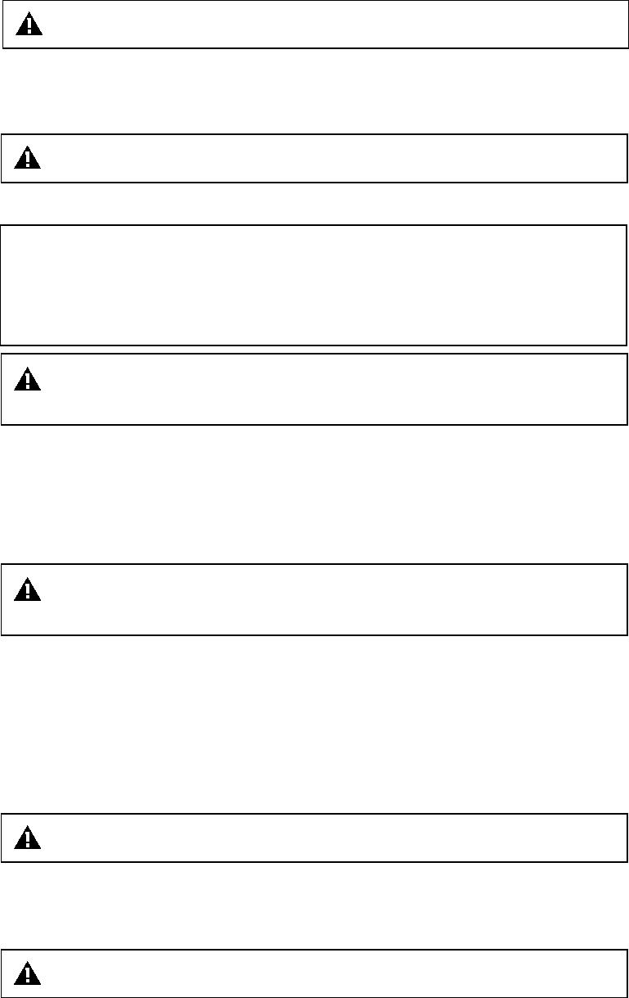
22. Remove the pressure cap from the coolant header tank.
Warning: The cooling system will be pressurized and hot.
23. Raise the vehicle lift.
24. Release the clamp from the hose attached to the radiator-flushing adaptor and drain off the
coolant.
Warning: Coolant will be hot!
25. Reclamp the hose and lower the lift.
Note: Before beginning with the following procedure, carefully examine the
contents of the Radiator Flushing Kits (Part Number JLM 20361). Each kit
contains two bottles of flushing solution, part 1 (blue label) and part 2 (pink
label). Each box contains two kits to provide the required quantity for
one vehicle. Select the two bottles of part 1 flushing solution.
Warning: It is important to wear protective clothing and goggles when
working with chemical solutions.
26. Remove the air purge breather cap.
27. Use a funnel to ensure that no spillage occurs and pour the two (2) bottles of part 1
solution into the coolant reservoir. Continue to refill the cooling system with clean plain
water until the level stabilizes at the top of the breather neck.
28. Reinstall the air purge breather cap.
Caution: Immediately wash away any coolant spilled on the vehicle
bodywork.
29. Fill up coolant header tank.
30. Install and tighten coolant pressure cap.
31. Start and run the engine at 2500 – 3000 rpm for 30 minutes, with the climate controls set as
previously.
32. Switch off the engine.
33. Remove the pressure cap from the coolant header tank.
Warning: The cooling system will be pressurized and hot.
34. Raise the vehicle lift.
35. Release the clamp from the hose attached to the radiator-flushing adaptor and drain off the
coolant and flushing solution.
Warning: Coolant will be hot!
36. Reclamp the hose and lower the lift.
37. Remove the air purge breather cap.
Page 4 of 9
Bulletin Number 303-11
Date of issue 06/97 Amended 09/01

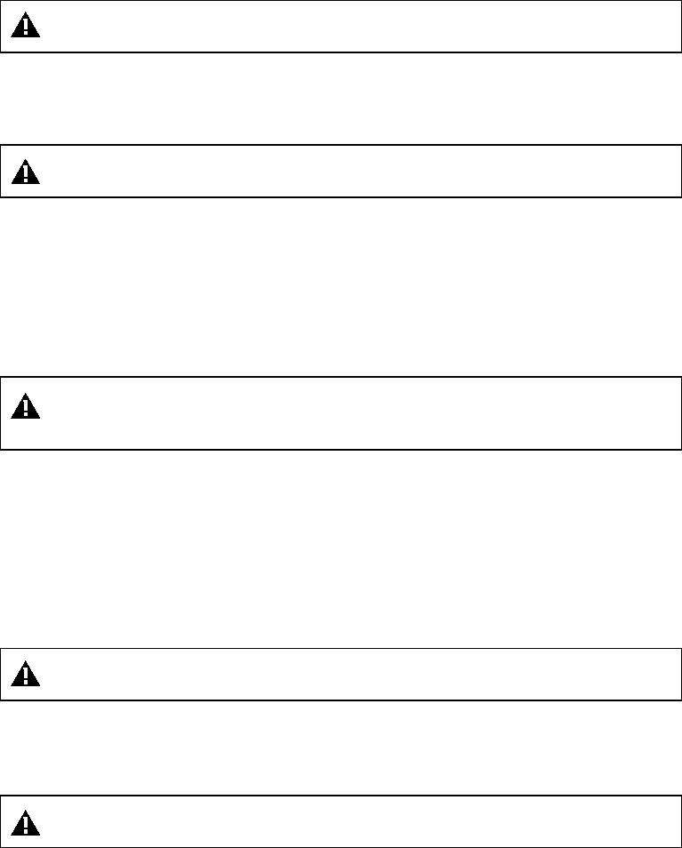
38. Via the header tank, refill the cooling system with clean plain water until the level stabilizes
at the top of the breather neck.
39. Reinstall the air purge breather cap.
40. Fill up coolant header tank.
41. Install and tighten coolant pressure cap.
42. Start the engine and run at approximately 2000 rpm for 5 minutes with the climate controls
set as previously.
43. Switch off the engine.
44. Remove the pressure cap from the coolant header tank.
Warning: The cooling system will be pressurized and hot.
45. Raise the vehicle lift.
46. Release the clamp from the hose attached to the radiator-flushing adaptor and drain off the
coolant.
Warning: Coolant will be hot!
47. Reclamp the hose and lower the lift.
48. Remove the air purge breather cap.
49. Via the header tank, using a funnel, pour the contents of the TWO bottles of SECOND
Flushing Solution into the cooling system. Continue to refill the cooling system with clean
plain water via the header tank until the level stabilizes at the top of the breather neck.
50. Reinstall the air purge breather cap.
Caution: Immediately wash away any coolant spilled on the vehicle
bodywork.
51. Fill up coolant header tank.
52. Install and tighten coolant pressure cap.
53. Start and run the engine at 2500 – 3000 rpm for 15 minutes, with the climate controls set as
previously.
54. Switch off the engine.
55. Remove the pressure cap from the coolant header tank.
Warning: The cooling system will be pressurized and hot.
56. Raise the vehicle lift.
57. Release the clamp from the hose attached to the radiator-flushing adaptor and drain off the
coolant and flushing solution.
Warning: Coolant will be hot!
58. Reclamp the hose and lower the lift.
59. Remove the air purge breather cap.
Date of issue 06/97 Amended 09/01
Bulletin Number 303-11 Page 5 of 9

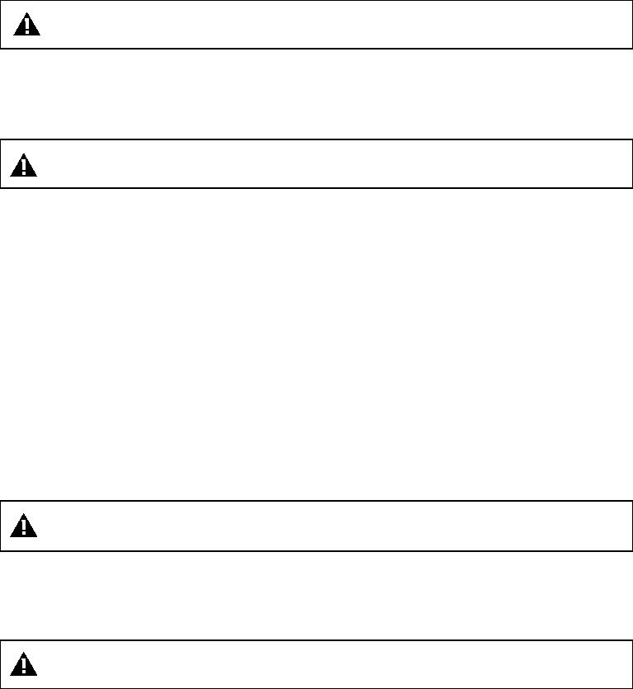
60. Via the header tank, refill the cooling system with clean plain water until the level stabilizes
at the top of the breather neck.
61. Reinstall the air purge breather cap.
62. Fill up coolant header tank.
63. Install and tighten coolant pressure cap.
64. Start the engine and run at approximately 1500 rpm for 5 minutes with the climate controls
set as previously.
65. Switch off the engine.
66. Remove the pressure cap from the coolant header tank.
Warning: The cooling system will be pressurized and hot.
67. Raise the vehicle lift.
68. Release the clamp from the hose attached to the radiator-flushing adaptor and drain off the
coolant.
Warning: Coolant will be hot!
69. Reclamp the hose and lower the lift.
70. Remove the air purge breather cap from the coolant header tank.
71. Via the header tank, refill the cooling system with clean plain water until the level stabilizes
at the top of the breather neck.
72. Reinstall the air purge breather cap.
73. Fill up coolant header tank.
74. Install and tighten coolant pressure cap.
75. Start the engine and run at approximately 1500 rpm for 15 seconds with the climate controls
set as previously.
76. Switch off the engine.
77. Remove the pressure cap from the coolant header tank.
Warning: The cooling system will be pressurized and hot.
78. Raise the vehicle lift.
79. Release the clamp from the hose attached to the radiator-flushing adaptor and drain off the
coolant.
Warning: Coolant will be hot!
80. Disconnect the hose from the radiator flushing adaptor tool and remove.
81. Disconnect and remove the adaptor tool.
82. Remove and discard the existing o-ring from the radiator drain plug.
83. Install and seat a new o-ring seal.
Page 6 of 9
Bulletin Number 303-11
Date of issue 06/97 Amended 09/01

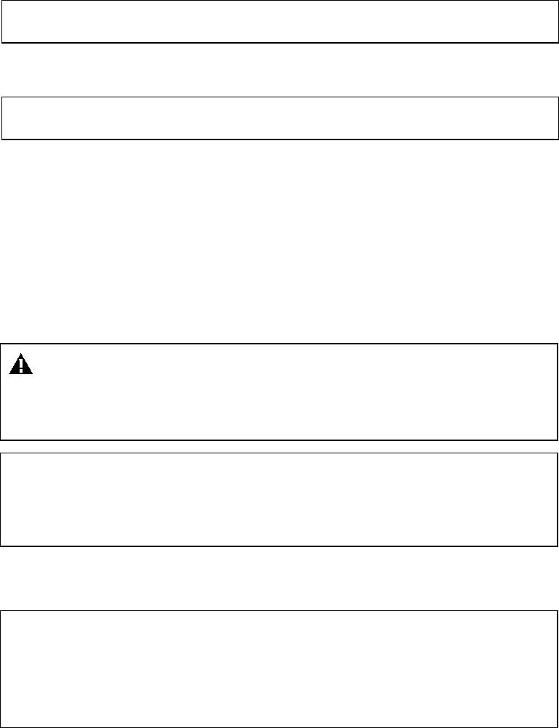
84. Reinstall and tighten the drain plug.
85. On XK series vehicles, install the generator-cooling duct. (Torque the generator cooling
duct securing bolt to 6 Nm)
86. For access, XK series vehicles, release and remove the air cleaner cover, mass air flow
sensor and air intake hose assembly.
87. On all vehicles, reinstall the clip on the header tank to recovery bottle hose.
Note: If the header tank to recovery bottle hose clip is damaged in any way, a
new one must be installed (Part Number JHC 501401).
88. Reconnect the recovery bottle hose to the header tank and crimp the clip securely.
Note: If difficulty is experienced in latching the clip, it may be necessary to
install a new clip.
89. Remove the hose clamp from the heater bypass hose.
90. On XK series vehicles, install the air cleaner cover, mass air flow sensor and air intake
assembly. On V8 XJ series vehicles, install the engine compartment rear cover.
The cooling system should now be filled with XLC Extended Life Coolant. See the following
Workshop Procedure for refilling process.
STEP 3: REFILLING OF COOLING SYSTEM WITH XLC EXTENDED LIFE COOLANT
Caution: Before the use of Havoline XLC Extended Life Coolant is
permitted on Jaguar vehicles (prior to VIN 042636 XK Series vehicles and
vin 878274 V8 XJ series vehicles), the flushing procedure in steps 1 and 2
must be carried out.
Note: As the cooling system cannot be fully drained, it will contain residual
water at this stage. It is therefore necessary to introduce a measured quantity
of undiluted Jaguar XLC antifreeze into the cooling system and Fill up with
plain water.
1.
2.
Remove the air purge breather cap.
Carefully pour 4.25 liters of Jaguar XLC antifreeze into the header tank.
Note: Only Jaguar antifreeze Havoline XLC Extended Life Coolant
(specification: WSS M 97B44-D) should be used on XK series and V8 XJ
series vehicles. Antifreeze to this specification has been used in all 2000
Model Year XK Series and V8 XJ Series vehicles and may be recognized by
its orange color.
3.
Continue to add clean plain water into the header tank until the level stabilizes at the top of
the breather neck.
Date of issue 06/97 Amended 09/01
Bulletin Number 303-11 Page 7 of 9

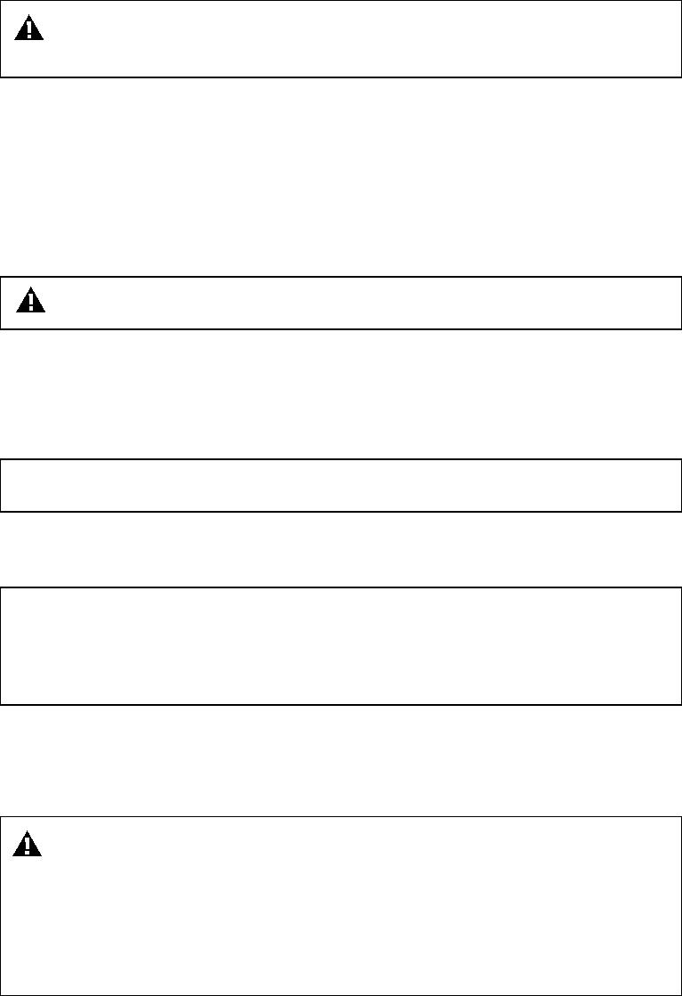

4.
Reinstall the air purge breather cap.
Caution: Immediately wash away any antifreeze spilled on the vehicle
bodywork.
5.
6.
7.
Fill up coolant header tank.
Install and tighten coolant pressure cap.
Start and run the engine at approximately 2000 rpm for 2 minutes, with the climate controls
set as previously, to circulate and mix the coolant.
8
Switch off the engine.
9.
Remove the pressure cap from the coolant header tank.
Warning: Take care! The cooling system will be pressurized and hot.
10. Using a pipette or hydrometer, take a sample of coolant from the header tank.
11. Using a temperature-compensated coolant tester, check that the concentration of the coolant
now corresponds to: 50% (± 5%) Antifreeze by volume or provides protection for
circulation at -35 °C (-31 °F)
Note: If necessary, drain off a quantity of coolant and add antifreeze to the
system to adjust the concentration.
12. Before reinstalling the pressure cap, apply header tank label (part number MNF 7699AA)
onto the engine bay cover, adjacent to the filler neck.
Note: To test that the chemical flushing procedure has worked, once again,
run through the heater core circulation test procedure in Step 1. Where a
temperature reading of more than 40 °C (104 °F) has been indicated, the
coolant circulation rate is satisfactory and no further action is required.
Where a temperature reading of less than 40 °C (104 °F) has been indicated, the coolant
circulation rate through the heater core is unsatisfactory. In this event, contact Dealer Technical
Support for further information.
Caution: Do not permit the vehicle to stand over night with:
·
·
·
The cooling system drained.
The cooling system filled with either one of the two flushing solutions.
Without having completed the draining of the second flushing solution
followed by at least one refill with clean plain water, followed by draining
and refilling once again with clean plain water.
Warning: It should be noted that all displaced oils and fluids should
be disposed of locally, ensuring compliance with local legislation and
health and safety guidelines.
Page 8 of 9
Bulletin Number 303-11
Date of issue 06/97 Amended 09/01

Parts Information:
DESCRIPTION
Radiator flushing kit
O-ring – Drain plug - XK Series
O-ring – Drain plug - V8 XJ Series
Hose clip
PART NUMBER
JLM 20361
JLM 20622
QTY
2 *
1
1
1
JLM 20628
JHC 501401
MNF 7699AA
JLM 20972/3
Header tank label
XLC Extended Life Coolant – 5 Liter*
1
1
* Part no. JLM 20361 is listed as a radiator flushing solution kit. A kit consists of 1 bottle of part
1 solution and 1 bottle of part 2 solution. Part no. JLM 20361 will only be supplied as a boxed
quantity of 2 kits (2 bottles of part 1 and 2 bottles of part 2.) Use the entire contents for this
service operation.
Warranty Information:
FAULT
CODE
JB GB 49
R.O.
NUMBER
26.91.03
TIME
ALLOWANCE
DESCRIPTION
Heater core test and chemical/
water flush procedure
V8 XJ Series
3.2 hrs.
3.5 hrs.
XK Series
Date of issue 06/97 Amended 09/01
Bulletin Number 303-11 Page 9 of 9

