Setting the Cam Angle Sensor on an AJ16 engine.

For the sake of this document I will assume the cam angle sensors setting is unknown.

This is how I did mine when I had NO idea of what I was trying to achieve, just that the engine cranked excessively prior to actually firing into life.

I removed the radiator fans, 2 bolts and 2 wire plugs. Gives much better access to the large bolt at the front of the engine for hand turning the engine.

Now, look at the toothed wheel bolted on the rear of the front crankshaft pulley. You will notice there is a tooth MISSING. This is the “timing key” for what I am explaining.

Rotate the engine by hand, a 32mm socket and suitable bar will be required to do this. Rotate the engine CLOCKWISE only as viewed from the front. DO NOT rotate this engine backwards (Anti Clockwise). If you go “past” the timing mark. Go around again. You have been told.

When that missing tooth aligns with the Crank Angle Sensor (the pick up on the alloy bracket on the timing cover), STOP.

Remove the oil filler cap, look inside, and you will see the cam lobes of the Inlet cam, #4 cylinder. Now, if the “pointy bit” of the lobe is facing towards you, GREAT, you have the engine set for the next step. If you see the “heel” then rotate the engine ONE more turn, and then STOP again.

***Photo #2 shows the heel of that lobe, I have other things on the go at the moment, and when I get time I will rotate this engine to show the pointy bit, but what is shown is OK for the exercise here.

Refit the oil filler cap.

Look in the window of the Cam Angle Sensor, and you should see the indent of the tin plate inside in that window. I BET YOU DON’T SEE IT.

*** Photo #1 shows the sensor at the centre of this document.

Remove the 2 Torx screws, remove that tin cover. Note how far away that indent is from the window. If it’s close, there may be enough adjustment on the slot to get it in site. If so, then loosen the securing bolt and rotate the Sensor to achieve what is needed.

If it is TOO far away, then raising the sensor out of the engine will be required to achieve the setting. To do this, unplug the connector, remove the bolt, and SLOWLY raise the Sensor. There is NO need to remove it, just raise it far enough to unmesh the gears. Rotate the inner tin plate to somewhere near where you want it, and slide it back down. You may need to do this a few times to get it right. DO NOT BE SCARED, nothing is going to jump out and smack you, TRUST ME.

Once satisfied, bolt it down, refit the plug, and the cover. Remove that socket and bar from the front, refit the fans, and do the deed, START THE ENGINE.

The reason for getting this timing correct, is this sensor triggers the sequential fuel injection system. This system is able to work out the sequence eventually, hence the excessive cranking, but as soon as the engine is turned off, the whole injection sequence sorting starts again the next time you try to start it.

I have only 2 snaps at the moment.

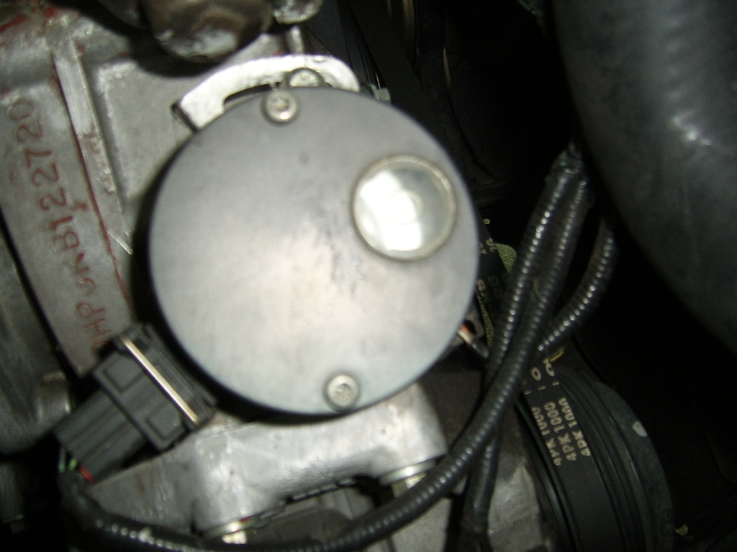
Figure 1 Cam Angle Sensor AJ16

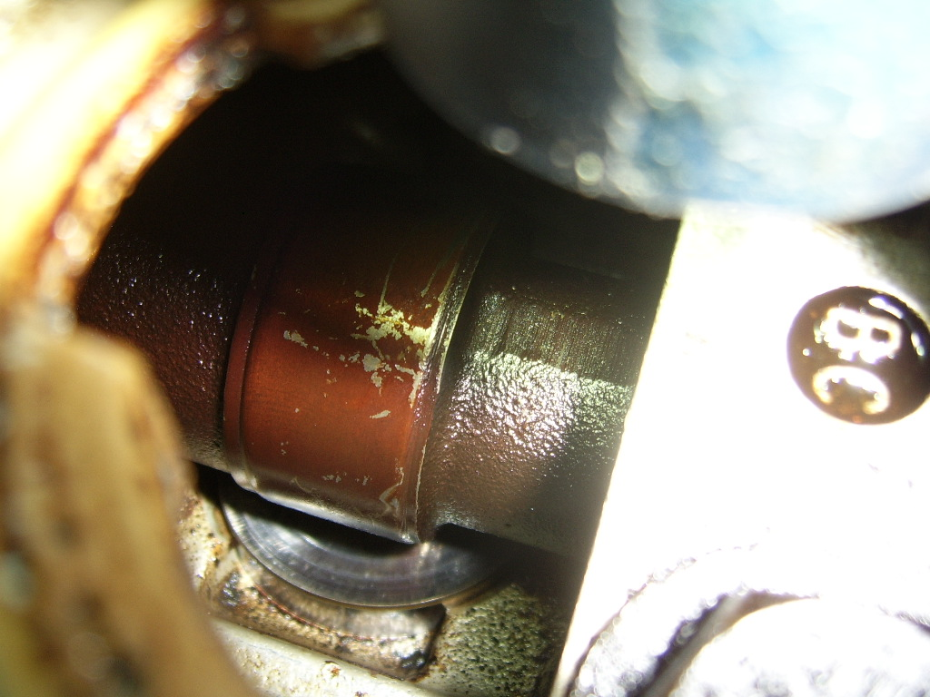
Figure 2 Camshaft HEEL viewed thru the oil filler hole.

