AJ16 Top Timing Chain Tentioner Fiasco.

This is what I have FINALLY found with my noisy AJ16 engine.

The car has done 143000kms at this time.

The top tensioner assembly was the “update” unit, but it was worn, and sloppy in the bore, fair enough, new unit sourced and fitted, BUGGA, the noise is still there, better, but NOT Jaguar quiet. Some say that these engines are that noisy, I am not convinced, as the AJ6 engine/s we have and I have heard are QUIET, and some are still running the “old style” tensioners.

Bit the bullet, new damper guides, chains, lower piston assembly all sourced, and off with the timing cover, and duly dealt with. YES, the old damper guides were buggered (worn out), all grooved like railway tracks. Some sense of satisfaction that I had actually found something wrong that would attribute to the noises I was getting.

BUGGA again, that bloody rattle on “hot start” was still evident at some times, and also the dredded 1500-1750 rpm rattle was still hanging around. No need to remove the timing cover again, nothing more to replace, waste of time and money.

I put up with it for nearly 10000kms, and finally got fed up, and convinced myself it had to be something to do with the top tensioner unit, mainly in what I considered oil drain off (original reason for the TSB to replace the unit in the first place), or the spring is not supplying enough pre-tension on the blade to keep it tight until oil pressure arrives to sort it.

Removed the tensioner, simply enough task, up on the bench, and dismantled it CAREFULLY, as I wanted to see just what was what inside this thing. I also dismantled the old unit, in a separate tray, and noted the spring was assembled different. By that I mean that the spring has a different fitting in each end, and the old unit was reverse of the new unit, WHO’S RIGHT HERE, no bloody idea. I would have thought that the new unit as supplied from Jaguar in a sealed box would be correctly assembled, MAYBE, much trying and looking was required to understand just how this thing MIGHT work.

The attached photos will show clearer what I cannot put into words. Basically the “rivet” looking thing in one end of the spring goes INSIDE the piston that goes inside the plunger, and the “jet” looking thing, goes inside the plunger that pushes on the top chain blade. This is very confusing, coz oil is required to pass through the end of the plunger, there is a tiny hole in the end face, to lubricate the chain blade pivot point, so a “jet” here would be sensible, but without knowing the intentions of the designer, “seat of pants thinking” was used.

To try and clarify how this thing works in my opinion. The oil is fed into the assembly via a hole in the side from a drilling from the exhaust front cam bearing oil gallery. This pushes the plunger out of the casing and applies tension to the chain. The “whipping” of the chain at FIRST start after installing the unit “fires” the spring loaded piston, and then oil pressure arrives and the unit is “installed” as they say. When the engine is shut down the oil pressure of the engine drops off to zero, BUT oil cannot go back via the supply hole due to cam bearing tolerences (too close), there is NO valve in this supply drilling, and the “one way valve” in the base of the outer casing permits the oil inside the plunger and casing to stay put for a time. The assembly is fitted to the side of the cylinder head in such a fashion as to be “tail down” and this helps as does the spring which holds the plunger in an extended position thus keeping the chamber/s full of oil, and in such an angled fitment the oil cannot run “uphill” so stays in the assembly albeit under NO pressure, as there are no actual seals etc inside the assembly to prevent oil bleed out, but the tolerences are very close indeed.

I looked at this thing from ALL angles, and scrapped all thoughts of reason, and went with “my common sense”. I assembled it as it came from Jaguar, deciding the OLD unit was incorrectly assembled by some previous unknown and refitted the thing to the car, started the engine and once the initial “unholy rattle” disappeared, the annoying rattle was no more, too good to be true, I am NOT that lucky, went for a drive, no more rev range rattle, parked for a quiet beer under a shady tree, and about 30 minutes later fired it up, NO rattle, fair dinkum, this thing always gave that “ching” at hot start, but no more, drove home, waited again, started it again, and again, all quiet, consumed much beer, then typed this.

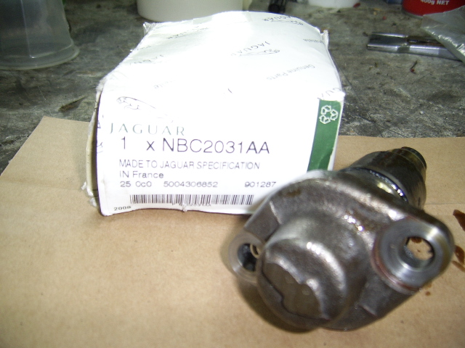
Figure 1Tentioner as received

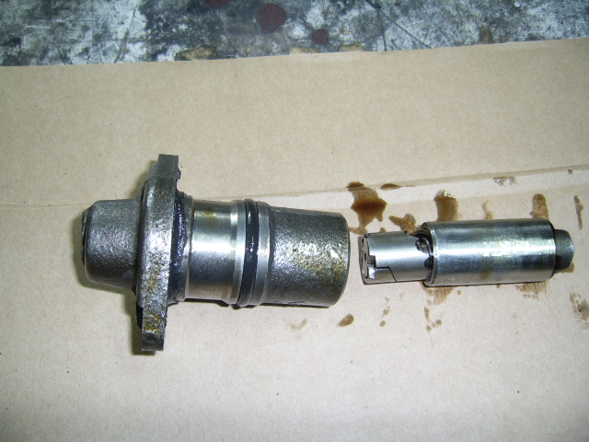
Figure 2The 2 main components, spring loaded plunger on the right.

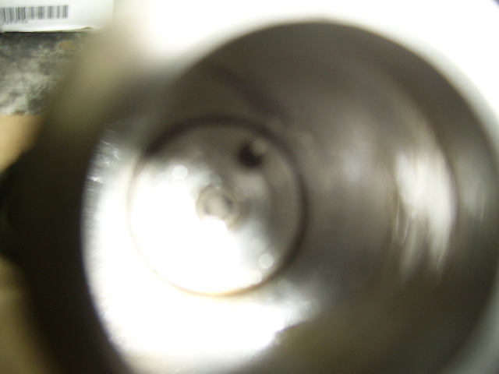
Figure 3Oil inlet hole at 1 o'clock with the anti-bleed thingy in the centre.

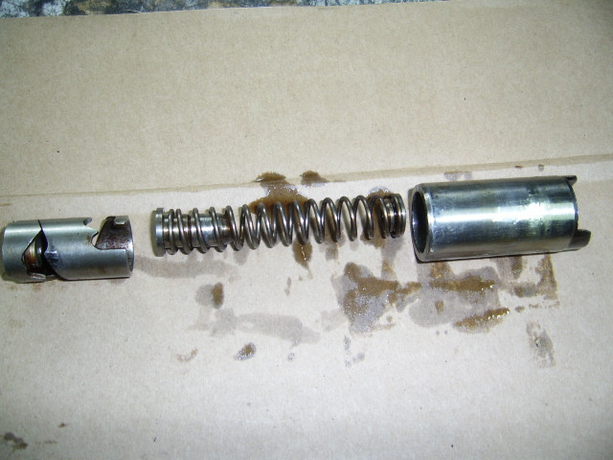
Figure 4Spring assembled correct as supplied from Jaguar.

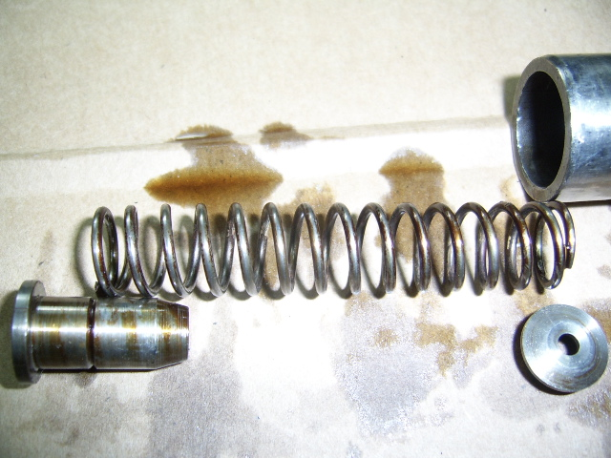
Figure 5Showing the rivet and jet I was talking about above.

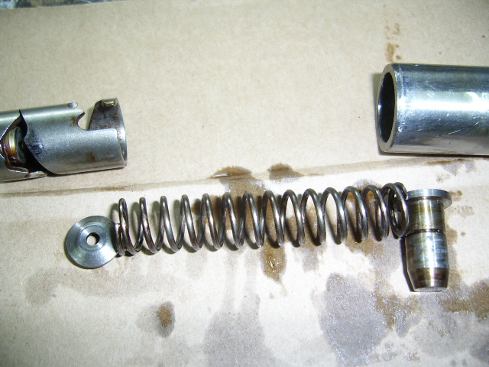
Figure 6 This is the INCORRECT assembly

Picture “1” shows the unit as received from Jaguar, including the box with the latest Part No.

Picture “2” shows the 2 main items, the housing, and the plunger assembly.

Picture “3” shows the oil IN hole up inside the housing, this is supplied from the front cam bearing of the exhaust camshaft. Not clear in the picture (and not really of any significance) is the valve thingy in the centre of the base, it is NOT removable (that I can see), and serves to slow down oil bleed off once the engine is OFF. Oil will bleed off, there is nothing to stop it, and the spring will retain “primary” tention on the blade at this point, and oil pressure will take over once the engine is started.

Picture “4” shows the plunger dismantled, with ALL the components in CORRECT fitment position.

Picture “5” shows the “rivet” and “jet” that sit in the ends of the spring.

Picture “6” shows the spring/plunger in INCORRECT assembly order.

Just to clear up the assembly of the spring loaded plungers in the top and bottom tensioners:

1) The top tensioner is pressure fed from the oil system of the engine, in my case 85psi.

2) The lower tensioner is NOT pressure fed. The oil flows into the unit from drip down from above components, including flow off from the cam shaft area, and the one way valve in the base of the housing allows the unit to “pump up” its own pressure by the movement of the plunger assembly caused by the slight “whipping action” as the chain passes over the face of the blade.

The top tensioner has the “rivet” inside the plunger, so oil can flow out the hole in the end and lubricate the top chain and blades etc, and the run off goes into the “funnel” top face of the lower tensioner.

The lower tensioner has the “rivet” inside the plunger, to allow oil build up to apply hydraulic pressure to the blade.

I hope this assists with the mystery surrounding this unit, as NO parts diagram shows the “update” assembly, they all show the early unit, and the technical bulletin is of no help in this area either, as it only states to fit the unit, rev the engine to ”fire” the spring, check for oil leaks, drive on.

27 December 2010, the infernal rattle had returned. Fair dinkum this car is definitely female with a grudge.

I am CONVINCED that this has something to do with that spring loaded plunger NOT supplying sufficient tension to stop rattles until oil pressure arrives (as I said before), OR oil pressure is too low, other engine issues.

Now just to clarify, I am a QUIETISH kind of driver, so high revs are not common, must be old age, however things do change in the brain when I get into the V12 Beast. By this I mean that I do not “rev the ring” out of this engine and this could be where it went pear shaped, coz in frustration I gave it a good old “Italian Tune UP” which is basically pedal to the floor and let it go, and I was at the stage I had nothing to loose. Anyway during this “tune up” the engine went QUIET (I know I said that before), but this was different. All rattles were gone, and stayed gone.

I still pulled that tensioner just for fun, and noted the plunger assembly was quite firm in the bore of the outer housing, and I noted some scuff marks on the piston, much like chatter marks, and conceded that the spring loaded assembly may NOT have been “firing” fully with low revs, and the top end of the tacho had in fact fully released it, dunno, not a “see through” area so assumption is all we got here.

NOT CONVINCED.

I took the old top tensioner assembly, and drilled a hole in the middle of the “arrow” in the end of the unit, and duly tapped a 1/8” BSP thread in it to accommodate my master oil pressure gauge. I installed this in the engine and noted the oil pressure AT THE TENTIONER. What a surprise 80-85psi cold. I was NOT expecting that, and the pressure stayed there even when HOT, and did not alter from idle to 2500rpm, so enough oil pressure is definitely available to operate this assembly. I ran the engine until the thermo fans cut in, shut it down, waited 20 minutes, started it again, and noted a slight rattle which I ignored due to using the old tensioner, but noted that oil pressure took only a short time to arrive, basically as the starter cranked the engine, but full pressure took about 1.5 seconds to arrive, and once it arrived all noises ceased. There is a photo below showing the oil pressure arrangement I used.

I re-installed the new unit, started the engine, then varied the revs up to 3500 a few times, and each time the “rev range rattle” as we call it got less and less.

I am NOT convinced I found anything, but at least now I/we have oil pressure readings at the tensioner. This pressure is slightly higher than I had at the oil filter housing, BUT, that was done some time ago and the engine was due for an oil change, and this time the oil is only 1000km old, and I accept these figures as true for my engine. Pretty damn good in anyone’s opinion I reckon.

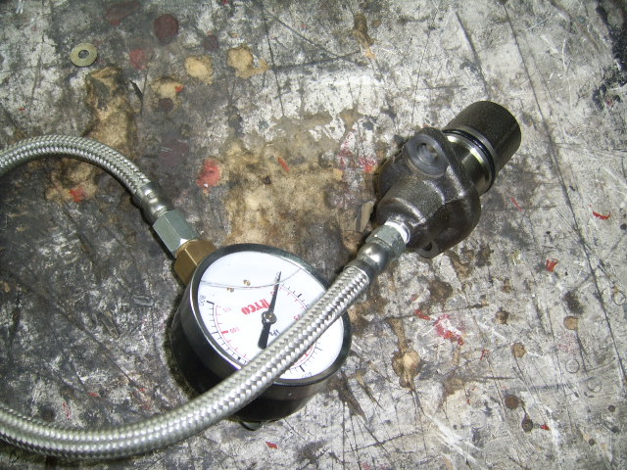
Figure 7 Old unit with pressure gauge attached

UPDATE: 10/1/2011, the bloody rattle is back, BUT it is lower down, right near the a/c compressor, mmm, could it be that, nah, but I took the belt off just to be sure, NO change.

Uncovered the mighty XJ-S and put this thing up in the air, and OFF with the timing cover, finally convinced myself that there is something amuck in there.

WELL, the lower chain was “slack”, mmm, lower tensioner was jammed solid, bugga. Off with that unit, up on the bench, and not very professionally got that piston out of the cylinder, and found that the spring ratchet assembly had NOT “fired”. Now I am absolutely convinced that this thing “fired” on the previous fitment. I did not waste too much thought on it, and investigated why the thing was jammed, and found the metal item that has the ratchet spiral machined in it was “out of round” and this was causing it to jam inside the plunger, and possibly not “fire off”. No way of reshaping it, so used the piston out of the old top tensioner unit (same item), and the spring from the old top unit was also used (20% stronger than the original according to Jaguar).

Refitted this assembly to the engine, and got a BIG screwdriver and worked it a few times until it “fired”, and the chain went tight.

Due to me an anal type of guy, I removed the camcover (again) and rechecked the cam timing, I just wanted it ALL to be as it should, and the fact the lower chain was “slack” had me concerned. It was out a little bit, so reset and wound the engine over one full cycle and rechecked, all OK.

Back on with the timing cover, and started the engine, SILENT, yeh, had this before, ran it until “N” arrived, and it was still silent, drove the thing around the block (confident I am), and it was soooo quiet. Switched off, waited, restarted, SILENT. Drove some more, further and higher revs, and not a sound. Apart from the tacho saying otherwise I would have said it had stalled when at idle.

Now done some 200kms and it is SILENT.

This car was retired in 2014, and sold to a collector friend, and at 210000kms, the engine is SILENT.

