Bluetooth 3

So, went to Allied Electronics online, and found the mating connector called out in the dox on this site for the proper connector (and pins...can't forget the pins...) and proceeded to connect the Motorola T605 bluetooth interface to the already-existing connector in the center armrest/console.

I decided to use the existing wiring in the car for the overhead mic; this meant that I had to re-terminate the mic cable coming out of the 605 into the connector (pin 4 mic+, pin 5 mic -). This photo is of the mic cable stripped back, and the shield twisted:
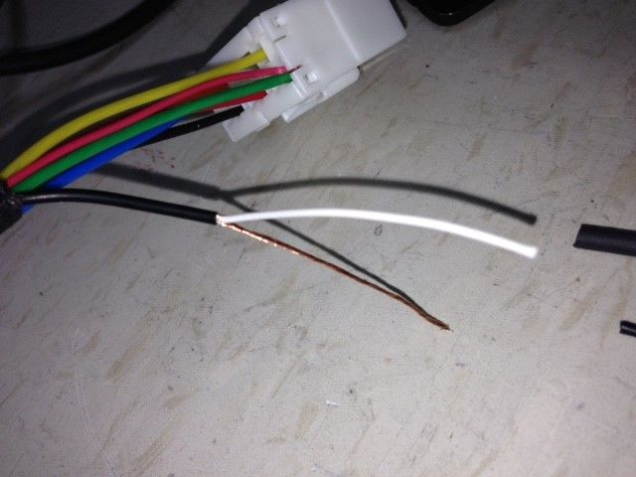
I then covered the shield with Alpha FIT shrink tubing, and slid a larger piece of shrink down on to the end of the external sheath to clean up the strip-back:
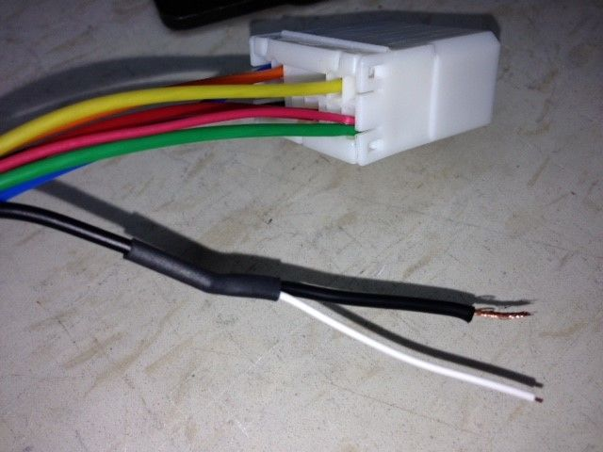
Now to the pins, still on the tree:
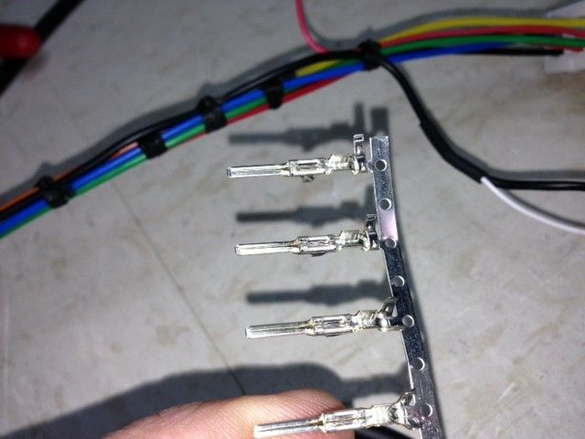
Note, I have the proper crimp tool (advantages of doing this as a pro for many years as a radio station chief engineer and then as an aviation mechanic); I stripped back the ends evenly, tinned the wires, and crimped them into the pins:
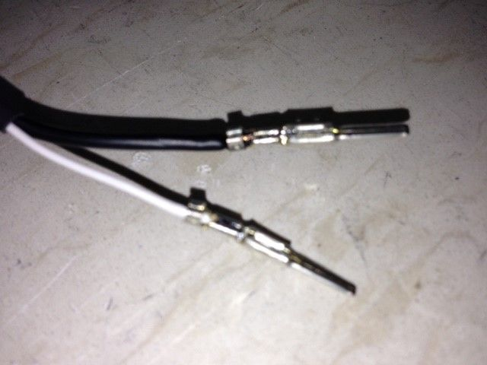
Also note, I did hit the crimped end of the wires with a touch of solder to ensure not only a tight mechanical connection (the crimp) but a good electrical connection (the solder). I know there's some controversy about crimp and solder causing a brittle joint, but, this is not in an area of vibration, so, I'm thinking, with the low signal level coming out of a microphone (-55dBM usually...very tiny signal in an electrically noisy environment), I'll take the chance.
Put the pins into the proper location in the plug and tied off the harness with some lacing cord (yeah, old school...):
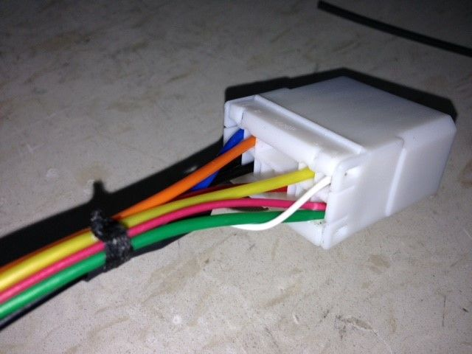
Now to install in the car...should be easy. I'll note that I'm going to use an FM adapter installed under the radio in the center console to feed the music audio (yeah, I know the plusses and minuses, but...have tested on the bench and if the modulator is mounted close to the radio rather than in the trunk, the signal strength to the radio gives acceptable, to me, results) and I've wired an extra pigtail off the switched +12 lead on the connector to eventually drive a small relay to control a +12V power feed relay for my VHF/UHF ham radio brick to be located in the trunk, with the head mounted on the Kuda 'sidecar' mount I installed last weekend

