Hi Ali123. I have also had a recent CAN problem - not the same as yours but the following may be helpful. I'm no expert, so my information is due to the knowledge and experience of others.
The CAN network is actually very simple - it's a pair of twisted green and yellow wires that run from the ABS Module to the DLC / OBD connector :
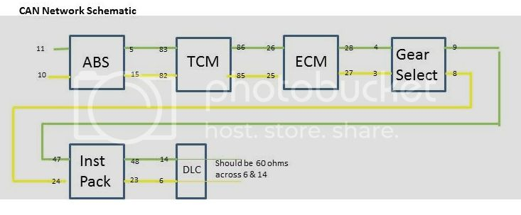
A P1797 would indicate a fault in the wiring between the TCM and the ECU (ECM). At each end of the CAN network are 120 ohm resistors - so effectively in parallel. If you have access to a Multimeter - set on ohms - ignition off - you should get a resistance of 60 ohms between pins 6 & 14 of the DLC / OBD connector. A reading of 120 ohms would indicate an open circuit somewhere, and a very high reading would indicate a short-circuit.
The CAN wires are easy to see - they are the ONLY twisted pair wires - so, if you have the patience and a bit of knowledge, you can disconnect various plugs, and check the wiring between the various modules.
However, it might be better to go to a Dealership or Independent with the proper Jaguar WDS system as - I believe - they can "interrogate" each module individually which would give you a precise location for the fault.
I don't think it's dangerous to drive the car - the CAN network passes information around the system, but all modules have a failsafe mode should the network develop a fault, so as far as I know, the car should continue to be roadworthy and safe.
Edit : Like you, my fault is intermittent, so I guess there's no point in any DIY or Dealer diagnosis unless the problem is actually happening.

