PREPARING THE 2002 XJR STEERING WHEEL BUTTONS FOR MODERN RADIO PROGRAMMING
(S/W = Steering wheel)
About a year ago I had posted my progress on this attempt to find the way to make my 2002 XJR S/W buttons to work with an aftermarket radio, but a good while has gone by since, as I faced some other rather time consuming, expensive and challenging problems with this my XJR. Now that everything has been resolved, I finally gave myself time to re-assess this project. For X308 owners / members who have replaced, or will replace the stock radio with a new aftermarket modern radio and wish to be able to use their XJR’s S/W control buttons to work with this new radio, I have finally figured out the way to achieve this so I’m now using my XJR’s S/W buttons with my new non-Jaguar, non-Alpine radio. So, the fairly detailed set of instructions on how to achieve this project on your XJR is fairly long for a normal post here, so I will send it in a MS Word document to anybody interested.

General practice recommends disconnecting the battery before doing this kind of work, even when the Jaguar manual specifically instructs that the only power involved with airbags is ignition ON power (not battery power) to a module that feeds the airbags, again, no direct battery power involved. But, you never know what mystery may want to get involved, so better to disconnect it…

The basic concept here is to prepare the X308 XJR (and XJ8?) S/W buttons circuit in a manner that an aftermarket newer radio can identify and successfully read the XJR resistive S/W buttons circuit. So, the first hurdle to resolve here is that Jaguar designed not only the radio control switches, but all of the S/W control buttons/circuits to work from a LOGIC ground instead of the normal battery ground, be it the radio buttons, or the cruise control (C/C) buttons, or the horn button and even the airbag. So, to use the S/W radio buttons, the ground must be changed from logic ground to battery ground for the aftermarket radio to be able to use the S/W buttons. This gets a little complicated by the fact that the radio buttons logic ground and the C/C buttons logic ground, they both come into the steering wheel via a single line, which is, then, split inside the S/W to both circuits. Jaguar strictly warns against connecting logic and battery grounds together because some of the car’s features will no longer work, plus, cutting off this logic ground incoming line anywhere outside the S/W will leave the cruise control without logic ground, i.e. inoperative. This is the reason why this project cannot be done without going inside the S/W. The S/W radio buttons’ connections are located on a printed circuit (pc) board which is found under the radio buttons and under the airbag, so for this reason and, needless to say, for safety reasons, the airbag must come out. The S/W had to be removed, as well, in order to see how the two radio lines from inside the S/W to the radio would be routed, which turned out to be quite the task because, no matter how good you think you’ve routed them through, a full turn of the S/W can roll and pull some wire length that can get tangled up in there and which will not return in the opposite direction when the S/W is turned back in the opposite direction. Actually, I have already pulled broken these wires twice while turning the S/W. So, the question was, how did Jaguar route all those wires coming out of the S/W in a way that they’d turn harmoniously along with the S/W? Well, the same way that all cars with buttons on the S/W do this and that’s via a pretty smart device called the “Clock Spring”, which is visible behind the upper S/W column cowl once the S/W has been removed and which turns along with the steering wheel happily rolling all eight lines inside, left turn and right turn along with the steering wheel. Too bad that all the clock spring slots (lines) are taken by these eight wires, so how could I possibly include my two radio wires inside this wonder clock spring in order to bring them out of the S/W without “accidents”?

Well, like this…

Page 1
- The S/W buttons “signal” lead. Again, this is one of the two lines of communication between the S/W buttons and the radio sensing leads that we need to safely pull out of the S/W).

Remove the two Torx screws that hold the airbag from behind the S/W and just carefully pull the airbag out of the S/W, then carefully pull open the airbag connector and place the airbag in a safe place away from the work area.
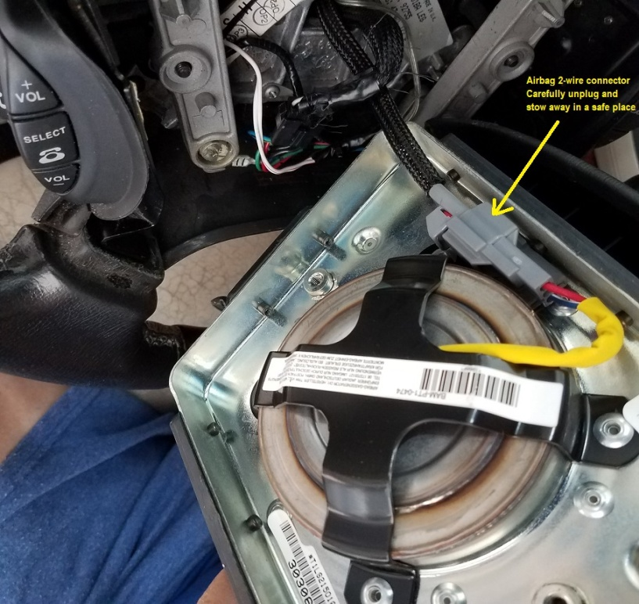

Now, inside the S/W, remove the two screws that hold the S/W radio buttons’ assembly:
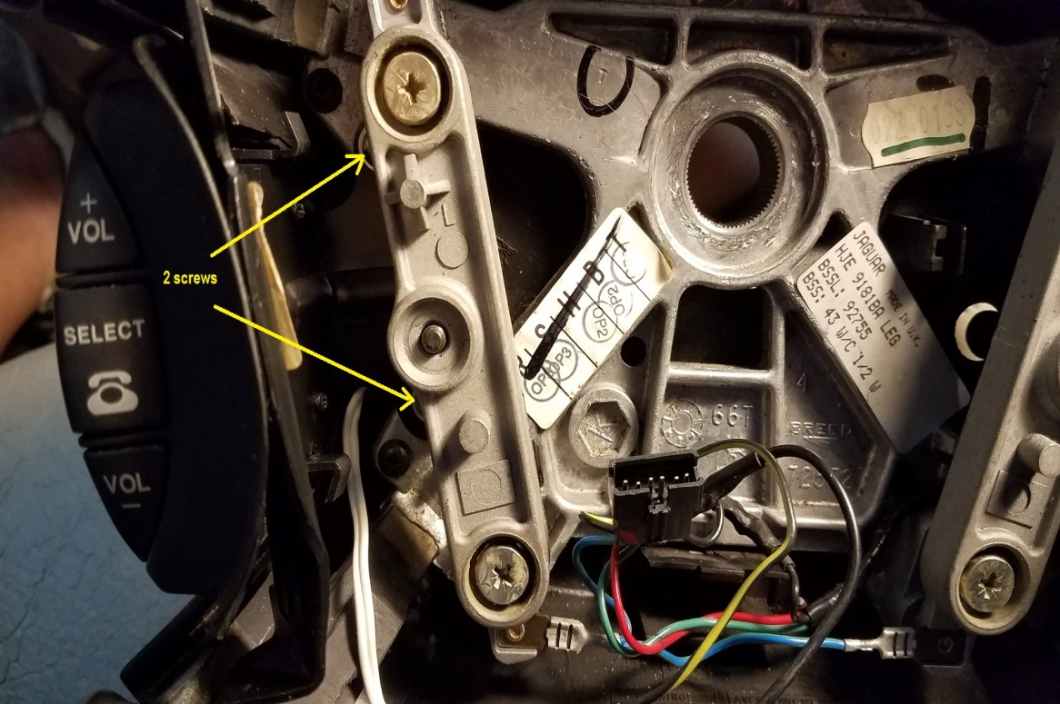
Page 2
Underneath the buttons assy is the pc board covered by a metal plate. To view this pc board, carefully remove the four tiny screws from its cover plate and this will reveal the pc board with the three connection points (and the actual
4 switches).

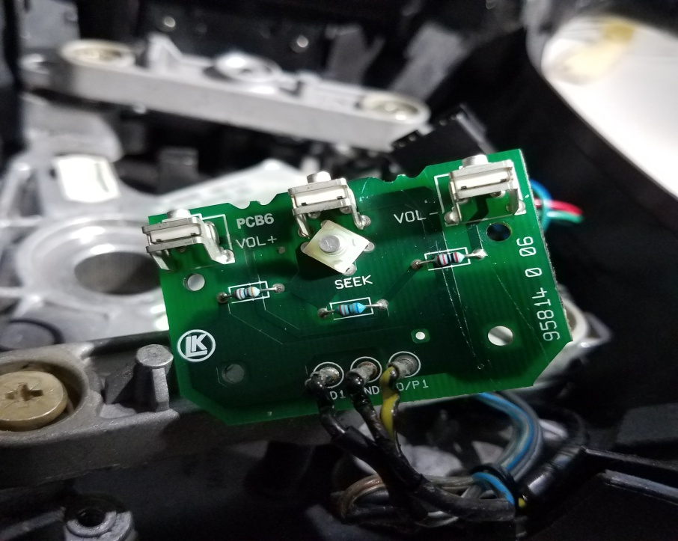

The GND and the O/P1 posts (center and right posts in above picture) show the two soldered wires that originally went to the old OEM Alpine radio and we’ll use the one that’s soldered to the “O/P1” point (black/yellow stripe and not purple yellow as the Jaguar diagram shows). This wire goes out of the S/W via pin 2 of the clock spring and once it has passed through to the other side of the clock spring, it must be cut and must be connected to the lead that the new radio provides for S/W programmable buttons. Just leave the other end of the cut-off wire there, it won’t hurt anything. FYI, this line had been going from the S/W buttons to the Alpine OEM radio since day 1; funny thing is that the Jaguar diagram calls it “red/white” but nobody, including myself and a fellow member here, has ever been able to find a wire of such color down there. We have looked and looked for this wire under the S/W column because, with finding this wire down there you can simply cut it and connect it to the lead that the radio provides for programming of the S/W buttons, but to no avail…

Page 3
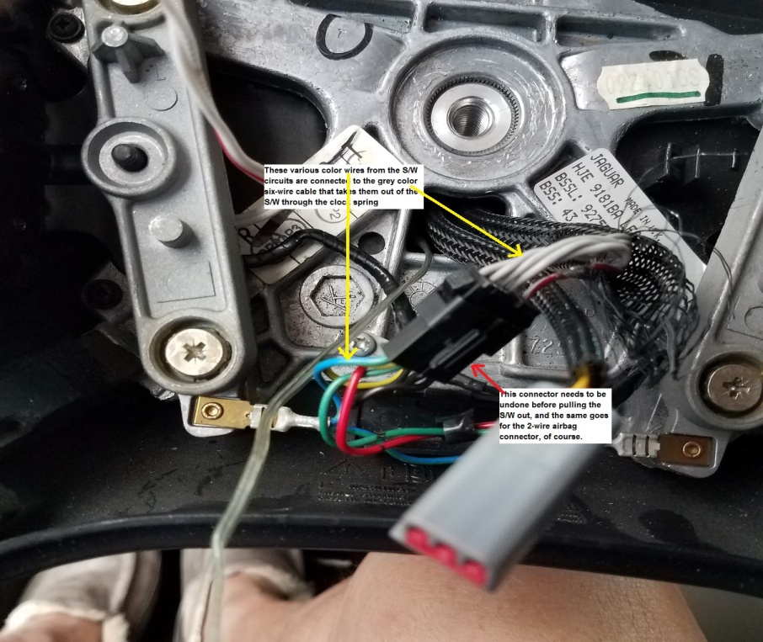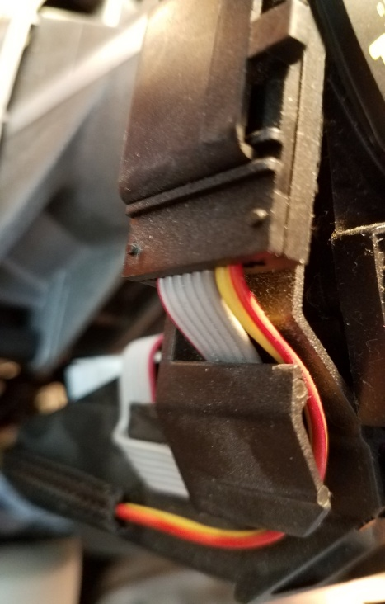
The 6-wire grey cable and the 2-wire airbag cable, now beyond the clock spring

- The S/W buttons “common” lead (the second of the two leads we need to connect to the new radio).
Originally, the existing horn’s logic ground lead goes out of the S/W via pin 5 of the clock spring. This lead needs to be cut off while still inside the S/W and then to be connected to the horn button end of the cut (and not to the end of the cut that goes to pin 5). Then, while still inside the S/W, we connect it to the C/C’s logic ground lead that goes out of the S/W via pin 6 of the clock spring (and also pin 6 of the 6 grey wires cable). By having the horn’s logic ground and the C/C logic ground share pin 6 (they both go out to the exact same place, which is the car’s “bulkhead ground stud”) it now leaves us pin 5 of the clock spring available to bring in the battery ground that we need in order to complete the S/W buttons circuit in the manner for the new radio buttons to work. So, find the pin 5 wire beyond the clock spring (the car side and not the S/W side), which had been bringing in logic ground to the horn before it was cut inside the S/W, cut it off and connect it to a good battery ground (preferable the point where the new radio’s ground connection was made when it was first installed) and also connect it to the second of the leads that the radio provides for S/W buttons programming, which may well be connected to true ground inside the radio. Finally, inside the S/W, follow the pin 5 wire that was just hanging there after it was previously cut off from the horn’s logic ground lead and then connect it to the wire that’s soldered to the GND post on the buttons’ pc board. This will connect the other end of the S/W radio buttons circuit to the new radio’s lead for the S/W programmable buttons feature. So, from this point on the X308 XJR’s S/W buttons will work fine with a modern Android (or whatever) radio.

Page 4
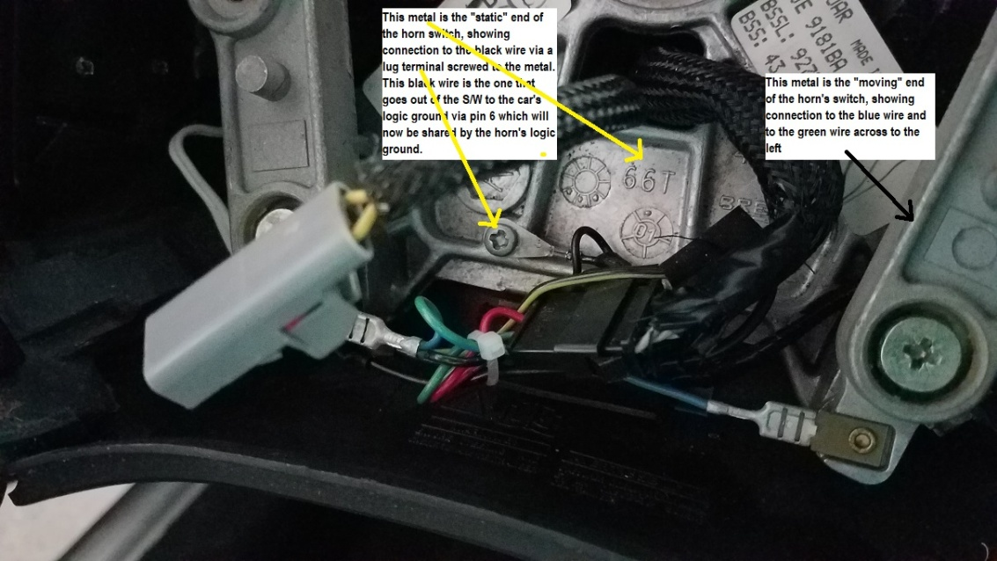

I have verified operation of this modified wiring by checking resistance across these two wires. Depending on what steering wheel button I press, the ohmmeter has read the exact resistance combinations from the 3.3K, 6.8K and 20K resistors/switches, resistance ohms as specified on Jaguar’s electric diagram. Being of a resistive design, the Android radio buttons will identify these resistive values and ask the programmer which function is desired for each of the selected resistance combinations (i.e. “buttons”). Once this was done, the steering wheel’s buttons now work the same way they worked before with the stock Alpine radio.

My new radio
Just FYI, I should add that my new radio has a HD 7” display, yet it’s only a single din fit behind the screen and it’s also less than 5” deep so it fits totally loose in there. It has two USB inputs and a SanDisk input, plus Bluetooth, Internet, phone display mirror link, etc. Instead of CD or DVD, I have 56 USB GB of music and 256 GB SanDisk with 168 movies, plus Bluetooth.

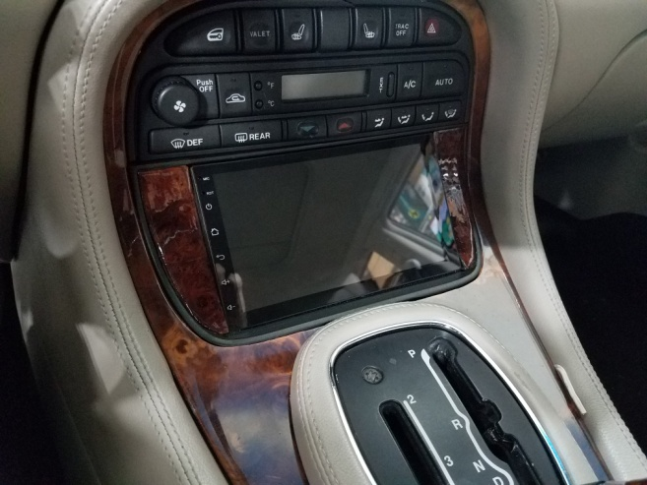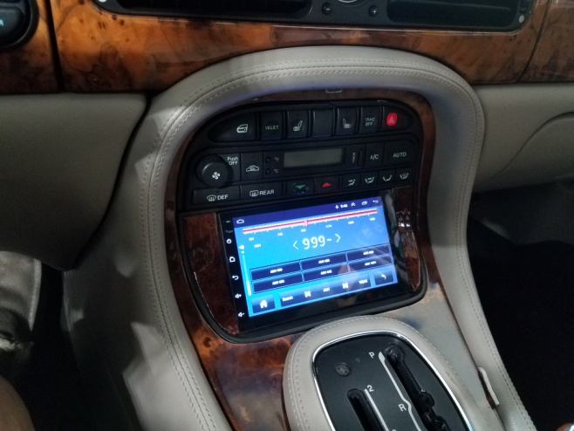

Page 5

