 |  | XJ8 TIMING CHAIN TENSIONER TOOL |  |  |  |  |  |  |  | 40 mm toend of square |  |  |  | Tap thread the holes |  |  | 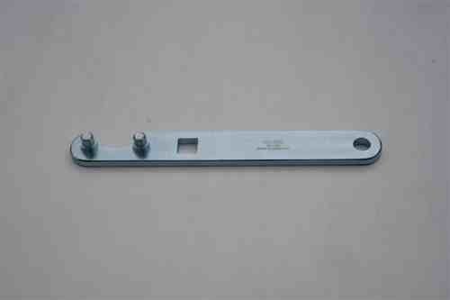
 |  |  |  |  | 6 mm thick X 25 mm width x 205 mm long steel bar |  |  |  |  |  |  | 33 mm or 1 5/16 * ctr to ctr |  |  | 8 mm * peg holes
 |  | TO SCALE
 |  |  |  |  |  |  |  |  |  |  |  |  |  |  | 25 cm width
 |  |  |  |  |  |  |  |  |  |  |  |  |  | Clear timing casing
 |  |  |  |  |  |  |  |  | 13 mm * square
 |  |  |  |  |  |  | 6 mm thick X 25 mm width x 205 mm long steel bar |  |  |  |  |  |  | Must be a min of 33 mm or 1 5/16" dia arc cut away so use 35mm to clear sproket fully
 |  |  |  |  |  |  | 205 mm long |  |  |  |  |  |  | to clear sprocket
 |  | This tool is used to hold exhaust sprocket & secondary chain whilst you tighten the VVT and exhaust sprocket's centre bolts
 |  | the bar can be as long as you want to get plenty of torque, or use a 1/2 inch drive and breaker bar in the square hole
 |  | -cavate: some get away without using this tool
 |  | Note the cams acting on the values causes the two sprockets to seat such that the secondary timing chain on the RH Bank is loose on the top edge
 |  | only when the engine is running does this slack on the top chain get taken up, hence you can get a loose rattle on start up

XJ8 TIMING CAM LOCKING TOOL x 2
 |  |  |  |  | 20 mm x 45 mm x 185 mm long alloy bar
TO SCALE
 |  |  |  |  | 172 mm (6 3/4") * ctr to ctr ( for 2 x 6 mm holes)
The most essential tool |  |  |  |  | Measure off cover 15/11/03
 |  |  | This tool is essential if sprockets and timing chains are removed to lock bank's 2 cams
 |  |  | This plate must thick enough to take considerable torque as sprocket bolt is tightened to 115-125 Nm |  |  |  |  |  |  |  |  |  | 30 mm
 |  | Essentially the bar must be regid enough to hold cams flat and still and have 2 holes 169-170 mm apart |  |  |  |  |  |  |  |  |  |  |  | 45 mm width
 |  |  | Note the two bolts which are only 6mm in size must take considerable strain
 |  |  |  |  |  |  |  |  |  |  |  |  | 15 mm
 |  | 23 mm |  |  |  | 140 mm between legs |  |  |  |  | 23 mm
 |  |  |  |  |  | position of 2nd cam cup
8mm or 5/16th
 |  |  |  |  |  |  | 8 mm tapped hole |  |  |  |  |  | 16 mm thick
 |  |  |  |  | 6mm offset
8mm or 5/16th |  |  |  |  |  |  |  |  | step of 4 mm |  |  |  | plus 4 mm step
 |  | 6 mm * untapped hole |  |  |  |  |  |  |  |  | 6 mm * untapped hole
 |  |  |  |  |  | Position of Ist cam cup |  |  |  |  | max 20mm from edge of cam cup and 6mm hole centre if a thicker plate is used
 |  |  |  |  |  | The gap between cam cups inner edges is at the most 1 11/16"
 |  |  |  | can get away without this central hole and the 4 mm step in the plate where bolt centres in an oil hole in the engine head

XJ8 TIMING CRANK LOCK TOOL
TO SCALE |  |  |  |  | 35 mm long
Essential tool
 |  |  |  |  |  | 6 mm (or 8 mm) hole
 |  |  |  |  | 16 mm dia |  |  | 13 mm dia peg
This tool is essential if cam end sprockets and timing chains are removed to lock can
or use a 16 mm bolt ground at end or a piece of wood dowl to hold crank in position

the distance between the two threaded hole is 74-75 mm
Another user -I estimate the distance would be 7.3 cm from center to center
It is better if you have playing area (7,3-7,5 cm), because then easier to screw the tool to the pulley,
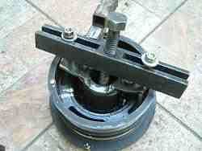

Got the old fan belt and a four sided wheel brace, put the fan belt round the crank pulley and the two remaining pulleys on the left side of the engine, then twisted the fan belt 7 or 8 times using the wheel brace. Rested one end of the brace on the block inside the left hand cam cover (near the thermostat housing) and pushed forward on the top of the wheel brace to keep the pressure on. It put enough pressure on the crank pulley to hold it still while i turned the extractor bolt with my other hand. Thank god. Crank bolts and pulleys are a job i wouldn't want to tackle too many times, but at least now i know how.

Crankshaft Bolt. Removing the bolt requires a good quality 24mm socket, preferably impact grade. These bolts are
tightened to 275ftlb/365nm, so you can expect release torque to be at least that high. Using a long breaker bar (you will
need it to be 3 or 4 feet long), the flywheel will need to be locked.
There is a rubber inspection bung on the back of the bellhousing. Remove this and when the engine is turned over by hand you will see a hole in the flexplate into which a bar can be placed. However, it is better to put a 15mm socket onto one of the torque converter bolt heads than to place a high load on the thin flex plate material through the hole mentioned earlier. There is an alternative to locking the crank and using a long breaker bar on the crank bolt: if you have a very high torque air impact wrench, which has a short body, and if you are lucky, you may be able to perform this task quickly and easily using the air impact wrench without removing the radiator. We’ve done it this way sometimes, using a specially cut-down 24mm socket

