Jaguar Series 3 XJ6 fuel tank switching system Page 1 of 2

there is a fuel tank switching valve in the trunk and a fuel return valve at each fuel tank. There is a separate fuel level sensor or Sender in each tank. Some testing is going to be needed to determine any problem. Start by accessing the switchover valve solenoid in the trunk near the fuel pump. Voltage tests should be done at the valve to see if it is getting the signal to switch over. When the left tank is selected, no voltage is applied to fuel solenoid circuit. When the right tank is selected, battery voltage is applied to the switchover valve circuit. If you are not getting a signal the circuit needs to be tested at the switch in the dash. Often you can see a combination of problems with the switchover valve and the L & R return valves and the fuel level senders. See attached diagram of the system below.

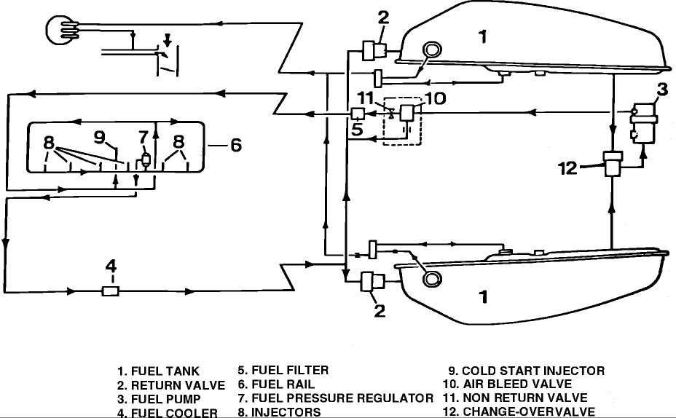

Fuel Change Over Valve: p/n CBC4269
Fuel Pump: p/n CBC5657
Fuel Return Valve RIGHT: p/n CBC4270
Fuel Return Valve LEFT: p/n CAC3939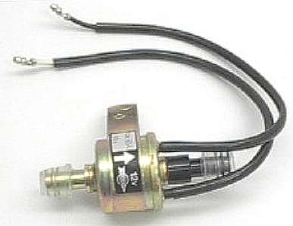

continued: Jaguar Series 3 XJ6 fuel tank switching system Page 2

The twin fuel tank setup on fuel injected 1979-1987 Series III XJ6 cars is occasionally the source of problems, especially now that most of these cars are more than 20 years old. This model has a fuel tank changeover switch on the dash above the console that selects which tank is in use. If this switch does not change tanks properly, first pop the switch out to check that the 6-pin connector has not overheated and melted due to a poor connection. These connectors are not available new at this time and have to be sourced from a used harness if needed. If any corrosion is present at the connection, clean this off. The switch itself will sometimes go bad, but that is not a common problem.

The operation of the Series III fuel changeover system is a bit more complicated than it might first appear. Like almost all fuel injection systems, the fuel pump sends sufficient fuel from the tank to satisfy engine demand under extended wide-open throttle.
In normal operation, unused fuel is returned to the tank. On the Series III Jaguar, the changeover system is designed to return the fuel to the tank from which it originally was drawn. There are three valves involved in this: the main changeover valve in the trunk, which selects from which tank fuel is drawn, and the two fuel return valves, which open and close in concert to return fuel to the proper tank.

Suppose that one is using the LH fuel tank. The changeover valve will be set to pull fuel from the LH tank, the LH return valve will be open, and the RH return valve will be closed.
If the dash switch is operated to select the Right tank, the changeover valve will switch to pull fuel from the RH tank, and the RH return valve will open and the LH return valve will close. If the return valves are not operating properly, fuel can be cross-pumped into the incorrect tank, often resulting in fuel leakage as that tank becomes overfilled. Improper operation is also indicated if a tank suddenly has more fuel in it after driving than it did before.

Return valve operation is easily checked from outside the car. With the engine idling, open each fuel cap and using a flashlight and something like a long bladed screwdriver (to push open the spring-loaded lower flap) one can see the return fuel flow into the tank since the return fuel pipe is just below the tank's filler neck. At idle, there should be a solid flow of fuel returning to the tank selected and no fuel flow at all into the other tank. Operate the changeover switch and recheck the fuel return flow. The fuel should now be returning to the newly-selected tank only.

If the fuel is returning into both tanks or into the wrong tank, there is a problem with one or both of the fuel return valves. Sometimes return valve non-operation is due to varnish or similar trash and cleaning will restore the valve to function; sometimes the valve simply will be dead and require replacement.

