Front sub-frame mounts replacement:

This is relevant to my ’85 Coupe. Then updated 9/2019 with ’75 4.2 Coupe.

This is the V12 version, the 6cyl is the same.

These mounts keep the cradle square and firmly attached to the car. When they fail a knocking noise similar to a shocker knock, or a balljoint knock will be heard. They also fail from old age, and the jacking of the car using the Jaguar jacking points puts a terrible strain on them. I know this sounds dumb, but it is fact, with the weight of the cradle and the engine being supported when jacked that way, simply tears them apart. Incorrect fitment of the rear units from a previous life can see the alloy base section cracked which will give the same noises.

DOING THE REAR MOUNTS, FRONT CRADLE, commonly called “V” mounts:

The photo’s at the end are of these rears taken today (23 May 2011), coz I replaced them on a mates XJ-S. Took 8 hours of solid labour to do them. The power steer cooler was still fitted, so removal was part of that to gain access to the LH bolt, about 30 minutes to remove it, and the cooler DID NOT go back on the car, as it was leaking fluid.

To replace the rear mounting units the car will need to be SAFELY supported using the factory jacking points, due to the fact the cradle will require lowering a small amount to facilitate removal of the old units. I use 2 of the “pin style” safety stands with a 1” length of 1” water pipe (had it laying around, but anything will do) welded to the top face of the stand. This pipe will slide over the jacking point pin and the car cannot slide off the stands. See the photo at the end. It will become real clear when you look at the area concerned.

My suggestion is to ALWAYS replace these when you have the engine out of the car. The reasons will become obvious as you read on, or attempt to do them with the engine IN the car.

THE REMOVAL PROCESS:

The “rear” mounts are of a “V” style, and are bolted to the chassis rail with 2 long 9/16” bolts, and a single stud with 9/16” nut protruding from the lower section and going through the cradle. The nut on the stud is simple, as is the rear bolt as they are “in your face” as you look up from under the car. The front bolt is sandwiched between the cradle and the chassis, and the head is not visible. You can “feel it” if you reach in from the front side of the cradle.

With the car supported, place your floor jack under the cradle and “take some load”. Remove the rear bolt, and the nut and washer from the protruding stud from BOTH sides. Now go up front round mounts and LOOSEN the 2 big 1 1/8” nuts on the pivot bolts of the front mounts, so as to allow the cradle to drop at the rear without distorting these front mounts. Remove the top locking nut on the two shocks, and back off the lower nut to almost off, but not quite. Lower the jack slightly, the mounts will separate as they are probably broken all the way through. If not, don’t panic, just lower far enough for the 2 studs to clear the cradle holes.
SAFETY NOTATION:
Place a safety stand under the lowered edge of the cradle, just is case the jack fails, or “creeps”, this will keep you alive to enjoy the Jag in a few hours time.
Now reach in from the front with the 9/16” spanner, and feel for the head, and go for it. It will possibly give you 1 flat movement per attempt. Your temper will be tested, trust me, and you will be seriously concerned about refitting that bolt, but that will be easy, as a modification is done to the new mounts PRIOR to fitting.

The LH front bolt is NOT easy, as the access from the front is blocked by the power steer cooler (if fitted). I DO NOT run a power steer cooler on any of my V12’s, so access on mine is simpler by about 40%. Still a MAJOR PAIN.

Once out give that mounting face of the chassis a GOOD clean, and ensure it is flat. I have seen some where that face is not flat, and once the new mounts are secured, and the weight is returned the alloy base of the new mount cracks, and will then require replacing again. ALSO, clean out the “pocket” in the cradle that will be full of crud.

THE MODIFICATION I MENTIONED:

Take the new mounts, and cut the alloy away from one hole so as to create an open “slot”. Do this to each mount. They are handed as in the fitment to the cradle, not the chassis. See the photo’s at the end of this write up. Take your time, but don’t panic if the wrong hole is slotted, as I see no reason why both holes could not be slotted, and as long as decent washers are installed under the bolt heads no harm will come of the car.

REPLACEMENT TIME:

Refit that front bolt, real easy without the mount in the way, make sure you fit a flat washer to compensate for the missing section, and leave it protruding just enough so that the new mount “slides” into place. My advice is to clean the threads with a wire brush and then use anit-sieze compound on all parts when reassembling. Slide the new mount into place from underneath. You may find that on the new mount that the lower stud may push up through and become loose in the mount itself. This stud has a rectangular plate on top of it that must face in a specific direction! Ensure that the long sides are facing in and out and that the “gaps” are forward and rearward. You can fiddle with this alignment from the top with a screwdriver blade. This is before tightening the nut from underneath. You may have to do this a few times until the alignment is correct. But it MUST be correct! Refit the rear bolt, tighten these bolts without being “silly” about it, overtight is not required. CAREFULLY raise the floor jack and observe the studs entering the cradle holes nice and sweet. Again, see above note about alignment. DO NOT force it, as the alloy of the mount will crack if you get heavy handed with the jack. Once the jack has “taken some load” again fit the washers and nuts to the studs.

Tighten the front pins at the front mounts you loosened at the start. Tighten the two shocks bottom nut, be sure the shock “seats”. Wiggle the top of the shock; You hear and feel it snap in place. Then tighten again, then return the lock nut.

YOU ARE DONE.

NOW FOR THE FRONT SUCKERS:

I have NO photos of the front fitment, as I did them years ago, and no thought of a write up was given at that time. It is a pretty straight forward operation.

These are easily visible from under the front of the car. They are the largish round steel encased rubber bushes in the front “eye” of the cradle.

You will require a 1 1/8” socket and a LONG tube for your breaker bar, and a second spanner to hold the bolt head, a shifter (adjustable) wrench will suffice.

Support the car as per the rear mounts.

Undo that large nut, it will take some muscle, and again use the floor jack to “take some load”, and then drive out the large bolts. Now comes the fun bit, undoing the bolt that is on top of that “eye” that holds the bushes in place by clamping them to the “eye”. It is IMPOSSIBLE to get to this bolt with the cradle in its fitted position, so again lower that jack VERY slowly until access is possible. Take care here as the rear “V” mounts will be getting strained a tad, the fan will hit the shroud, etc, and the less these things occur the better. Another option is to remove the radiator which will give access to those bolts from above. Once they are loosened drive those bushes out and replace with the new bushes, jack the cradle back into place and drive the large bolts home and resecure the 2 large nuts.

YOU ARE DONE AGAIN.

This is the reason I suggest that these mounts are ALL replaced whilst the engine is out, for the obvious reasons it is a simple task.

Also note carefully that the rear “V” style mounts are the most common failure, whilst the front “eye” rubbers are far less of an issue.

The photos:

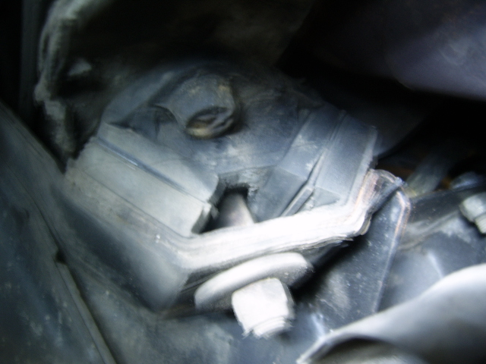
LH V mount as fitted to the car, with separation clearly visible

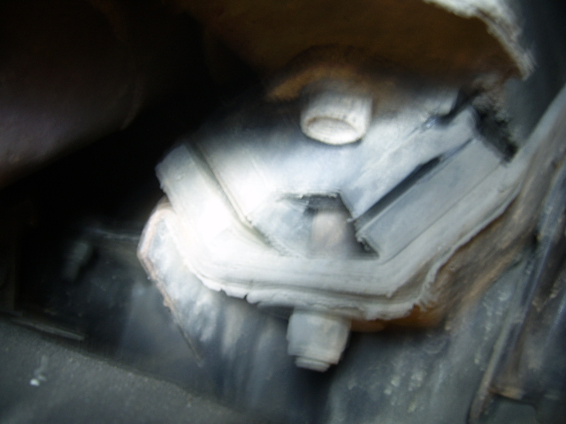
RH V mount in situ showing separation

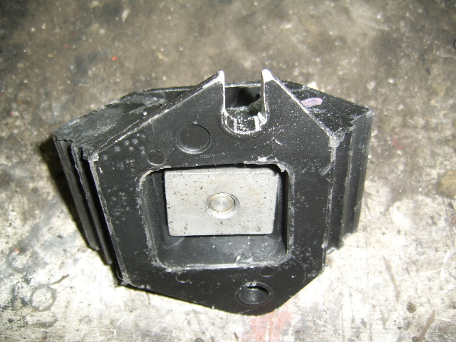
RH mount showing the slot. Also note the offset for handed refitment.

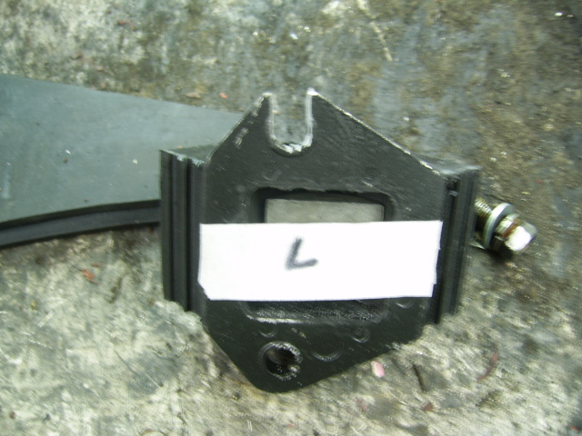
LH mount showing the slot and the offset for fitment.

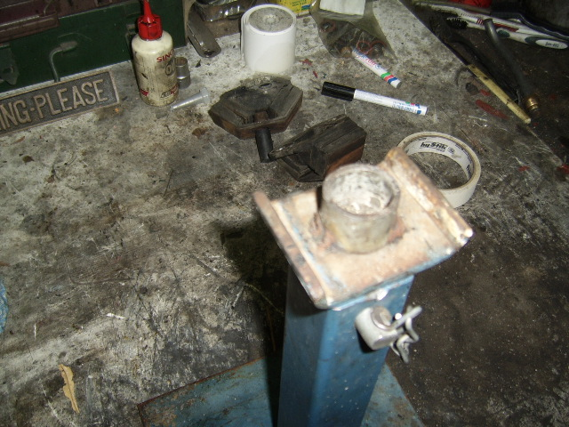
My jackstand showing that pipe welded to the top face.

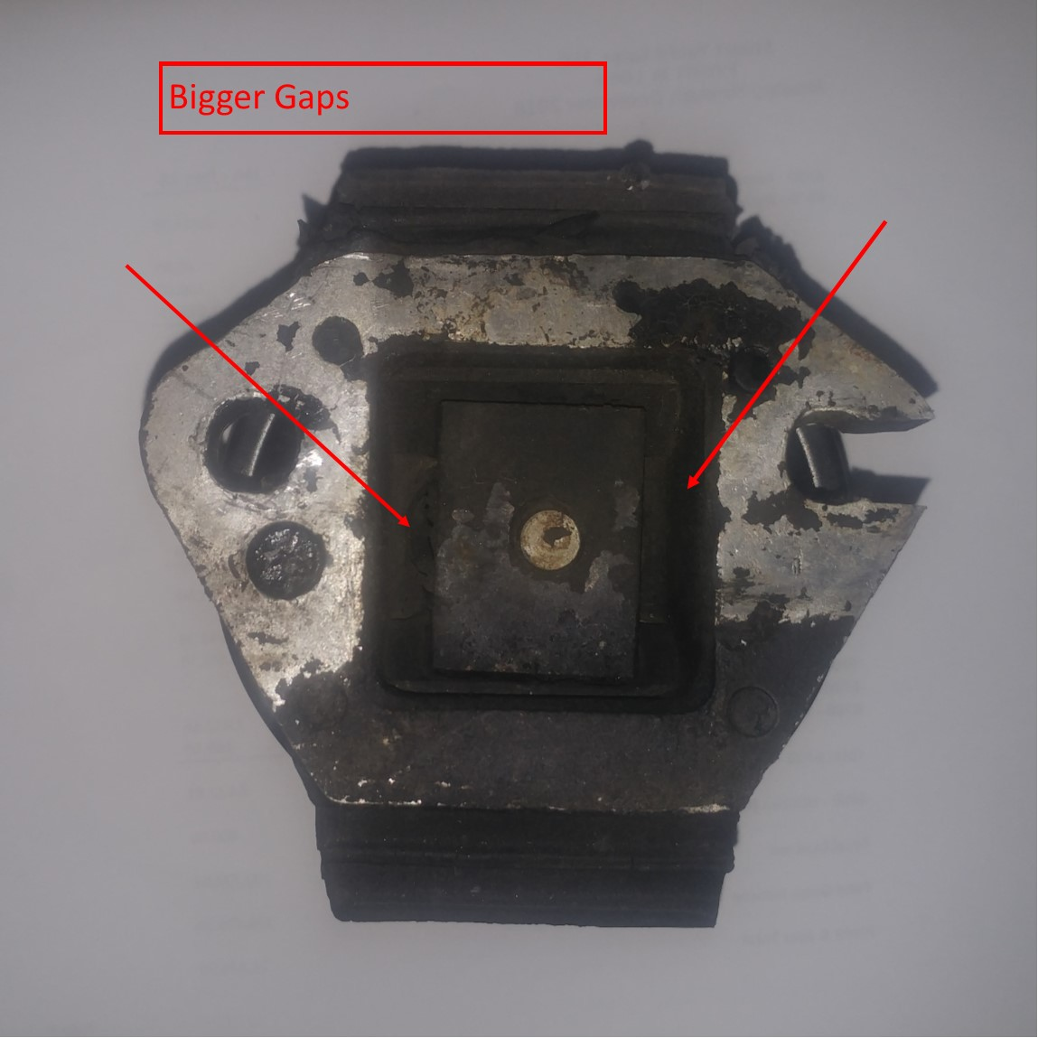
Slotted hole forward (both sides of car). Alignment of stud plate.

