XJ6 Trunk/Boot Spring Assist Strut Installation R-3a
RH and LH for dual spring assist

- Measure vertical height from trunk floor ledge to C.L. of 5/16” hole in OEM hinge arm: Confirm when ordering to ensure correct length strut
- S1 = ~ 11 29/32” 11.0” Strut
- S2 = ~ 10 ½” 10.0” Strut
- S3 = ~ 11 ¼” 10.5” Strut
- Various inputs from XJ6 owners indicate different dimensions for the same model, so measure your car and select the strut length closest to your XJ6

- Install ball/angle bracket on bottom of strut (snaps in place)
- Install LH & RH 10mm x 5/16” x ¾” ball fitting on hinge arm hole, ball fitting facing center of trunk.
- With trunk lid open to the max, install upper Strut on ball fitting
- Center of bottom angle fitting can be 0”-3/4” aft of vertical (90*)
- Drill two 1/8” pilot holes to attach each angle to trunk shelf
- Install each angle bracket with two (#10 x 5/8”) sheet metal screws with ball facing center of trunk (can be install directly over carpet)
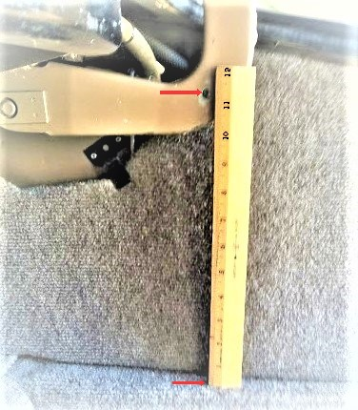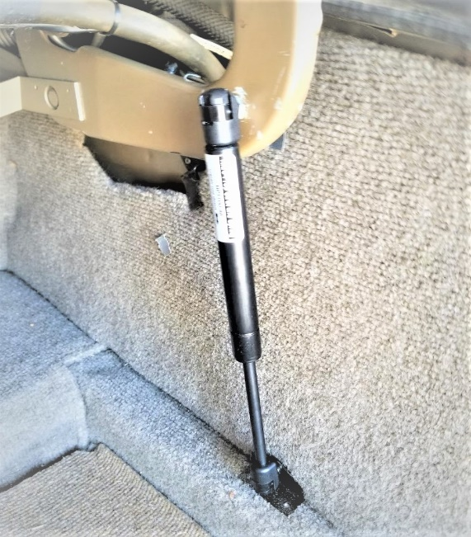
Measure Distance RH Final Installation

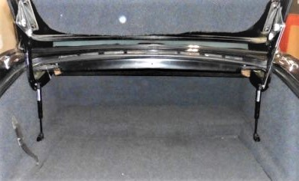
Dual Spring Assist with Extended opening Hinges

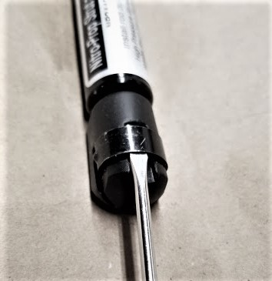
To remove end fitting from Ball, slide
small Flat tipped screwdriver under
clip and pull End Fitting off ball

