Clean Stud holes in cylinder head with reamer or correct size drill:
Which end of Stud is up? The short head studs have a 1/16” wider band at one end. This side goes down.
The longer head studs are threaded at both ends, but one end has an un-threaded tip. This end goes down.
Stud Placement There fourteen studs, four short and ten long. Four of the ten long studs (let’s call them the longest studs for discussion purposes) are about 3/16” longer than the remaining six. These longest studs hold the lift brackets.
The four short studs are easy to place as they go in the four corners. Moving in toward the center of the head from each end, next comes the four longest studs. And finally, the remaining six long studs are in the middle. Graphically it is:
(Front of car) A B C C C B A (rear of car) Length of studs A= 6 7/16”, B=12 15/16”, C = 12 11/16”
The exhaust side “B” front stud should be a dowel stud. There is some clearance around the studs. As a result, the head could be slightly out of place. A dowel stud is fatter where the head slides on so as to “locate” the head on the block.
Ready the Block Remove all oil and grease from the mating surfaces by means of a cloth dampened with gas or other volatile grease solvent, wiping dry with a clean cloth.
The head gasket is stamped with the word “Top ”to ensure that it is fitted with the correct side facing upwards. The timing chains have to be raised up through the hole in the gasket which, in turn, has to be lowered evenly over the studs.
Used some hi-temp grease on the block stud threads.
Cover the lower stud ends with a thin hi-temp grease layer, and screw them in at 27- ft-lb.
Used a bead of GE Silicone II around each of 10 interior studs at interface with head gasket.
Fitting the Head Beware when lowering the head onto the studs, NOT to contact that one open valve with the top of the studs. The valves WILL BEND very easily.
Wrap the studs with a thin turn or two of electrical tape to protect the surface of the head. Make it into the shape of a cone at the tip.
The easiest way to fit the head is to have two people lowering and a third aligning it evenly on to the block (otherwise it may bind on the studs).
First, remove any bolts from the camshaft flanges and place the timing chain sprocket assemblies in the top loops of the chains. Rest the sprockets in the supporting brackets and tie them together with a length of wire or plastic strap so that the head can be lowered over them.
Use a hi-temp grease on upper portions of all 14 studs. Makes it easier for the head to slide on studs.
Use thin layer of Copper Coat on surfaces around timing chains.
Drop the head down quickly after the grease and copper coat, adding washers, engine lifting brackets and high-tension lead support bracket to the studs.

Used a bead of GE Silicone II around each of 14 studs at the cylinder head under the washers and lifting lugs
Fit the spark plug lead carrier to some of the studs on the right-hand side and the ‘0’ washers to the remaining ones. The washers are part of the sealing system that keeps the water in the block. The thicker ones should be on all, but the lifting eye studs.
(if re-using washers, polish with very fine sandpaper) (Nut threads should be cleaned with tap and solvent)

Place a thin layer of grease on top of the cylinder head washers (under the dome nuts). It helps give a more accurate reading when torquing the nuts. Put the lifting lug against the head, and a washer under the nut, but not a washer under the lifting lug. If you have sufficient thread, you shouldn’t need two washers per stud.
Torque the Domed head nuts in stages (start at 20 ft/lb.), ½ turn at a time, to 54 ft/lb. working from the center of the head towards both ends. See FIG. A. Tighten the six nuts at the front of the cylinder head.
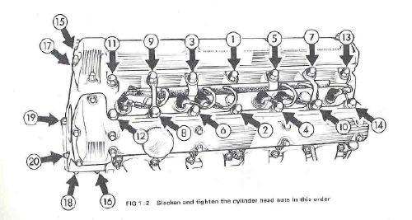
Figure A XKE head, XJ6 S3 head has different lifting brackets.
After installation of the dome nuts, wait a few hours and then re-torque in correct order. The studs stretch a significant amount.
On 4.2-liter models fitted with air c0nditioning equipment, mount the alternator and the compressor to access nuts 16 and 18.

