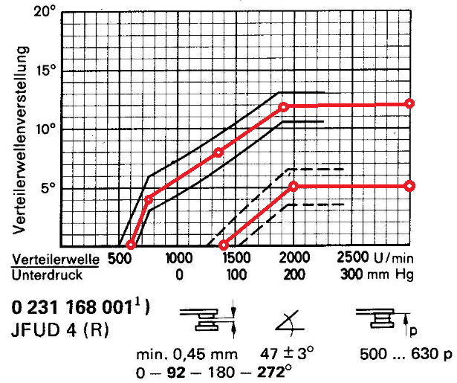

 | Lucas | 40617A | Advance curve for XKE with triple SUs (93 Fuel @ 9.1 comp
SMOG | Lucas | 41060A | Advance curve for XJ6 S1 with twin carburetors? (Zenith in USA 93 Fuel @ 9.1 comp)
SMOG | Lucas | 41912A | Advance curve for XJ6 S3 with EFI (California 83-85 CEI)(87 Fuel @ 8.1 comp)
 | Pertronix | D177600 | Advance curve for XJ6 S1 ( D171618 with HP coil for XJ6 S3)
Vacuum Advance Numbers
40617A 6-20-4.5 Vac Adv (9 @ Crank)
41912A 7-14-8 Vac Adv (16 @ Crank)

