Best Power at Idle
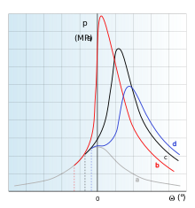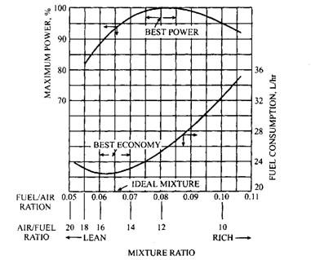
Spark timing
Pressure in cylinder pattern in dependence on ignition timing: (a) - misfire, (b) too soon, (c) optimal, (d) too late.
Spark timing, relative to piston position, is based on static (initial or base) timing without mechanical advance. The distributor's centrifugal timing advance mechanism makes the spark occur sooner as engine speed increases. Many of these engines will also use a vacuum advance that advances timing during light loads and deceleration, independent of the centrifugal advance. This typically applies to automotive use.

Engine Air-fuel Ratios
An automobile SI engine, as indicated above, works with the air-fuel mixture ranging from 8:1 to 18.5:1. But the ideal ratio would be one that provides both the maximum power and the best economy, while producing the least emissions. But such a ratio does not exist because the fuel requirements of an engine vary widely depending upon temperature, load, and speed conditions. The best fuel economy is obtained with a 15:1 to 16:1 ratio, while maximum power output is achieved with a 12.5:1 to 13.5:1 ratio. A rich mixture in the order of 11:1 is required for idle heavy load, and high-speed conditions. A lean mixture is required for normal cruising and light load conditions. Figure 9.36 represents the characteristic curves showing the effect of mixture ratio on efficiency and fuel consumption.

