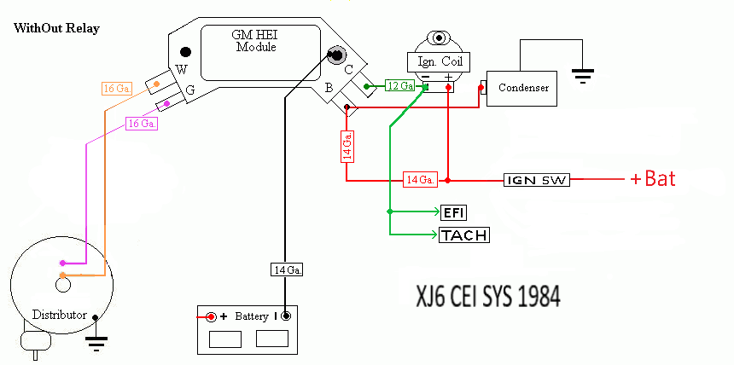

Jaguar/Lucas 2 wire amplifier wiring system diagram.
Jaguar wiring is typically one wire gauge smaller than shown in this GM layout. (12>14, 14>16, 16>18 Gauge.)
Jaguar XJ6 S3: 1. C to (-) terminal of Ignition Coil = White with black stiped wire
2. B to (+) terminal of Ignition Coil = White wire
3. IGN SW to (+) terminal of Coil = Brown (or White) wire
4. EFI to (-) terminal of Ignition Coil = White with Black wire
5. Tach to (-) terminal of Ignition Coil = Slate with Blue spiral stripe wire

Condenser can be mounted on Ignition coil bracket mount bolt, with the + terminal of condenser hooked directly to positive terminal of Ignition coil. Wire from B to condenser is eliminated.

