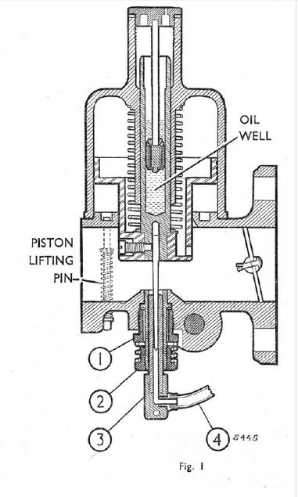
Other type of mixture screw?
1. lock nut
2. Jet adjusting nut
I am assuming this adjustment, which I don’t seem to have on my carby does the same job as the mixture screw at the top of my carby next to the idle screw, being moving the jet up and down in the bridge section of the body.
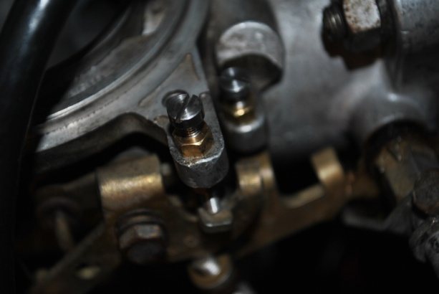
My mixture screw

