Cooling system upgrade, modification.

This is a write up of the cooling system work I have carried out on my ’85 XJ-S V12.

A good deal of this was done in 1998, the engine was out for rebuild (separate write up) and the final result was 2000, when the car was returned to the daily use regime.

I was NOT having overheating/hot running issues, but erratic temp gauge was annoying, and the basic “clutter” of all the OE items was getting up my nose. Very old school, and very inefficient in my opinion.

The root cause of the start of proceedings was the plastic fan “exploded” and vented itself via the bonnet. This was on a return run from an interstate trip, and at quite (very) high speed. A quick roadside investigation found the fan in pieces, and hub all wobbly, too hard, cut the belt, drove on.

The work plan without removing the engine would be:

- Radiator out, recored.
- All old fan junk removed and discarded.
- Water pump off.
- Long fan bearing studs cut short and threaded to suit no hub installation.
- Thermostats removed. Housings cleaned of some scale.
- Water rails on top of each cylinder head removed, so new tubes, and seals could be fitted.
- Front cross over pipe removed and discarded, as a new stainless steel pipe would be fitted.
- LH header tank removed, discarded, new stainless unit would be used.
- RH radiator banjo bolt modified, so that the cross drillings lined up with the banjo central relief casting.

Now the seek and discover comes into play.

I think waaay outside the square regularly, works for me.

Having read about corrosion issues with the by-pass port inside the thermostat housing, a look see was in order. NO corrosion, BUT, my eye caught the fact that there were NO witness marks on the seats as would be expected with the by-pass disc constantly coming into contact with this face, mmmmm. I measured the distance from the thermostat mounting lip at the opening of the housing to the face of the port down inside, this is 41mm. Took the thermostats and measured the “closed length” which was 31mm, and knowing that thermostats only open approx 8mm to achieve “fully open”, so this gives 39mm when FULLY open, no more cooling system control remaining. This travel was confirmed by boiling the stats, and getting the same readings of travel I suspected. Purchased 2 new thermostats and did the same measurements, EXACTLY the same. Communication with Jaguar Australia was fruitless, so I went my own path, as I usually do anyway.

Looked through the Tridon cooling system catalogue I had, and found a by-pass stat, 54mm diam, that was 35mm “closed length”, giving an “open length of 43mm, plenty of scope, and it is a Ford stat.

The Tridon part # TT228-180.
The Dayco is DT18A.

In my opinion this thermostat issue is the biggest concern with these engines. As we all know, if those by-pass ports are NOT 100% closed at operating temperature this engine will run HOT, no ifs, no buts.

The next issue was the radiator positioning. I removed the lower grille, unbolted the engine oil cooler, and noted the brackets to be slotted, so the unit can slide forward about 12mm, did that, replaced the grille. Next came the moving forward of the radiator itself. Not that hard. I removed the 2 locating pins on the lower rail, slid the radiator into position, allowing it to sit on the 2 rubber ring mounts in the lower support panel, slid it forward as far as it would go, it collides with the engine cooler core, then fitted the top rail, and measured the amount of rework required to bring the radiator to a true vertical position. I simply filed the holes in the top panel to elongate them as required to allow me to use the factory top rubber mounts. A simple metal plate behind those mounts kept them in the forward position. A slight rework of the top mount brackets of the a/c condenser was simply done to accommodate the move forward.

The lower portion of the radiator was held in place with a simple piece of 25mm aluminium angle, about 300mm long, which was secured to the lower radiator support member of the car, and the vertical face simply bore up against the lower steel railing of the radiator itself, no damage can take place.

Twin thermo fans were installed. These were a Ford “twin fan assembly”, and of heavy duty specification. The LH fan is wired for a/c operation only. The RH fan is thermo controlled using the 85c temp switch already installed in the lower hose inlet spout.

The fans simply slide in, as if made for the car, and I reused the 2 small angle brackets that attached the lower OE cowling to the lower radiator support panel, as per original, and they provided a perfect “slide fit” for the lower corners of the Ford fans, again, as if made for this application.

The “pulley pack” on the front of crankshaft was removed, and the front “V” was machined off, not needed now, less weight, sweet.

The stainless cross pipe was installed, the stainless header tank was installed, ALL new coolant hoses fitted, and I mean ALL, no exceptions.

The new thermostats installed, and the system bled of air as required.

Next BUG that had annoyed me for years was that STUPID atmospheric tank in the LH inner guard panel. That would have to have been the dumbest idea that Jaguar ever came with. I removed all that junk in that LH area, closed the panel back up, it can remain empty. I located a slim 1ltr plastic container and decided this would be sufficient. The huge washer bottle was removed from the LH rear of the engine bay, and a smaller universal unit fitted in its place, then the “new” coolant bottle was fitted in front of that. The cooling system will purge approx 500ml when at operating temperature, so the size of the atmospheric tank needs be no bigger than 1ltr.

Another item noticed with the engine out and mentioned here due to my thoughts of its effect on cooling system efficiency.

Above the transmission, up inside the tunnel, is a large piece of thick foam insulation. Now this was hanging down, and basically sitting on the transmission casing, which was all that was preventing it from falling out of the car. By doing this it was effectively blocking air flow OUT of the engine bay. These cars get plenty of air INTO the engine bay via the front, but unless it can get out as quick as it gets in, you will at some stage get an “air stall” situation. The front lip spoiler provides some negative under car pressure to aid this air flow, but via the sides of the engine is limited. I refitted a modern insulation material, covered with a sheet of thin aluminium cut and shaped so it “popped” into place and stays put. There is now a visible gap between the transmission case and the top of the tunnel.

Also note that I do NOT use foam packing on the sides of the radiator, I did try it originally, but I was not happy with the fit, so removed it, and saw NO difference in temperature behaviour.

Some photos of various items are included as reference.

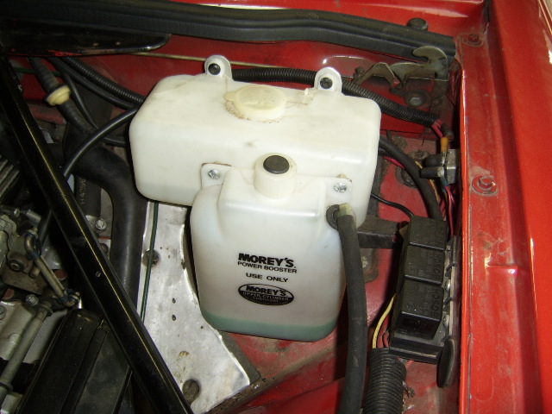
Radiator overflow bottle
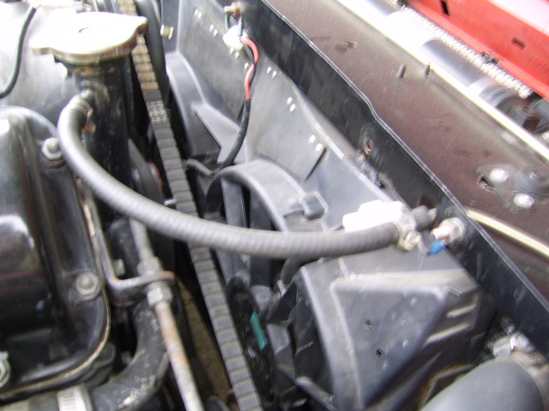RH view of fans

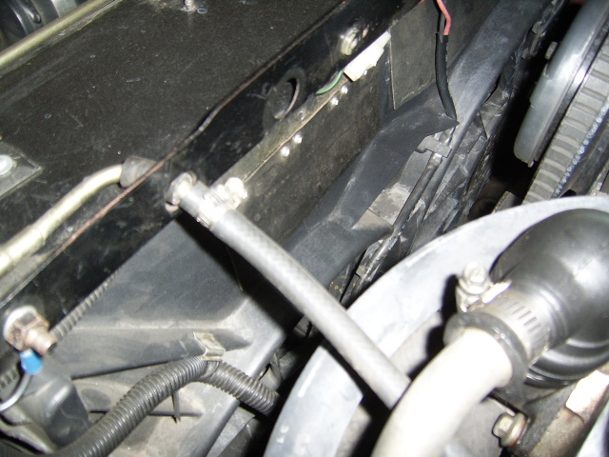
LH view of Ford fans

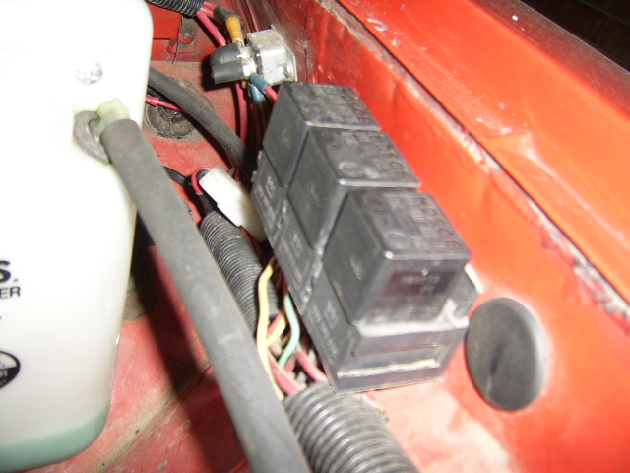
Relays for fans and a/c compressor

