AAV rebuild procedure:.

This is how I do the rebuild of these units. If that fails I remove them totally, and that is a separate write up so as to NOT confuse some people, mainly ME.

First thing is to make real sure the AAV is the culprit. I have heard all the stories in my 43 years with these beasts, and YES, the AAV is a pain in the *&^% at best, BUT, to the average V12 driver it is still the most efficient way of cold starting this engine.

TESTING:

Warm the engine up, it takes as long as it takes. Shut it down. Remove the LH air cleaner cover and element. Start the engine, put your thumb in the hole in the backing plate that is the INLET to the AAV. Don’t be too scared, I know thumbs in strange holes is NOT a natural activity, but trust it, it won’t hurt a bit. IF, and I mean IF the idle drops significantly the AAV is your issue. IF the idle drops a little bit, the AAV is NOT your main issue. This is where you have to make the ultimate decision, as I cannot see/hear your car.

Assuming the AAV is the culprit, I will continue.

Let the engine cool down, as HOT coolant is not nice, so drink some beer, ponder the work you are about to undertake and the HUGE enjoyment you are about to instill on yourself.

You will need:

Some fine wet and dry paper.
Cleaning solvent (I use carby cleaner in pp can).
AAV gasket, or RTV Hi-Temp.
Epoxy glue, like JB Weld, NOT the fast dry stuff as it returns to liquid at 100c.

Remove the 90deg top hose of the AAV, now this is British engineering at its utmost, which is Aussie for “bullshit design”, and you will soon see why. I would suggest you purchase one of these BEFORE starting the task, as you are almost guaranteed to split this sucker. They do get very hard and brittle as an age thing, so a new one will not go to waste.

Remove the 2 “torx” screws from the mounting face, and wiggle the AAV out of the cylinder head, and the hose that goes to the place you put your thumb. Be careful with that “inlet” hose, as it has a plastic elbow in its length to attach the vent hose from the distributor cap.

Up on the bench, GOOD.

There are 2 ways of separating this thing:

- Firmly (don’t crush the bloody thing) grip the “top hat” (bit that the 90deg hose went on) in a vice, and hit the outer rim of the casing so as to “drive” the casing off the “top hat”. Now it will take some hitting, and some come out this way, most do not.

OR

- Grip the unit in a vice with the inlet spout facing down, and using a hacksaw, or dremel, or similar cutting device, cut a slot in the outer casing length ways so as to slice through to upper rim section and a small section of the rest of the body. This slot will be about 1” long THAT IS ALL, TAKE YOUR TIME, until you see the inner portion in the slot. It does NOT take much, and what it does is release the GRIP the outer casing has on the inner section. Now grip that “top hat” section in the vice, and drive the outer casing off the centre section, BE CAREFUL, there is a spring and piston in there, it will NOT spring out, but if you RIP it apart they will fall in the cracks in the floor, then you are buggered.

Some of these have an aluminium piston, and some have a stainlees steel piston.

Now give everything a GOOD clean. Take the piston and ensure it slides VERY freely in the inner bore of the “top hat” piece, I bet it does not. If it does not, and most do not, take some wet and dry paper wrap it around your finger (if you got long fingers), or piece of round wood ,and carefully polish the bore, and try again. Time a care is paramount here, as too much “papering” and the bore is too big, no going back, so be careful please.

If you have an aluminium piston, carefully inspect the outer face for scoring, and clean up as required, either with a fine file and wet and dry paper. You are looking for a smooth slide in the housing, and this is time consuming, but essential.

If you have a stainless piston, then that will more than likely be in very good shape, and the bore of the “top hat” will be the issue that is jamming the piston.

TAKE YOUR TIME HERE, you want a free sliding piston, NOT sloppy, as that will give a vac leak, and you need another one of those, NOT.

Once you have the desired piston/body slide fit, you are nearly done. Wash all the bits again, and reassemble the 2 main items. I usually place the spring inside the “top hat”, and then the piston (which sits neatly over the spring), and then slide the outer casing over that unit. That way the piston stays in place. Open the vice jaws enough to allow the bulb to sit through the opening and the gasket face to sit flat on the top of the jaw face. Take a rubber mallet, and carefully drive the “top hat” into the outer casing lining up the slot you cut prior to dismantling the unit. I usually drive it down until the “top hat” is below the rim by about 2mm. Look inside the inlet spout, and observe the cut outs, and then heat it up, hot air gun, boiling water, whatever, and observe the 100% closing of those cut outs. If it closes, DRINK BEER, you are good at what you do. If it don’t close, but is very near, tap that ‘top hat” a bit further inside the housing, and try again. Now, bear in mind, that the further inside the casing the “top hat” sits the slower the cold idle will be, NOT by much, but a tad slower when cold may be a good thing in my opinion, as some engines are at 1500rpm, and I don’t like that.

Once you are satisfied with your rebuild, take some epoxy filler (I use JB Weld) and fill the slot you cut, and pour some around the top of the rim of the outer casing taking up the 2mm gap somewhat. This stuff takes 24 hours to dry, bad luck, the fast dry stuff will NOT work, as it melts at about 100c, remember, haha.

Refit the AAV to the engine, using a new gasket, or a bead of RTV, bleed the cooling system as some coolant loss usually takes place, and start the beast, and see just how good you really are.

Now one last thing that confuses most V12 people.

That 13mm hex thing on the side of the AAV, is the HOT IDLE adjustment screw, so don’t mess with that until the engine is fully warmed up. If you have messed with it simply screw it all the way home, and back it out 3 full turns which will be OK for now. Warm the engine up then turn it in to slow the engine to your required idle speed. I use 750 HOT in “P”. If you find you have screwed it all the way in and the idle is still too high, you got a vac leak somewhere. But just in case, put your thumb in that hole again, and see what takes place.

As I said I have had good success with this procedure. Mine a both removed, but as I also said, that is a separate write up.

The 12 photos accompanying are in order of one I just did tonight, and have captions that explain what you see. It took me 20 minutes to complete, and the JB Weld is drying overnight prior to returning it to the engine.

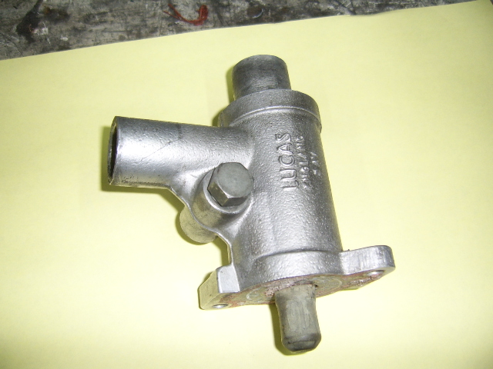
AAV as removed from the engine

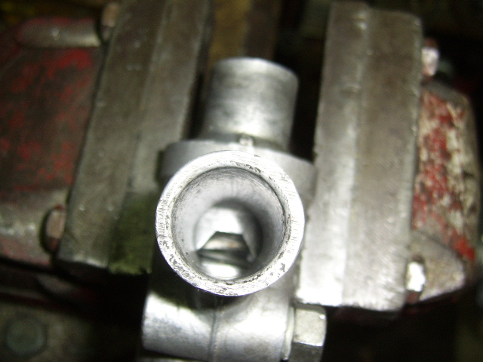
AAV as it is when cold or jammed

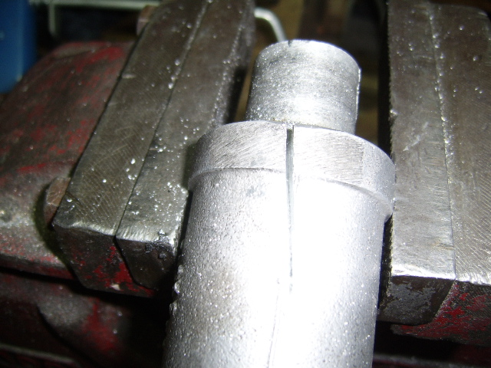
The CUT to release the grip

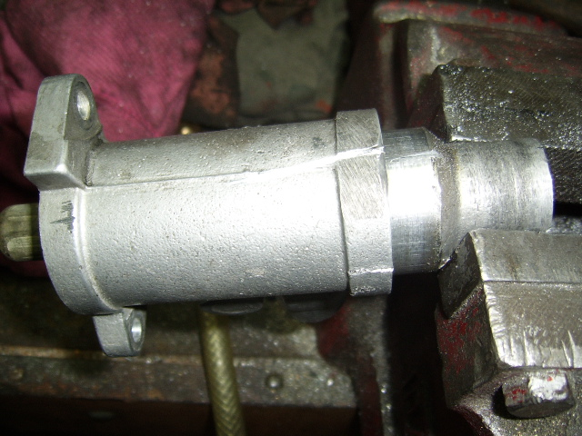
Seperation in progress

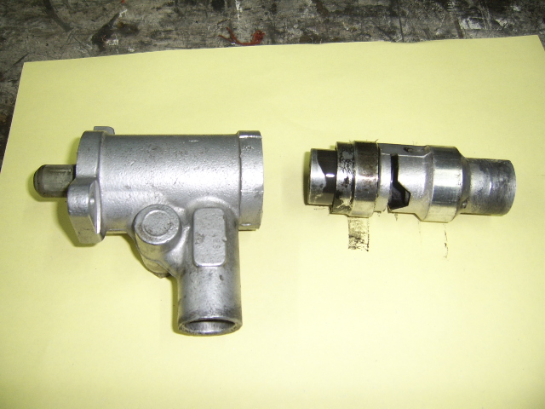
Body on the left and Tophat assembly on the right

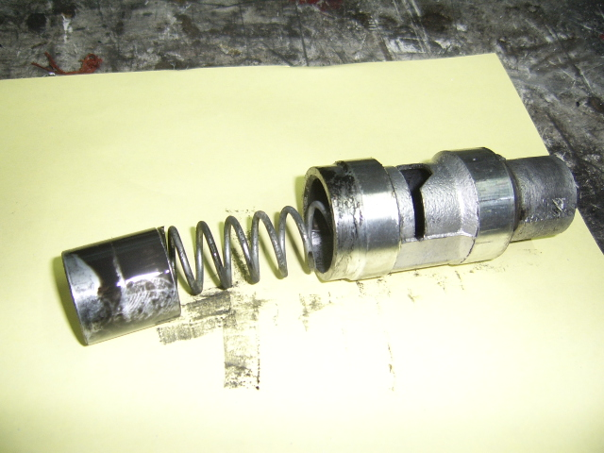
The 3 components of the Tophat

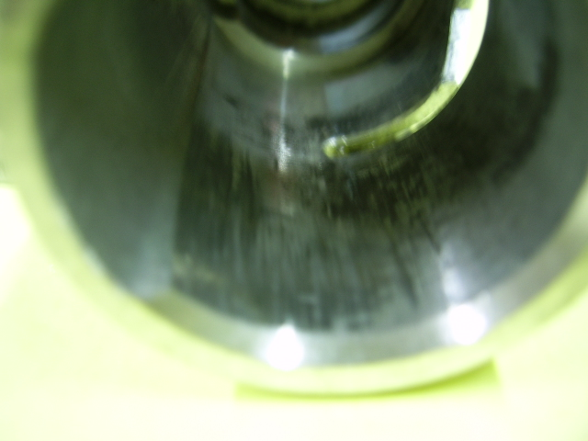
Score marks in the bore of the Tophat

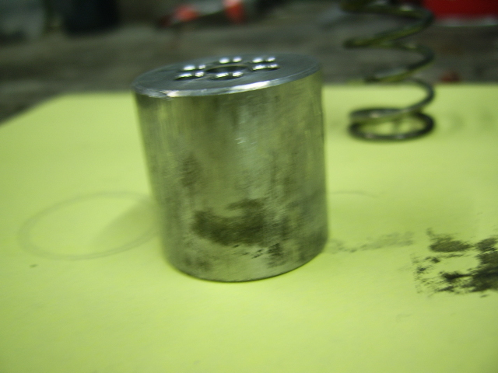
Alloy piston showing scores and carbon build up

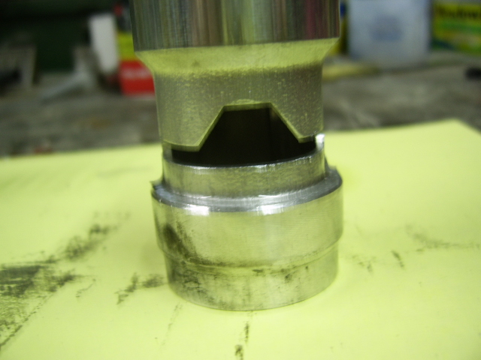
Tophat showing the cut outs that control cold idle.

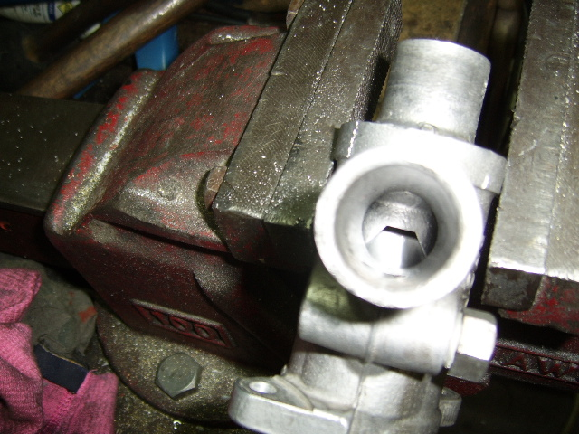
First test after rebuild, FAIL.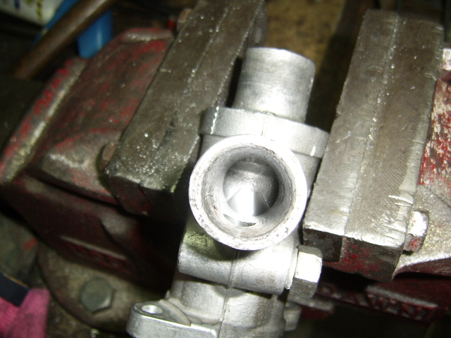
2nd test, PASS 100% closed.
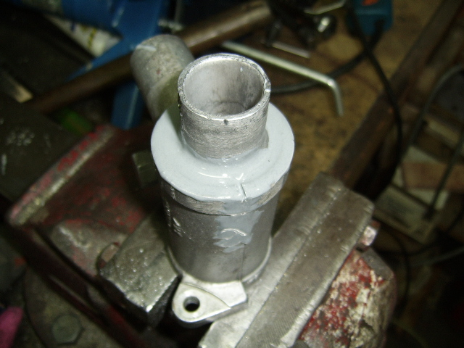
Completed unit with JB weld in place.

