Cold air intakes XJ-S, Grant’s method:

This is my cold air intake method, based on what I read, and what I wanted for my car. It may not suit everyone, so be it. It cost next to nothing, which suited me fine, as I am a scrooge big time.

All done pre Internet days, etc, so “seat of the pants stuff” Aussie style.

You will need:

6 X 50mm downpipe gutter spouts from your local hardware, plumbers whatever, I went to Bunnings, the girl in plumbing is easy on the eyes.

Some flexible 50mm ducting tubing (call it what you will), which I got from an auto parts store, which is commonly called “hot air intake ducting”, the brand I found was Fuel Miser, and was used on near all carby cars, such as Holden, Ford, Toyota etc. You may even find some at the wreckers, coz the same stuff is used for air distribution inside the car, behind the dash, in the console etc, mmm.

A 50mm metal hole saw, and an electric drill to drive it.

A tube of RTV sealant, some pop rivets.

IMAGINATION TIME.

1) Remove the 2 air cleaner covers, remove the temp sensor from the LH snorkel (don’t misplace the bloody thing, they cost money), cut off the snorkels as close as possible to the cover itself. Dress the hole to suit the adaptors you got from the hardware store until you are satisfied with the fit, it is not hard. The holes in left in the covers will be “oval” in shape, don’t panic, just dress the hole to suit the spouts, so they can be fitted from the inside, and the rest is sealed with RTV, and when painted will be sweet.

2) Insert those spouts from the inside of the cover, and pop rivet them in place, run some RTV around to finish off the joint/gap (watch the sharp edges they do cut fingers).

3) Drill a hole in the LH cover end plate to take the temp sensor you put to one side before. I hunted through my tins of stuff, and found a nut to thread onto the sensor. Refit the covers, have a beer, enjoy.

Now it’s decision time. I read about the guys that go into the panel behind the head light, some just poke them alongside the radiator, I decided not to, coz I did not like the look, my car after all. This is my way where I continued the intakes down to the apertures behind the bumper bar, where I decided that real cool air was what I wanted.

Alongside the header tank there are some relays, forgot which now, coz my under bonnet is all rewired, with most of the stuff removed from the engine bay, you will need to relocate that/those relay/s, to allow the hole to be cut through the inner guard. Not much relocating, just look at it carefully. On the RH side there is nothing in the way from memory.

Now the work begins, and I will start on the LH side, just coz I can.

Jack up the car, remove the front wheels (of course, support the thing properly it’s bloody heavy, and hurts like hell when it falls on you), remove those 2 silly plastic panels in front of the wheels, and look up inside the opening, this is where the tubes will come down from eventually. Take note of the screws used to hold the “top” metal panel to the inner guard, they are self tappers, and the pointy end is in the engine bay, just in front of the header tank, and in the same relative position on the RH side. This notation will give you the area to drill a 50mm hole in the inner guard, simple. Watch the fingers when drilling that hole, coz those hole saws can grab and bite like hell.

Take 2 more of your “spouts”, and attach them each side of the hole you just drilled, with the body panel being sandwiched between the 2 spouts, follow me so far hahaha, damn I’m lost, need a drink. Now the one in the engine bay may be too long, so test it first and shorten it as required, do another for the RH side whilst you are at it. The ones on the under side should be OK, again, your car, your choice. Run some RTV around the set up to tidy it up, as before. Now attach a piece of that 50mm tubing from the air cleaner to the spout, looks sweet ha.

More beer.

Now lay in front of the car, look up behind the bumper bar, where the backside of the indicator lamps go back through the body panel, and you will note that the hole in the body is waaaaaay bigger that required. This is where the end of the other tube will end up, as it comes down from the inner spout, and simply “reshape” the end of the tubing to suit the aperture, and attach it in place with RTV, not rocket science. Replace the LH inner plastic shield thing, put the wheel back on.

Now do the same on the RH side, BUT, there’s always a BUT. In the same area on the RH side is a bloody big vacuam tank, bugga, but there is enough room to work the tube around and out the front as on the other side. Trust me on that, coz I also have my cruise control bellows in the same area, and it all fits with some room left over for something else, one day. Refit the RH plastic shield, the wheel, lower the car, ENJOY.

Much beer to be consumed.

This would I imagine be a good days work, and the setting of the RTV will take time of course, so let it dry, it will be OK.

If this all sounds ODD, email me I will sort it out.

Some snaps to try and get the visual of what I talked about above.

Photo’s are below in no particular order, but the captions should clear any confusion.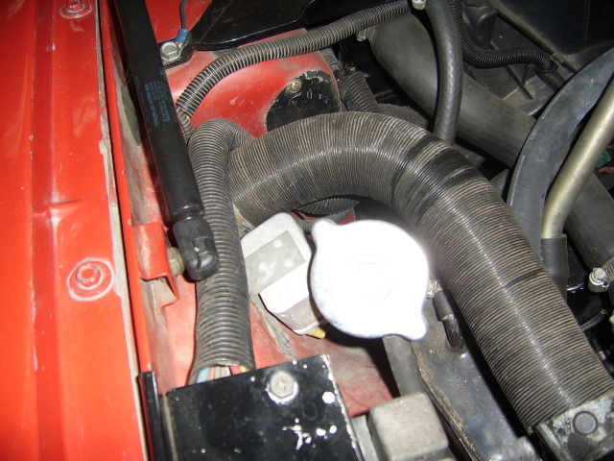
LH cold air intake, with the headlamp relay moved lower than normal to allow drilling of required hole

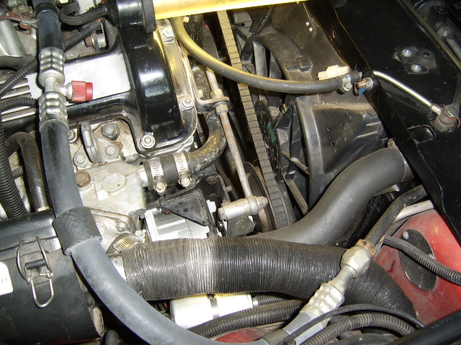RH cold air intake

