Diagnosing the Denanair Mk3

The ECM is located on the RH side of the HVAC evaporator assembly. To gain access you need to remove the kick panel at the front of the centre console, then remove the metal duct that the panel screws to this make access to the ECM easier.

There are 2 screws that hold the ECM in. The first 2 pics they are circled in RED
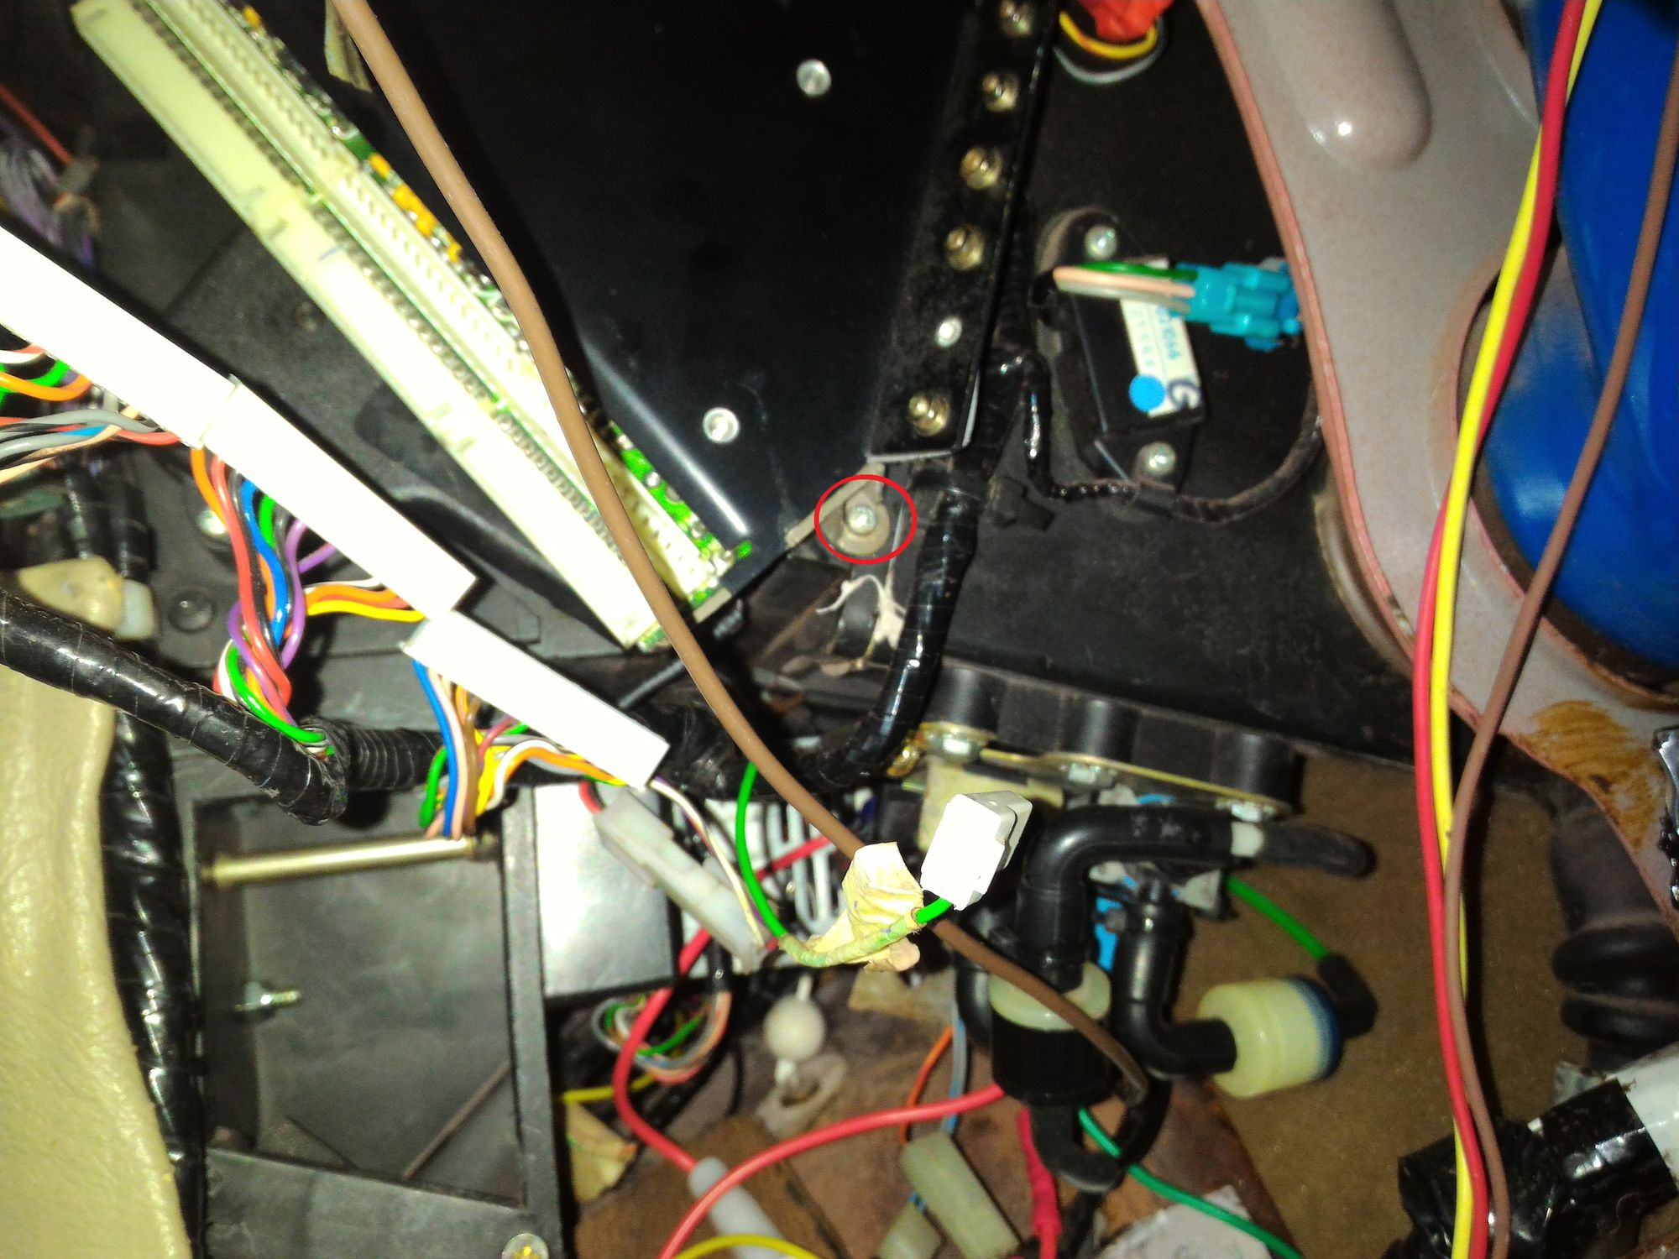
This pic is looking upwards
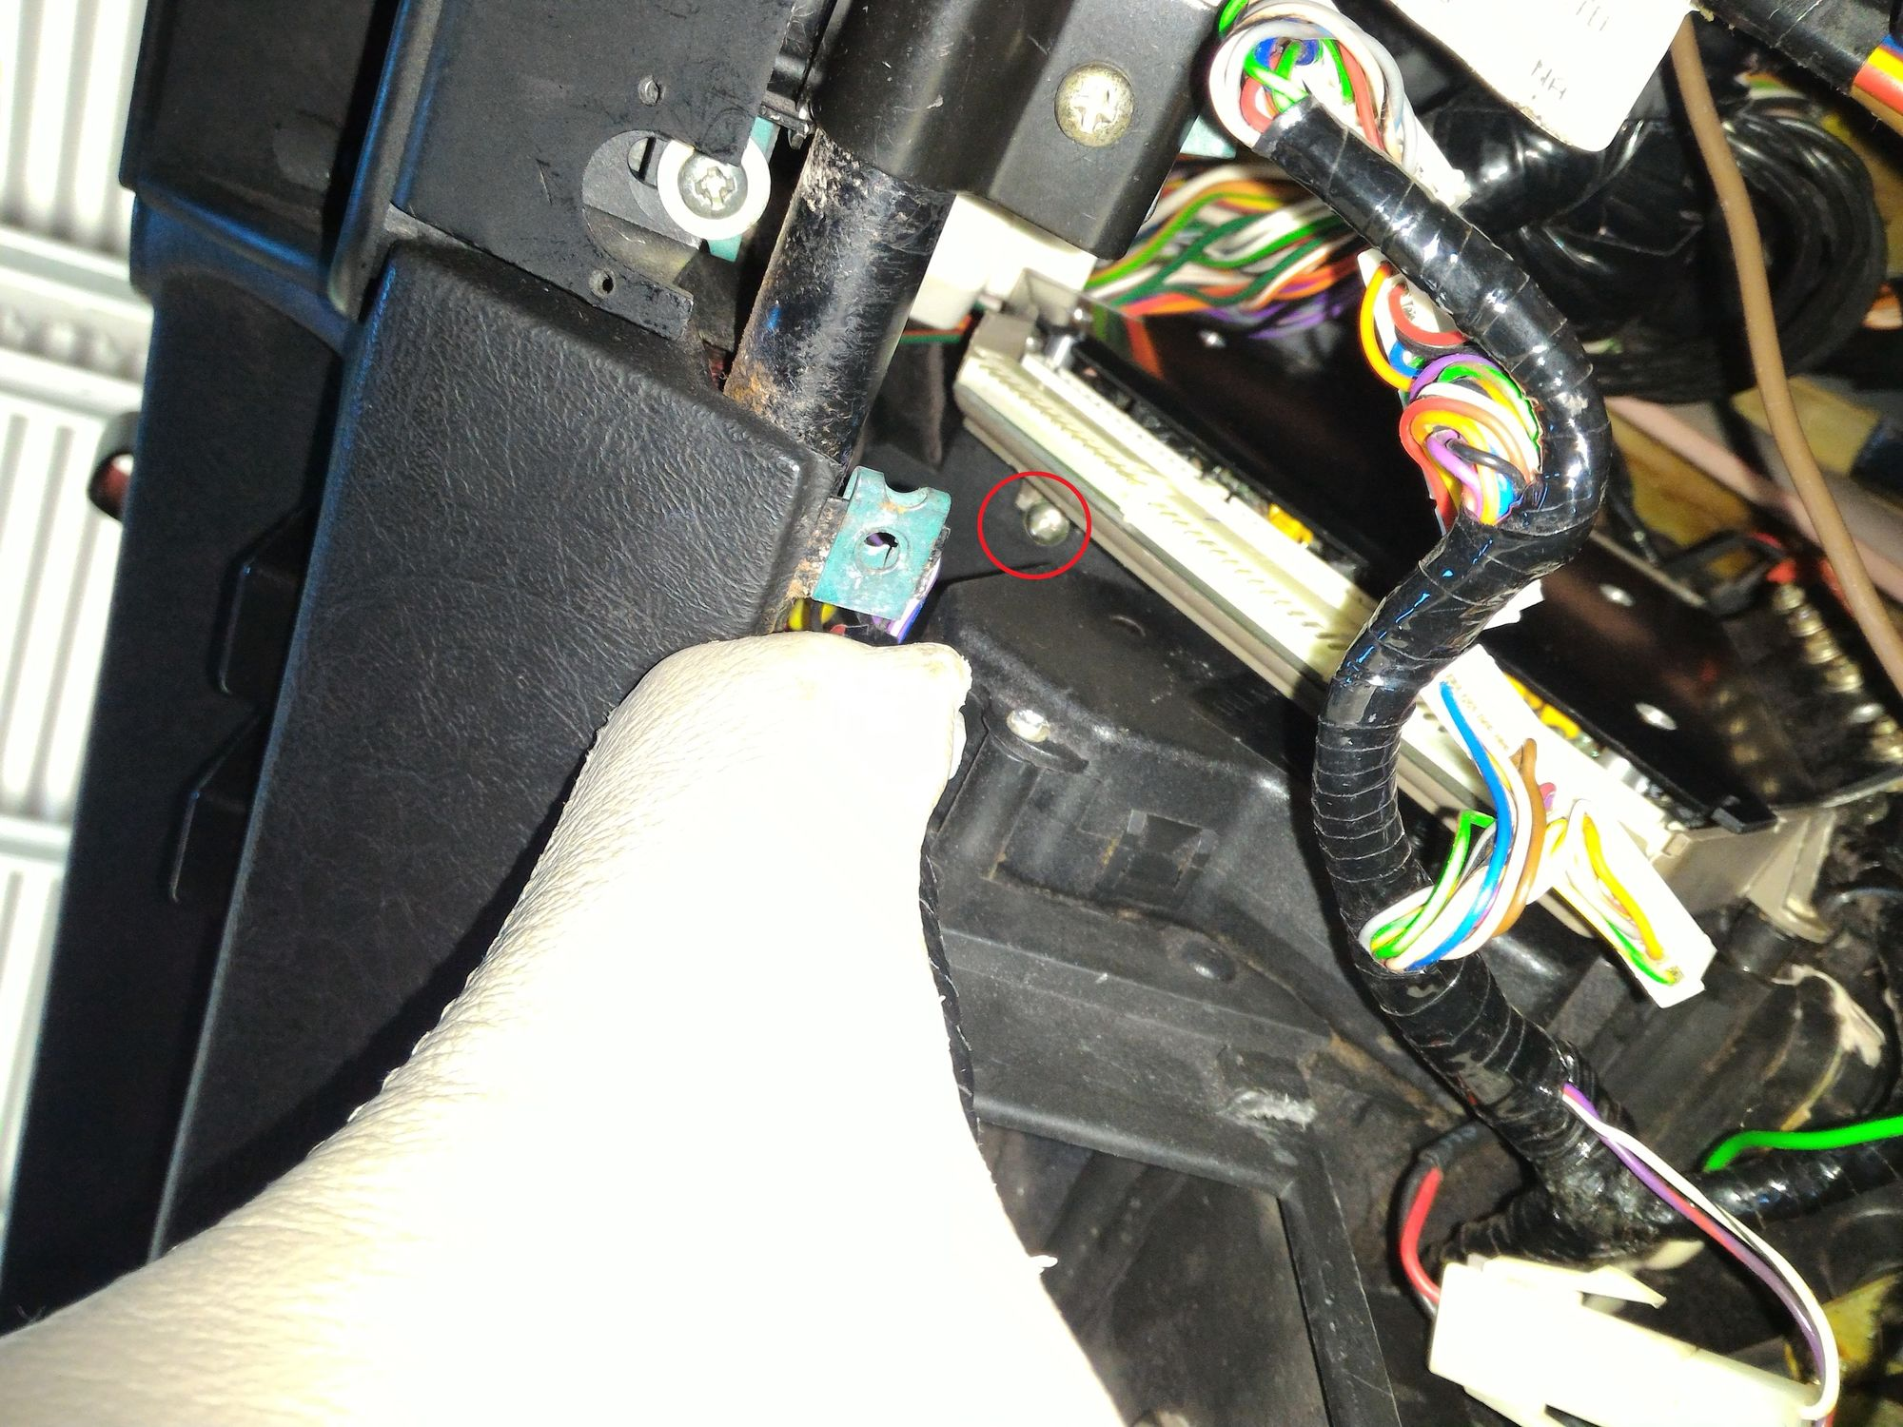

This is the ECM, you can see the connector at right angles to the plugs this is the test connector.
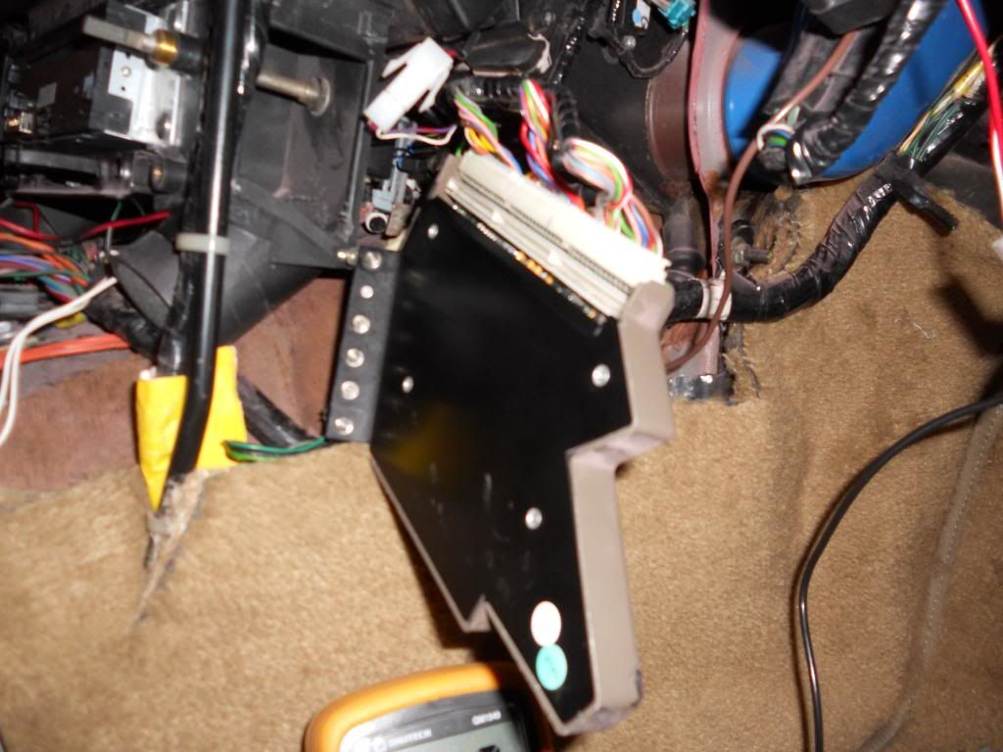
Get you self a couple of these jumper wires to test the ECM. They can be found in old PC's or you can buy them on eBay. DO NOT try and probe the pins with the meter probes if you short the pins you WILL damage the ECM.

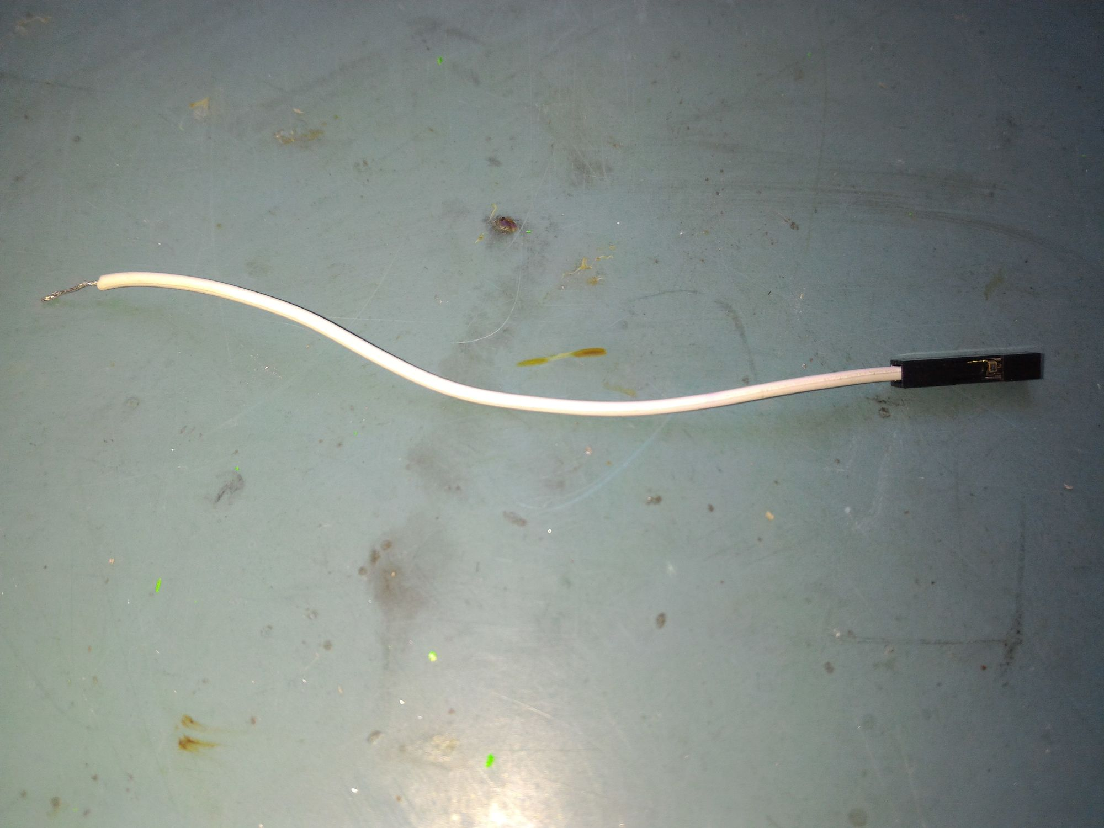

Then probe the ECM as directed by the diagnostics. Pin 1 is at the top of the ECM as it is installed in the car. It is marked on the PCB but can be hard to see.

