Transmission cooler relocation.

This is the way I did this relocation on my ‘85 XJ-S V12.

Firstly this is what I have done to ALL my Jaguars since 1968, and no ill effects to date.

My reasons are very simple, at least for me.

The trans cooler exchanger in the radiator is always in the lower portion, so the coolant has been cooled by the core, then re-heated by the trans fluid exchanger, which puts a load on the whole cooling system. Which as we all know on a V12 is working damn hard at best.

I do not run the cooler hoses back via the radiator, as I run these as a stand alone cooler for the transmission fluid.

This has assisted my cooling system in keeping the engine temperature under control much easier than previously. I also have had NO issues with the transmission fluid.

I removed the lines from the radiator, mine had push over hoses, some later cars have threaded fittings, so you will have to do what you have to do for hose extension.

I purchased a trans cooler from the local Auto Parts shop, and selected the one for a “large V8”.

This was mounted horizontally under the front apron panel on the XJ-S that is out in front of the radiator. I simply made brackets to suit the fitment, and it is about 1” above the lower edge of the front bumper rubber section. Not visible by any means, but plenty of air flow for the task.

Since my pipes for the trans cooler are on the RH side of the engine bay, I faced the hose spigots of the cooler towards the right. I attached suitable hoses from the cooler to the transmission pipes of the car, ensuring that there were NO kinks, and threaded them between the radiator RH tank and the body of the car, plenty of room.

I then ran the engine and topped off the fluid to allow for the spillage and additional volume of the new cooler.

When the radiator was out for a recore, I had the cooler unit removed from the RH tank, it just made sense at the time.

The attached photo is self explanatory.

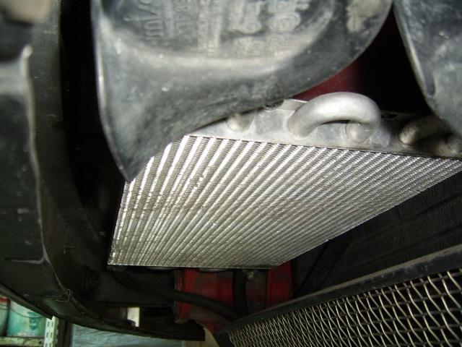
Figure 1 Transmission cooler looking from the LH side.

