Adjusting the V12 throttle discs.

These 2 discs are factory set, and rarely need attention. Age is now not on their side, so we enthusiasts need to know that these are set correctly, and in most cases opened up to 0.003” from the factory set 0.002”.

It is a simple process, but accuracy is paramount.

You will need:

A set of feeler strips, with a 0.003” strip included.
2 open end spanners to fit the locknut AND the adjusting bolt. These can be different sizes, your car to sort.
Some p/pack solvent, and clean rags.

- Remove the 2 air cleaner covers, and filter elements.
- Remove the 2 throttle cross rods.
- Soak a rag in solvent, and manually open one throttle, and wipe ALL the “Black Goo” out of the inside bore, and the disc itself. Once CLEAN, do the other side.
- Loosen the locknut CAREFULLY, open the throttle disc, and place the 0.003” feeler strip between the top of the disc and the bore of the housing. Release the throttle arm you are using to open said throttle, and allow it to close. This will “grip” the feeler strip. Carefully pull on the strip, and rotate the adjusting bolt outwards SLOWLY, and you will “FEEL” the strip start to move, STOP rotating that adjusting bolt. Tighten the locknut (NOT stupid tight, just firm will suffice). Recheck the “feel” of the strip, and redo the whole procedure if needed. Generally a single flat of the hex is all that is needed to do this simple adjustment.
- Do the same on the other throttle housing.
- Once happy, refit the 2 cross rods, and adjust them as mentioned in the separate write up “Setting the throttle rods……..”.
- Refit the 2 air cleaners, and covers.

Periodic cleaning of the throttle bodies is requires, and I do them when I am doing each oil change, and general under bonnet inspection.

The snap below shows the adjusting bolt and locknut. It is a tad blurry, as I was snapping the solenoid.
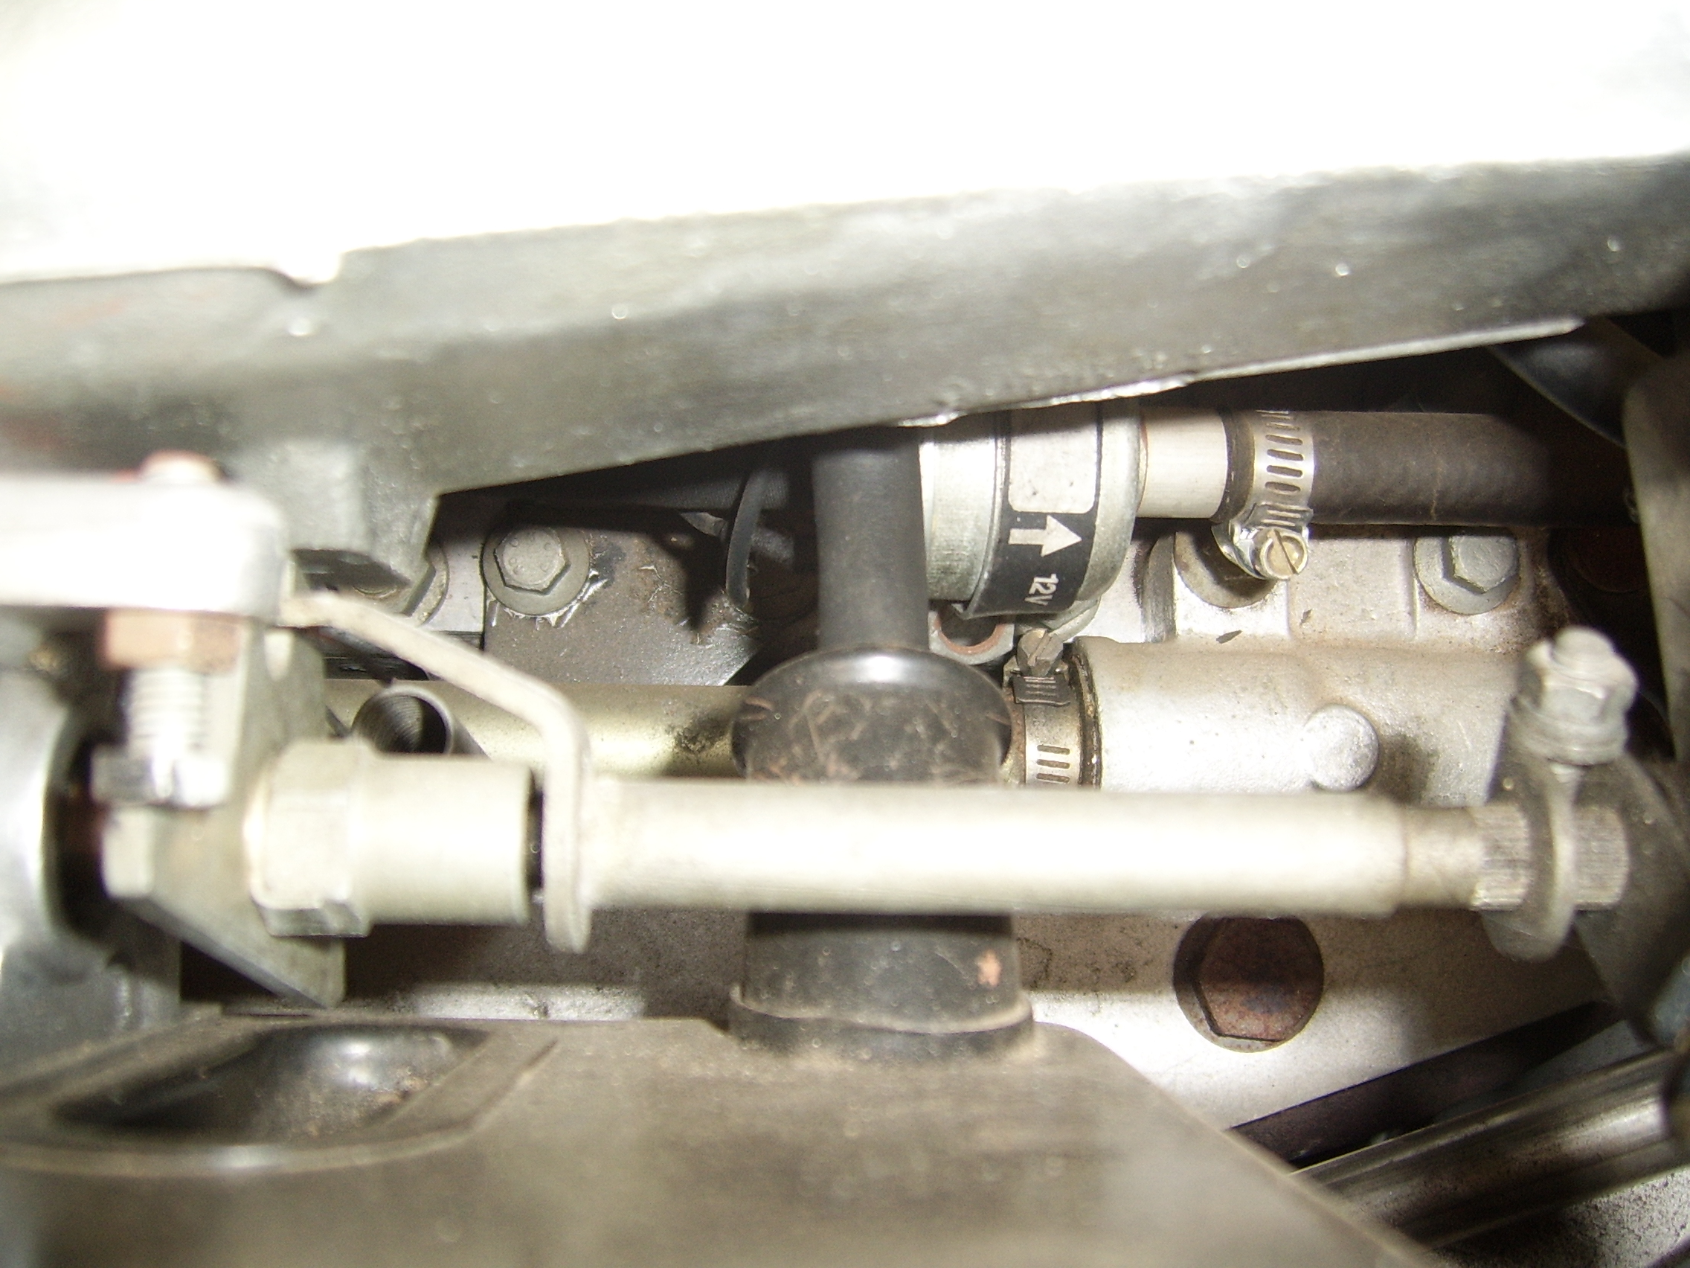

The snap below shows inside the throttle housing. It is NOT standard, it is my HE, and I have the large bore housings fitted, and the metal pipe is my distributor cap breather, as I do not run the stupid AAV. 