Jaguar rear outer pivot arm greasing. Inboard brake style.

As most of you may be aware, the greasing of the lower outer pivot bearings is a hit and miss affair. You didn’t know that, guess what, most of the time all that warm and fuzzy you get whenever you grease those 2 nipples are wasted. Sorry.

This is due to a small “bleed hole” in the face of that casting, about 90deg to the nipple inlet. So as you grease the area, thinking you are doing a great job, the grease is actually going out of this hole and up inside the tube that forms the lower wishbone. The resulting outcome is that NO grease has actually got into the bearings, which are at either end of that casting, water gets in, it has to, the only seals as such for those bearings a felt rings (if they are still intact, I doubt it), the bearings fail, the car gets all wobbly and knocky from the rear, and you got lots of work in front of you to replace them.

I simply drilled that bleed hole slightly larger, to suit whatever you choose to plug it, using wheel bearing grease on the drill bit, it is stickier than normal grease, and collects the drilling swarf perfectly. Then I inserted a suitable self tapping screw, VERY short in length, in that hole. You could go all fancy and tap a thread and put a suitable 4mm bolt in there, your car your choice, but it is NOT visible unless the rear hub is partly removed.

Now when the grease is pumped in, the grease actually has to flow inside the chamber until full, pressurising the chamber, until it oozes out of each end around the large washers, and felt seals if you still have them. This way you know that the bearings are greased, they have to be, the only exit is now via the bearings themselves.

I have done this alteration now to 5 vehicles, mine was 10+ years ago, and no wear at all.

To do this on the car, you will have to remove the driveshaft from the splines, should be simple, they used “never seized” on assembly, hahaha. I simply remove the split pin, loosen the castellated nut, refit the road wheel, drive the car SLOWLY in the driveway, and most times the shaft will slide loose. Remove the wheel, REMOVE THE GREASE NIPPLE ON THE UNDER SIDE, remove the nut, tilt the hub assembly outward, you may need to rotate the driveshaft to get the joints to bend just right to facilitate this, and this will expose the hole I am talking about. It will be directly facing you as you peer over the top lip of the hub. When done, liberally coat the splines with never seize, slide it all back, tighten the nut to spec, fit a NEW split pin.

If for some reason the splines will not slide out of the hub due to insufficient hub angular movement you will need to remove that lower shaft, simple task, just note where any washers/spacers are located to ease assembly.

The first time you grease the unit with the hole plugged, there will be considerable amounts of rusty looking muck oozing out of the ends. This is all the “goo” inside there that has accumulated over the years, and should cause NO issues providing that you continue greasing until fresh grease is oozing out. The bearings themselves rotate very slightly, and probably should not be used in this application, but I have not had a failure here in all my years, BUT, I grease them MY way, and maybe that is the secret. They only get a squirt or 2 every year, at “major service” time, and fresh grease always oozes out.

Some have removed the lower shaft and cleaned out all that gunk, that is entirely your choice, I have never done that.

If, however you have movement in this area, bearing replacement is mandatory, once they are buggered, there is only one fix, replacement.

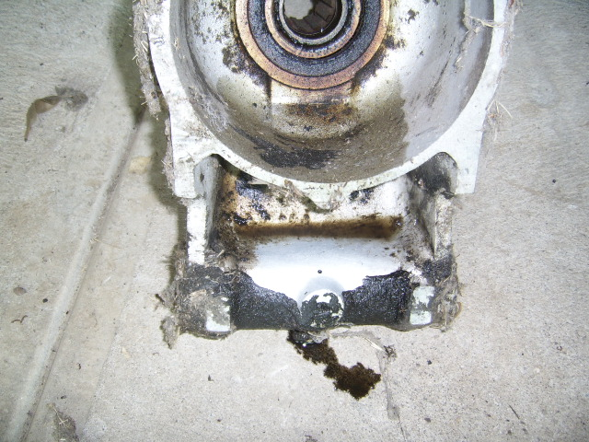
Figure 1General view of that SMALL hole

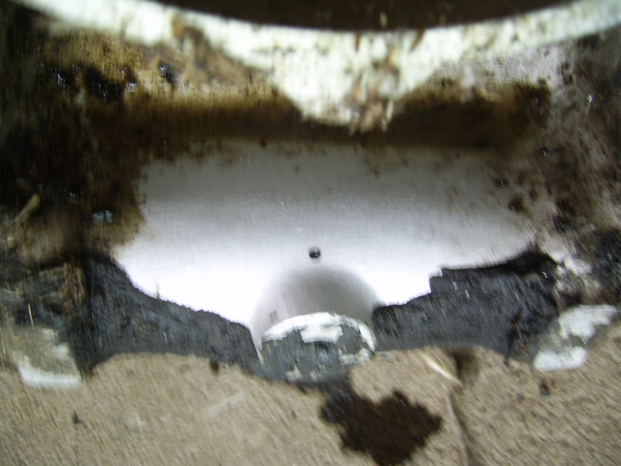
Figure 2Close up of said hole

This is an old hub under the bench, it clearly shows the hole I am discussing.

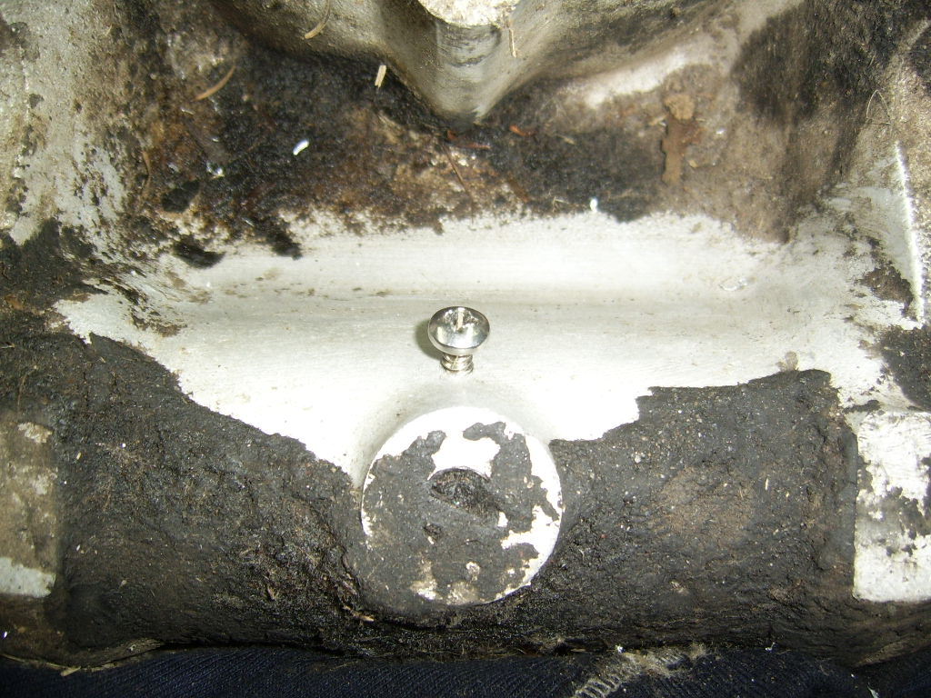

This the screw as a sample of what is needed. This is a tad too long, but for the sake of this article it serves the purpose.

