Changing the Half shaft Universal Joints and Rear Hub Bearing - Jaguar XJS 84
Changing the universal joints.

The hardest part of the whole rebuild process .
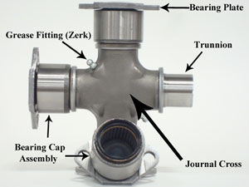

This picture is off the net for illustration purposes and is the same as the ones I installed into the half shafts …. different from the old ones which were a complete PIA to get out.
Changing out unis are usually a pretty easy exercise and this is the first time I have come across the following issues.
The old uni joints (no pic they all went into the bin) had a raised section where the grease fitting screwed in significantly reducing the distance this part of the joint will push into the yoke of the shat. So the joint can only be pressed out one way…. Yeah ok…. Problem is the trunnion would not press out far enough to push out the bearing cap assembly. I needed to get one of the caps out and push the opposite one back enough to get the trunnions out. This was not easy and took a lot of banging and did (only slightly)damage the inside of the yokes where the caps push into….!.
One uni joints where out I used a bearing scraper to patiently and carefully repair the insides of the yokes so the new caps would go in easily…. which they did.
One the trunnions where cleaned up I put the ne uni joints into the half shaft first.
Push the first cap in about ¾ of the way, stop before the dust cover comes out of the yoke.
Put the cross in and then with a Press or G Clamp press the opposite cap in until it goes onto the trunnion …. Ok … now I used a 19 mm socket as a dolly to press the caps in past the circlip groove …. One at a time and put the circlip in before pressing the other cap in cap in.
Pictures of the press, G Clamp and bearing scraper are attached.
OK … now onto the Hub Bearings.
Remove the drive shaft from the hub and knock the shaft out of the outer pivot … these SHOULD all come out freely, one of my splines was rusted and required heat and a press….! Don’t loose the spacer and washer which will be on the inner spline shat or on the stay with the inner bearing.
From the drive side of the hub knock the outer spline section out …. IMO this is best done with a press with the hub properly supported and the correct dia drift / dolly … it should come out easily but could be done with a hammer and drift if properly supported.
With a bearing splitter remove the outer hub bearing from the outer spline. …once again this comes of easily and I used a couple of pry bars once the bearing splitter had done its bit.
With a rag or something clean the grease out of the hub enough to see the recessed sections you will need to remove the outer races from the hosing ….see pic below .. just below the outer race in the housing …same for the inner race ….they knock out with a punch. By this stage the only thing holding the inner bearing in is the seal and will knock out with the outer race.
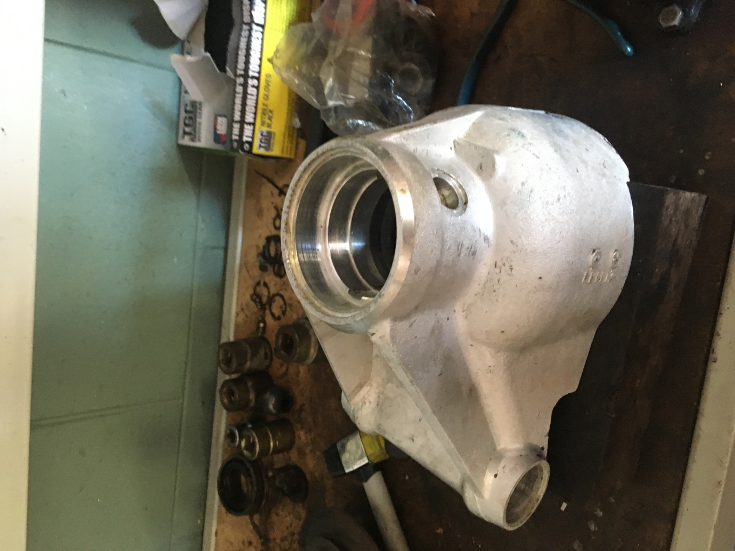
OK … now onto the outer fulcrum … note the sequence of the washers and spacers …. remove the felt seal retaining washers, felt seal, felt seal retainer, outer bearing shim, the spacer that sits between the outer race and the felt seal retainer then the inner bearing race, ….the bub should be in a vice with the inner pivot vertical.
Now remove the pipe / tube spacer from the inner fulcrum … there will be shims on one side so look out for these.
Turn the hub over in the vice and repeat the above …. All that should be left in your bub now is the outer fulcrum bearing shells.
These shells knock out the same way as the axle bearings , you will need a longer than standard punch for this.
Give both hubs a good clean and look for any nicks or burs in the aluminium where the bearing sit … I gave these a tidy up with a bearing scraper and fine wet and dry.
I think that by this stage it was getting on in the day and I had a red or two so I set about giving everything a good clean and inspect ….careful getting the felt retainers out .. they are salvageable and expensive otherwise.
Best put both fulcrum bearings and the Hub bearings in the freezer. I left them in the packaging when I did this over night … but its only the outer races / shells you want to chill.
Remove the bearings one at a time one at a time from the freezer and knock them in with a punch …. Do not rush …but do not waste any time either. Here are a few photos of the bearings going in …!
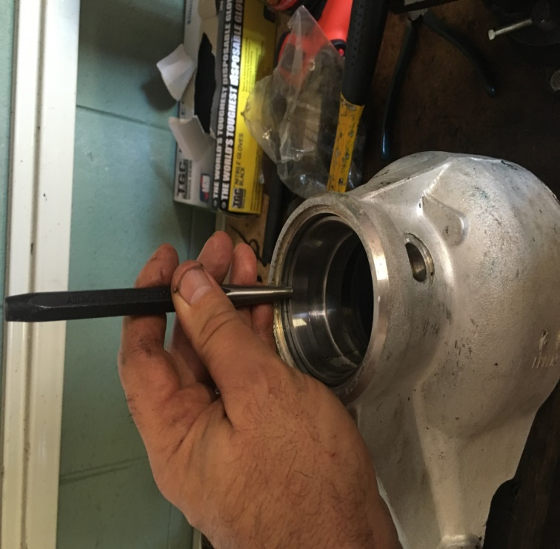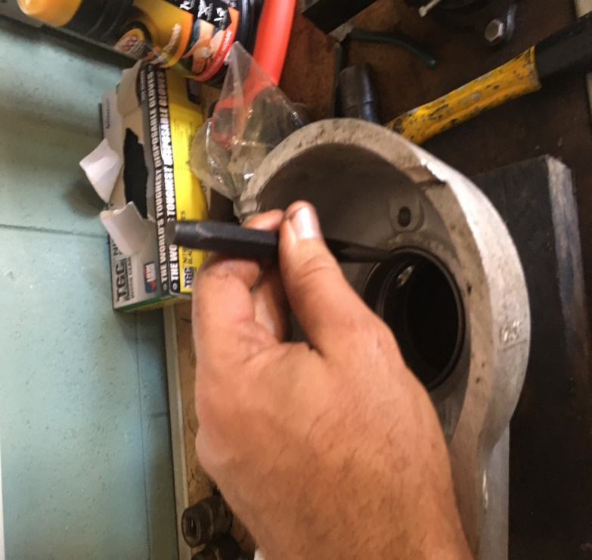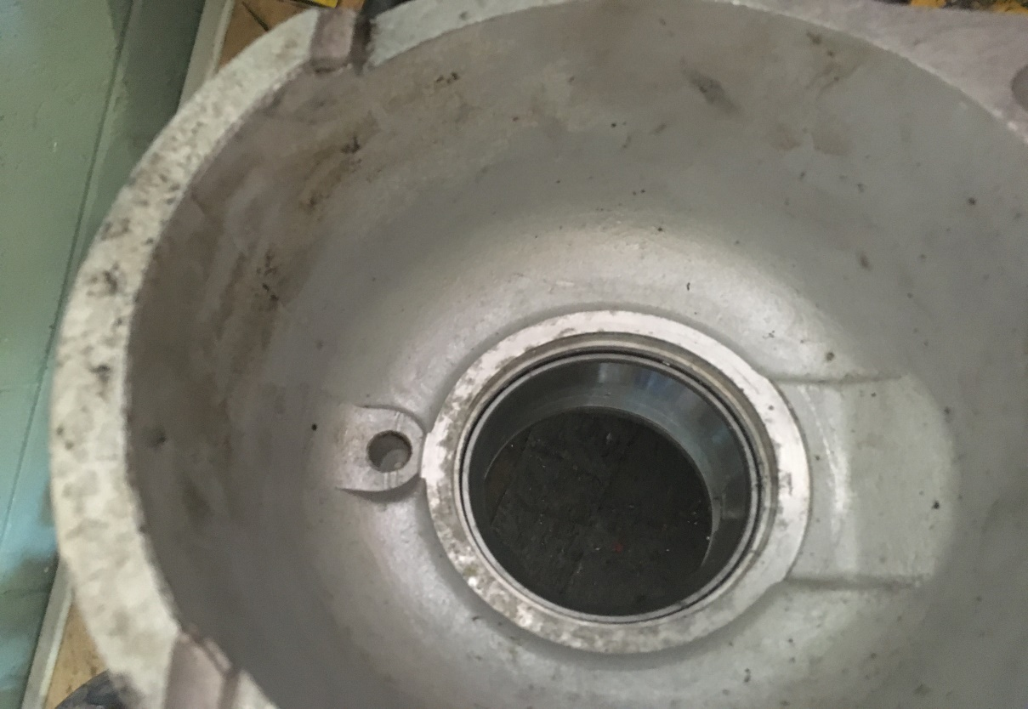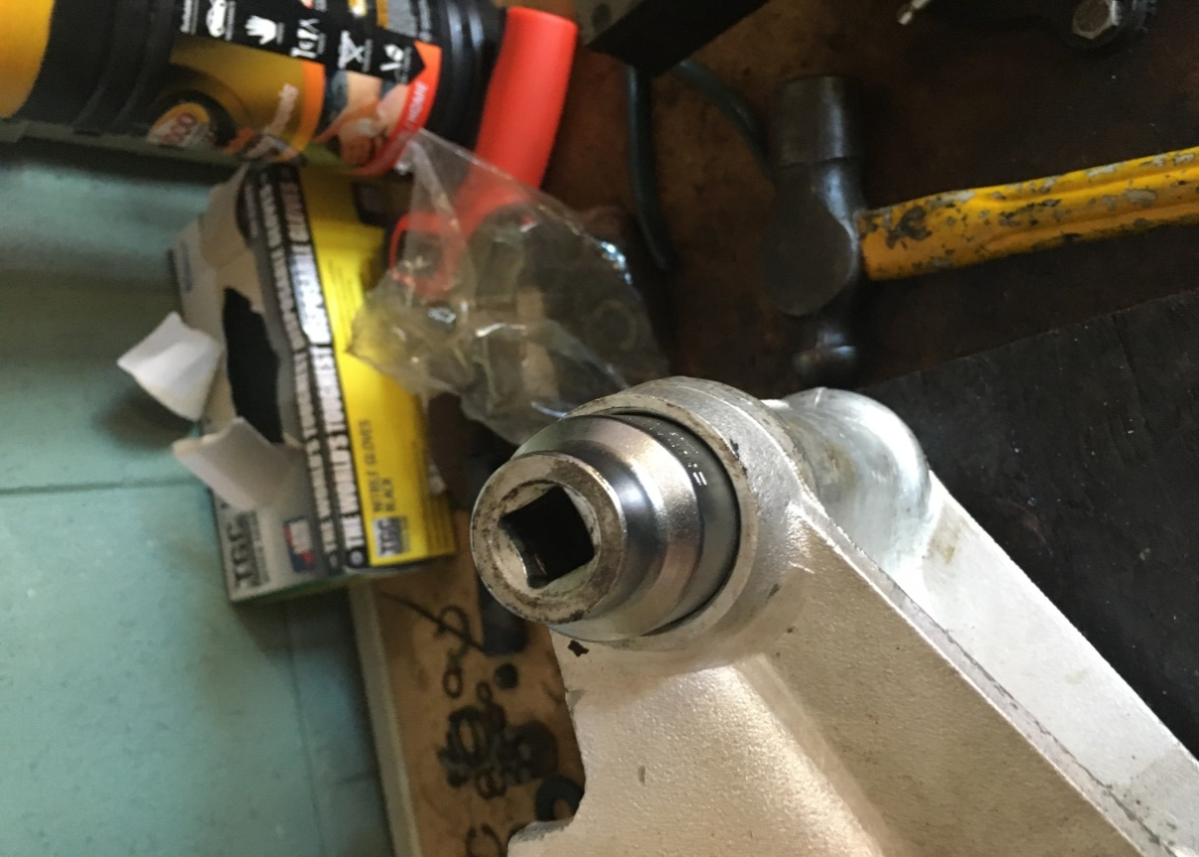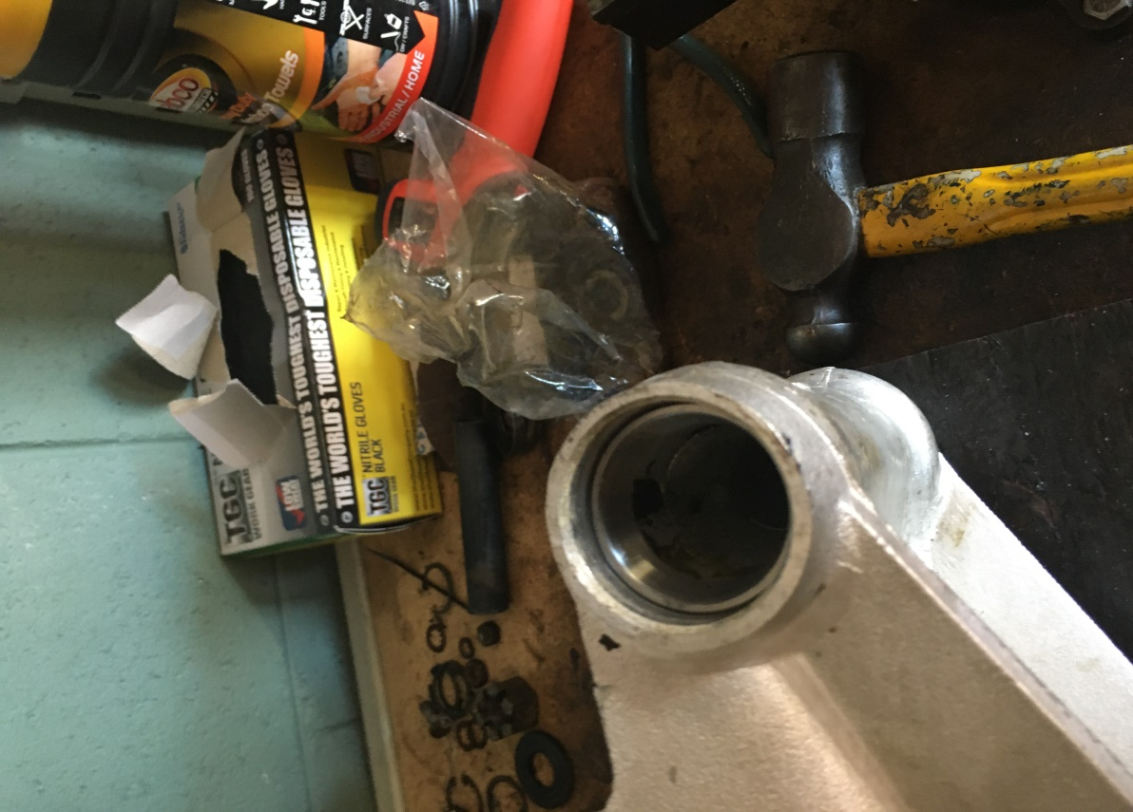
Ok … by this stage everything has been cleaned and ready for assembly.
Outer hub bearing on to the outer spline … and here is a picture ….! … knock this bearing all the way home … the note will change when it lands.
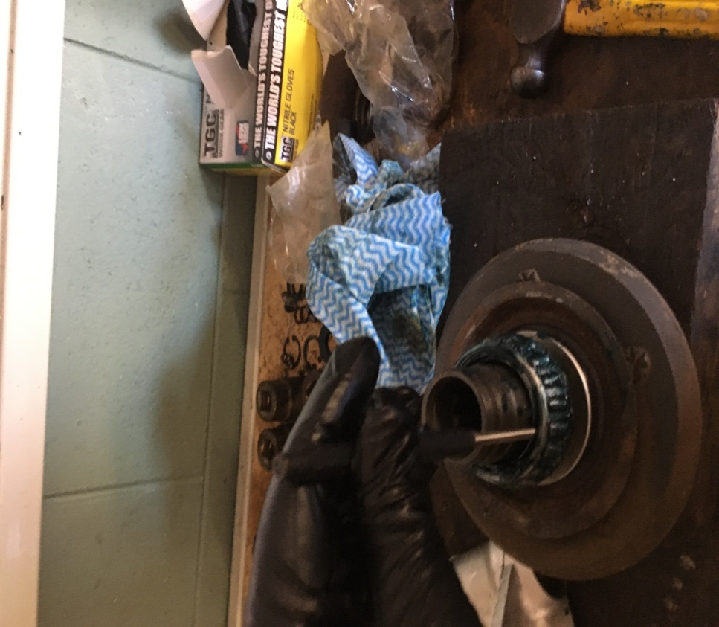

Now the outer hub seal goes in …pack the seal with grease … energiser innermost …
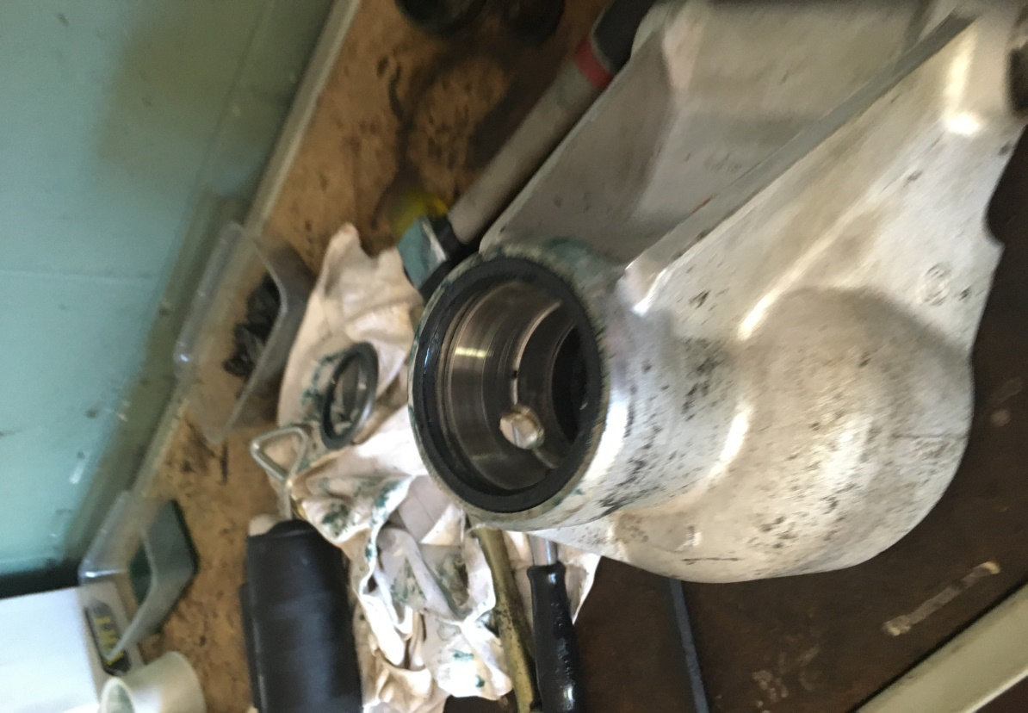

By this stage you can drop the outer spline in …plenty of grease so everything slides nicely and there is no pick up.
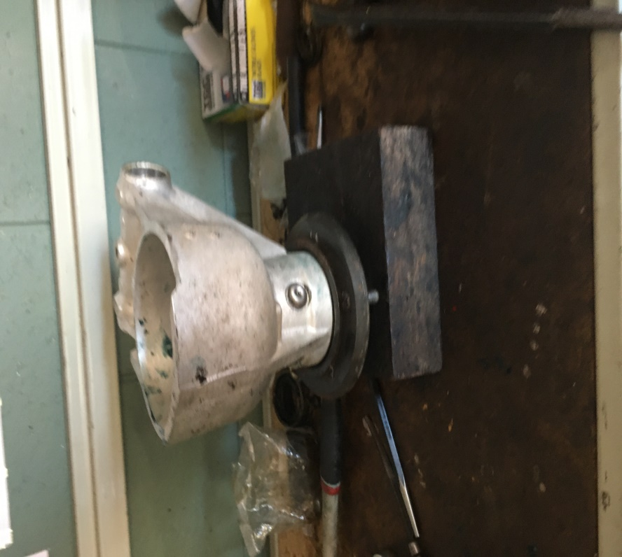
Now pump the hub area where the inner hub bearing goes with grease, pack the inner hub bearing with grease then knock the bearing about ¾ of the way onto the outer spline shaft … not all the way…!
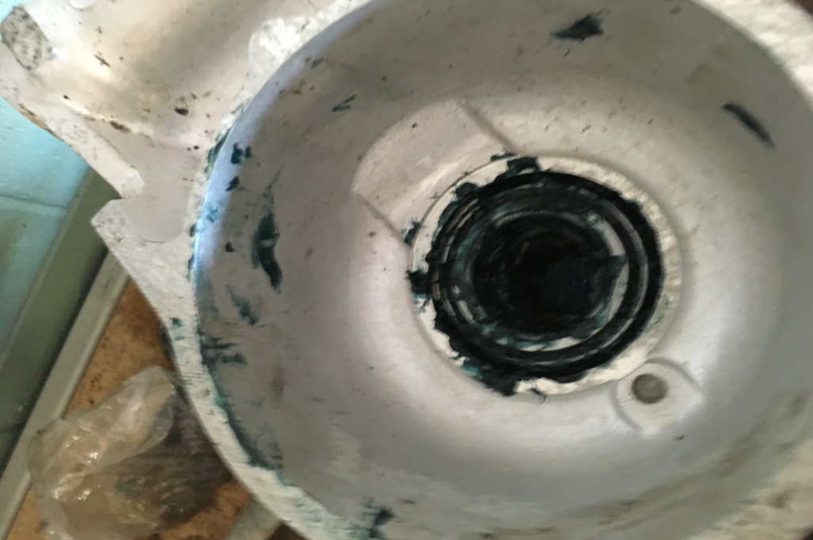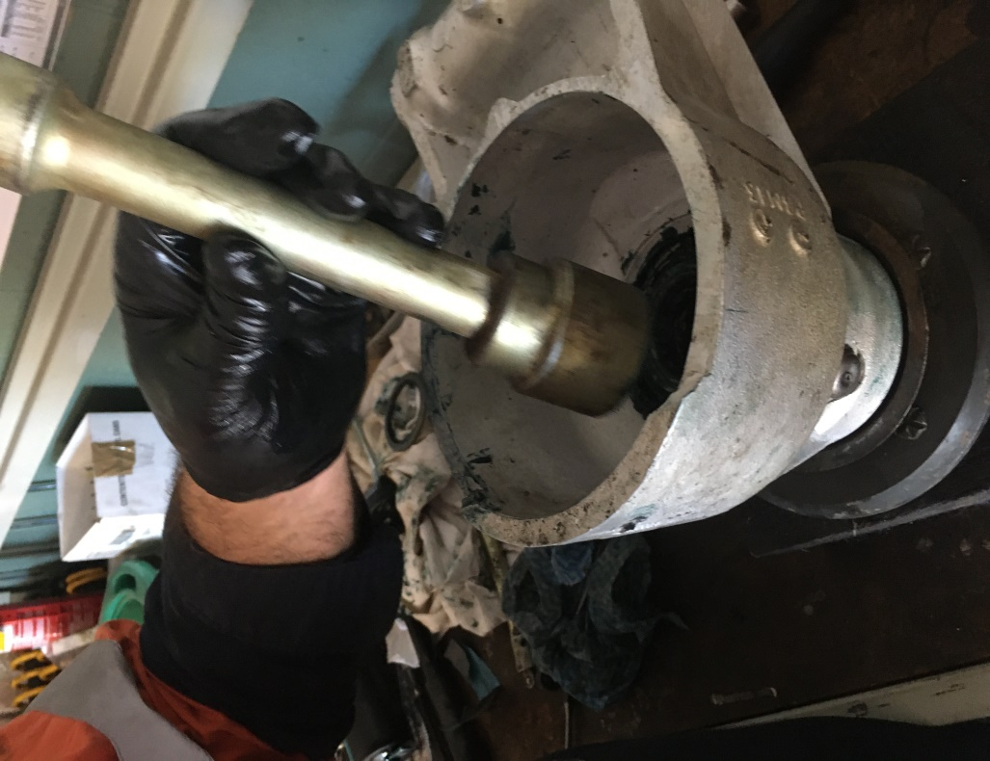

OK when I pulled the hubs apart the was 1 x 125 thou spacer on each hub providing the set end float so when I re assembled I put these in, before you do this check the nut runs freely on the shaft of the inner spline. Now insert the shaft / inner spline into the hub and pull it up all the way with the nut and washer until it will not go any further …. By hand on a spanner or socket … no hitting – please…. Or this can be done in a press …. Not having a suitable press I used the former method.
All good …. Now check you end float as per the next coupla photo’s. you are looking for 2 thou…. Which I got with the existing spacers.
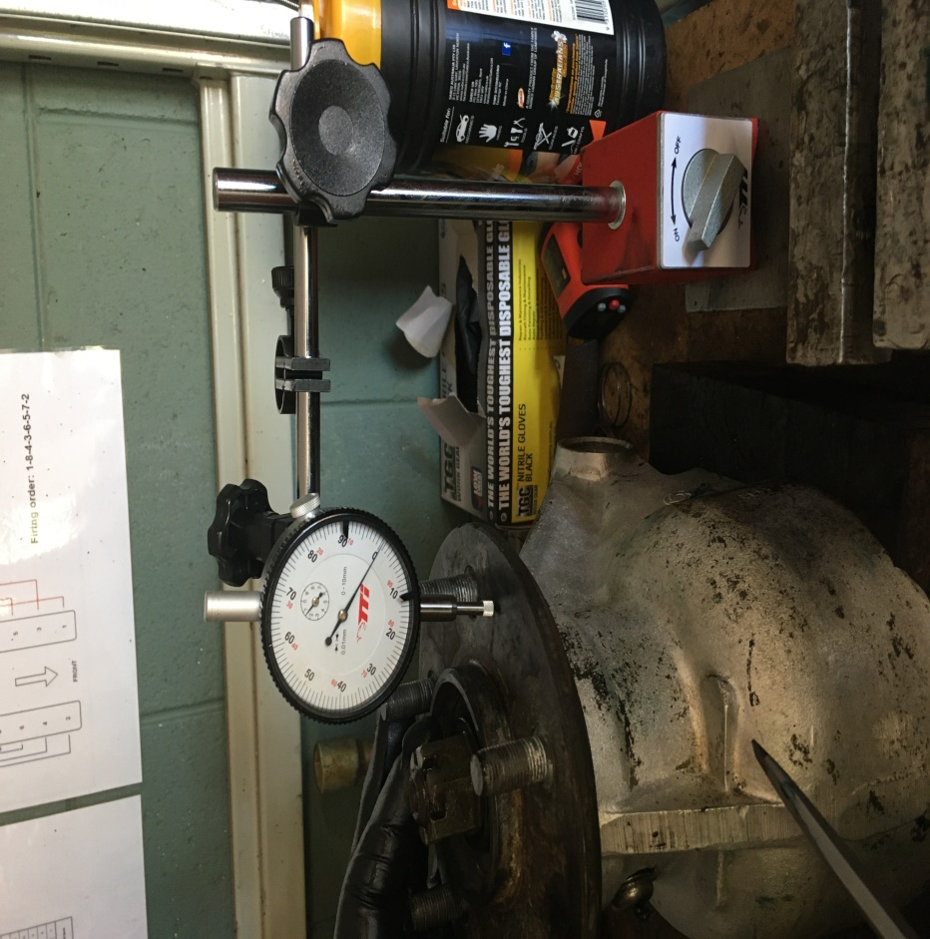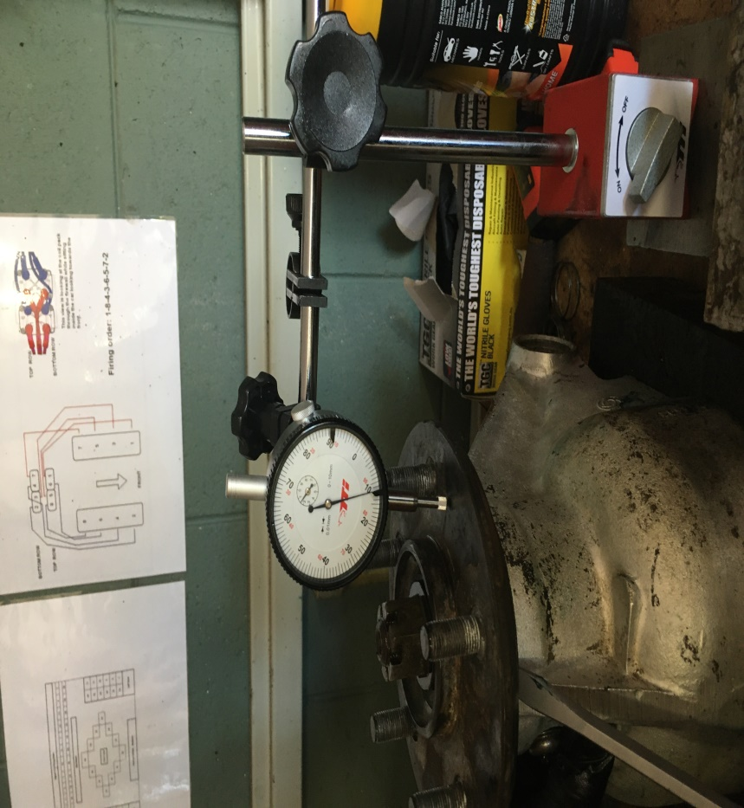

If /when you have the enfloat set put the inner hub seal in … I used a plastic hammer as a drift to gently tap it in. …worked perfectly. 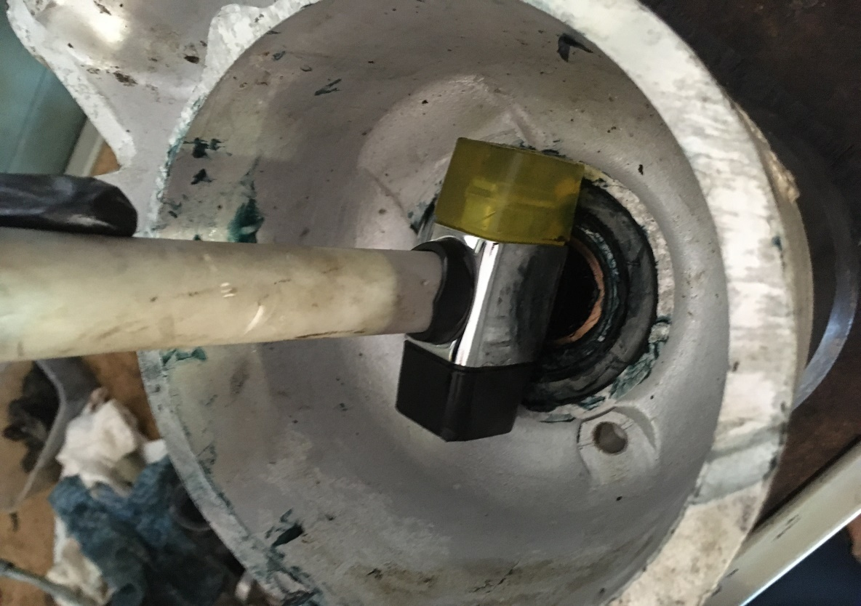
Now onto the Outer fulcrum set up
End float on this was 2 though as well which was achieved with the existing shims.
Outer fulcrum shaft go in the vice vertically secured on the nut
On one end of the fulcrum housing insert the inner race spacer ring inner race and felt seal retainer….onto the shaft place the washer, felt retainer washer and shim onto the shaft in the vice ….now slide the housing onto the shaft ….drop your spacer tube in…. shims as they came out ….then the outer race spacer , inner race bearing, felt seal retainer, outer bearing shim and washers.
Cut yourself a short piece of pipe that will fit over the shaft to act as a spacer so you can pull everything up tight …. then on goes the other shaft nut and tighten.
I pulled the nut up until it was firm and felt like it had landed … it’s a nyloc so no sure about torqueing this … do not think its necessary…?
OK now check the float …. See the photos below.
Note … I had packed the bearings before they were installed.
Got the 2 thou end float with existing shims … all good ….. greased up the felt seals … fulcrum nuts off one at a time … in they went … and then pumped the fulcrum full of grease ….job done.
Time for a Shiraz…..!
