Collision Bracket Removal TH400.

This bracket array on the transmission mount and its associated metalwork makes removing and refitting the transmission oil pan near impossible without removing the spring mount assembly and then this bracket.

Removal is the best way, and nothing bad will occur to your Jaguar with it gone, EXCEPT the transmission pan is now simple to remove and reinstall, so maybe the trans fluid/filter will get changed more often??.

Firstly remove the spring loaded transmission mount. This I a separate paper, and is readily available.

The Parts Drawing attached shows this bracket as #9.

Once the actual transmission mount is removed, the removal of this item is easy, and very straight forward.

HOWEVER

There are 2 bolts that pass thru this bracket and screw into the transmission casing. They MUST be replaced after this bracket is removed. Oil will flow out of the holes belonging to these bolts if they are left out, and they are part of the sequence of bolts that retains the transmission extension housing. My memory is lacking sadly, but I believe the length is not an issue, but PLEASE make sure as a common sense item. If needed, fit 2 spacers to those bolts, or simply cut them down to suit. I do not remember doing either of those things, but it was 20+ years ago that I did the last one.

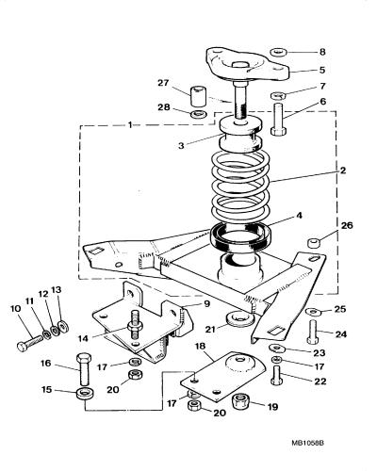
#9 is the bracket to remove.
#14 will need to be replaced with 2 trans pan bolts, same as the others around the pan, and readily available from any transmission service centre.
#10,11,12,13 MAY be the bolts that go from the rear into the trans casing, the drawing is not the most explicit in this area.
#18 is no longer needed.

Once the items are removed, refit the trans mount assembly, exhaust shields and exhaust.

