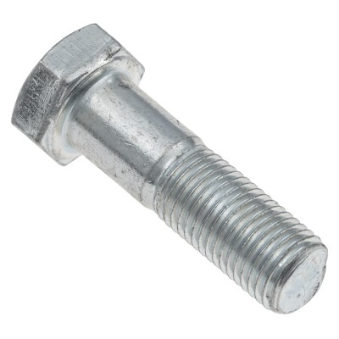

Driveshaft Bolt C19827 $1.89
- MOSS MOTORS>
- JAGUAR EARLY SEDANS>
- CLUTCH, GEARBOX & DRIVETRAIN>
- GEARBOX & DRIVESHAFT>
- DRIVESHAFT BOLT

