V12 thermostat fiasco explained

This is my findings, AND the solution to temperature gauge “floating syndrome”, that many people are frustrated by.

Remove both your thermostats.

Note the by-pass disc on the bottom, THIS IS THE MOST IMPORTANT PART OF THE THERMOSTAT.

Look up inside the housing you just removed the thermostat from, and note the ‘spigot hole” that is facing you. This is the by-pass port, and its face is prone to pitting. I have never seen a pitted one, but check it anyway.

Now comes the fun bit.

Measure the distance from the mounting face to that spigot face. It will be approx 41mm.

Test your thermostats, boil them, use a heat gun, whatever, you are going to replace them anyway, but do this just to humour yourself. My old units, Jaguar brand, only opened 39mm, YOU SURE, hell yes. Did it too many times, 39mm flat out. Now this is 2 mm at least too short to close that by-pass port 100%, and that port needs to be closed 100% for the cooling system to work anywhere near correctly.

Just to clarify what a thermostat does, I know, you know all this stuff, but just humour me for a few lines, PLEASE.

The thermostat has an opening temp, and a fully open temp, now anywhere in between these 2 temps is where the thermostat is constantly operating, it is constantly opening and closing, it is never satisfied, so in real terms, IT WORKS BLOODY HARD, and it wears out.

Just to clear up another “story” that persists out in mechanic land, the opening temp of a thermostat is in fact its “crack temperature”, meaning that is the temp at which the thermostat actually STARTS to open, hence the terminology known as the “crack temp”, and the thermostat is “fully open” 12degC above that. So, an 82c stat will crack open at 82c, and be fully open at 94c, follow, good, it is simple. Now if your cooling system does not do as it should, the engine temp can get above 94c, which causes the stat to “fully open” and stay there, IT HAS NOW LOST CONTROL OF THE COOLING SYSTEM, and overheating is just up the road.

Further to that, the radiator is expected to lower the temp of the fluid by approx 12-15c, so the bottom hose temp is about 80c +/-, and that is why the temp switch on the HE in the bottom hose housing is set at 85c, and brings on the auxiliary fan to assist cooling the beast down. Bottom hose sensing is much more accurate than top hose sensing.

The thermostat/s are constantly opening and closing to keep the cooling system at a happy medium, which is usually around 90c +/-, and does a good job at it, BUT, yes there is a BUT, that by-pass port MUST be closed, or else about 30% of the coolant NEVER sees the radiator, do the maths, simple as.

I purchased 2 new Jaguar units, same thing, too short. I was employed as the Spare parts manager for a Jaguar dealer at the time, and raised this with Jaguar Australia. No idea was the response, maybe there is something wrong with your car, politician in the making hahaha. NO, this is the case with 5 cars I have at my disposal, so I reckon Jaguar have messed up somewhere.

I never got an answer, gave up, retired from the dealer.

I searched on my own, and found a Tridon cooling system catalogue, very informative, and found in their listings a 54mm diameter thermostat, which was 35mm “closed”, and 43mm “open”, perfect.

This is a Tridon No is TT228-180, Dayco No is DT18A, and fits Ford cars down here and some others. I have used this thermostat now in some 12 odd V12’s, both Pre HE, and HE, and the cooling system is so well behaved it is downright scary, and I mean that seriously.

NOTATION 31/8/2015: The Dayco website NOW lists this DT18A as the correct thermostat for the V12 engines. Maybe my emails finally got read, who knows.

I replace all my Jaguar thermostats every 3-5 years, coz as I said, they do work hard, they are cheap, and engines are NOT.

I have attached 4 pages from the Tridon paper I studied back then in my search for the correct unit, which explain the operation of the cooling system, and thermostat operation very simply. This is a general system overview, and is NOT V12 specific, but the principles are the same no matter what badge is on the car.

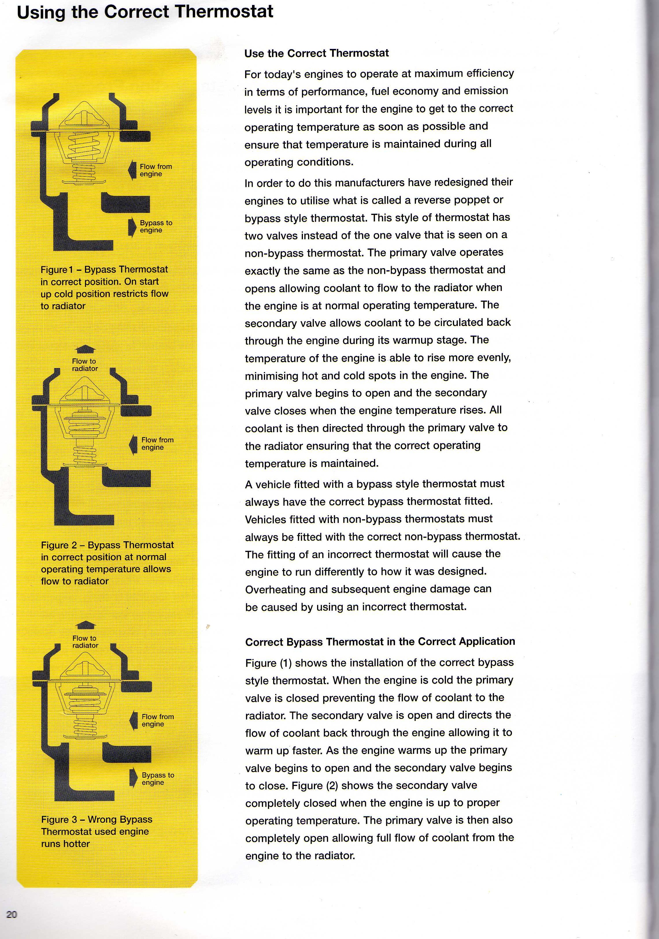
Tridon page 2

