Bleeding the V12 cooling system.

This first section is for the HE, the Pre HE will be at the bottom, it is different in a few ways.

This is related to my ’85 XJ-S HE, RHD.

This may be boring to some, but just for fun, and to humour the old guy author, GIVE IT A READ.

Overheat a V12 engine by any means, and you will be much poorer, they simply are NOT that forgiving.

There a many ways of doing this and most are well documented, and NONE are wrong, but I found the way I do it is simple enough, even for an Aussie.

Some simple requirements PRIOR to trying to fill/bleed one of these beasts, and it may appear boring, BAD LUCK, it will NOT bleed if these items are incorrect.

On the RH side of the radiator, up on top, is the infamous banjo bolt bleeder pipe fiasco. This banjo bolt has the cross holes drilled in the wrong place, and when assembled they are 90% blocked off by the banjo and/or the copper washers. Remove the banjo bolt, DO NOT DROP the 3 copper washers or the steel spacer. Look carefully at the bolt and note the 2 cross holes, they need to be elongated towards the threaded section by about ½ a hole.

Further clarification, fit 1 copper washer to the banjo bolt, and measure the distance from the face of that washer to the centre of the cross hole, WRITE IT DOWN, then measure the thickness of the banjo fitting (10mm I reckon), and halve it, so 5 mm, which should be the measurement you wrote down. I bet you wrote down 3mm or close to it, so with that arrangement the banjo fitting is blocking the cross holes and the beast cannot bleed, or at best bleed badly. Add to that some scale build up, and presto, overheat here I come.

Since you are at it, check that the pipe/s that run across the top of the radiator are not blocked, MOST ARE, and this will also cause overheating, trust me.

Once this is sorted reassemble the arrangement, new copper washers please.

Cast an eye over the other pipes and hose that are on the LH side of the engine, in particular the ½” pipe that travels from the cross over pipe to the header tank, some of these have been replaced and the “bend” in the hose is above the radiator height, NO GOOD. Also, the small hose, ¼”, that travels from the bleeder pipe to the LH thermo housing, can also be too high, it must “flow” from that pipe to the thermo spigot in a “downhill” fashion, most I have seen go up, then down, NO GOOD. These hoses MUST be below radiator height, air pockets will STAY in them if they are above this height, and the beast will never bleed, FULL STOP.

The atmospheric tank FIASCO needs to be sorted, follow the hose from the header tank to the rear of the engine bay and where it passes through the inner guard to go to the atmospheric tank hidden in the LH wing aperture. This hose is well documented as blocking, and that is NO good. The proper way is to remove the LHF wheel and that panel at the rear of the arch, and remove the header tank, empty the mud from it, wash it out, attend to all the rust in that area, then part fill the tank with coolant, and return it to its hiding place. Blow out that hose to ensure it is clean and operational. My atmospheric tank is now under the bonnet, much easier and less stress for me to look at the coolant level.

My reasons for installing my tank in the engine bay is that every time you open the header tank to “check the coolant” you introduce air into the system, and that long hose to the factory tank takes about 3 cycles of the cooling system to purge the air out of it. Mine is a shorter hose and a clear bottle, so eyeballing it is all that is required to establish coolant integrity.

Cast an eye over the heater tap at the rear of the engine. This tap may have been replaced, and it may be sitting a tad higher than originally, coz that bracket is a bugga to get at, so short cuts prevail, BUT, the tap may be too high, and above radiator height, damn I am boring, but it will make sense. The original tap is “just below” radiator height, so if it is attached to the original bracket, OK, but most of these cars now have the universal hose supported style tap fitted, and they may not be pushed down far enough behind the engine. This is a well documented area for air pockets, but if that tap and hoses are pushed down somewhere near the oil switch level, all is OK.

Filling the radiator:

This is NOT a quicky fill and drive, remember that please.
I raise the LH side of the car about 6”.

Remove both filler caps.

Remove the small plug (or tap) from the LH top face of the radiator.

Remove the small vac hose from the heater tap, just in case you got one of those strange Jags that actually holds vac for longer than 4 hours, hahaha, mine does.

**An update, 24 May 2011 from Julius in Iceland. The metal header tank WILL NOT drain when the rest of the cooling system is drained, fact. You have 3 choices, 1) remove it and drain and wash it out. 2) Insert the garden hose and flush the crud out, then use a suitable hose and “syphon” the remaining fluid from it. 3) Remove the hose from the bottom side of that tank allows it to drain a small amount, and wash it out before refitting that hose. Outside of square thinking helps here, so just flush and drain it as best you can. This will make filling more accurate and easier if that tank is empty. Coolant flows around that pipe/hose mentioned at the beginning, from the crossover pipe to the bottom edge of the header tank, and if fluid is sitting in that tank, the flow of coolant/air may/will be restricted so much so that the filler spout will be full, BUT no coolant is flowing out of the header tank, frustrating. **

Commence filling via the central spigot SLOWLY, and listen to the “gurgling” and such you will hear, this is good, as it is the air being pushed out. If you fill too quickly that air will be trapped, and bleeding takes longer, sometimes it will NOT bleed, and a drain and start again is required as those pockets just will not find their way out.

Coolant will flow from the header tank first, so refit the cap, continue filling, coolant will then flow from the LH top of the radiator, refit the plug, continue filling until the spigot is full, refit that cap.

YOU ARE DONE. DRINK BEER.

Replace that vac hose at the heater tap, run the engine, heater on HOT, check the caps for leaks, wait for it to get to normal temperature, feel that hose to the atmospheric tank, it should be warm/hot, indicating coolant flow. If it is not, you still got air in it, so wait for it to cool down, remove both caps and that plug/tap in the radiator top, and the vac hose from the heater tap, top it off again SLOWLY, and try again.

I will stress AGAIN, take your time, if she wants to go shopping, CALL A CAB.

Now with the atmospheric tank actually IN the engine bay, the guess work is gone, the engine will purge about 1/2ltr from cold to normal, and is easily seen in the bottle, and being a shorter hose air is purged quicker.

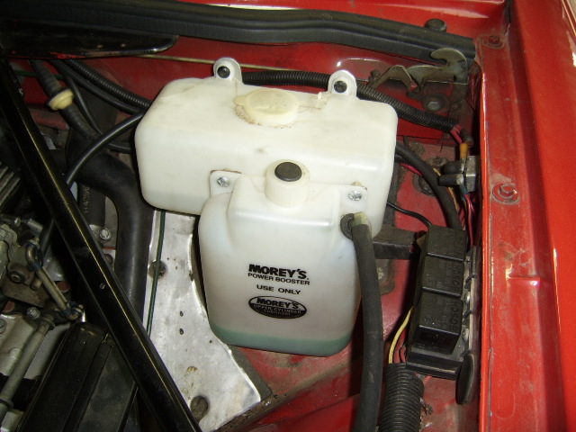

This is my atmospheric bottle. It is the Moreys labelled bottle 1ltr in capacity, and the coolant visible is the COLD level.

Pre HE EFI system.

I have used our ’76 XJ12 for this section.

The filling procedure is basically as above, with some slight variations.

1) The Pre HE does not have an atmospheric tank.

2) The header tank has a hose out the bottom that “T” joins to the heater return pipe to the radiator. Thus allowing the system to “fill” via the metal header tank, AND the bottom of the radiator, thus pushing air out as it fills. STILL FILL THE THING SLOWLY OR AIR POCKETS WILL BE YOUR FRIEND FOREVER.

3) The banjo arrangement is different, BUT still the same wrong drillings.

4) There is NO centre filler cap or spigot.

The rest is basically the same. Filling is via the header tank, and they can be a “mongrel” to top off, coz the filler neck on that tank is only about 1mm above the radiator bleed hole.

The expansion of these goes directly to the ground, so on cool down, air is introduced into the header tank, it does NOT seem to cause any issues, and as long as the coolant is visible through the filler spout, albeit down the spout somewhat, it is deemed to be OK.

Most owners have retro fitted an atmospheric tank to their Pre HE cars, and that is a GOOD idea, as it just keeps that radiator topped up.

I have NOT addressed the carby versions, NEVER had one, I have NO idea other that I know that the plumbing is very different.

