JAGUAR V12 TIMING CHAIN TENSIONER RETROFIT KIT

1. OVERVIEW:

This kit is designed to repair a broken tensioner, where the usual problem is damage to the moulded nylon part. The kit requires that the pressed metal parts of the original tensioner can be recovered. In the following pages ROM refers to the Jaguar Repair Operations Manual.

It is assumed the Morse brand tensioner used in the V12 did not vary while the 5.3 litre engine was in production. However, it is difficult to be sure of this.
If you have any problems or suggestions please contact me.

In the worst case scenario that for some reason you cannot use the kit because it is not compatible with parts salvaged from your old one, return the kit for a refund.
I would appreciate you let me know about this in advance and I might ask you to take ‘photos and measurements so we can maybe arrange a suitable fix for the future.

Richard Dowling. rmdowling@optusnet.net.au.

2 KIT PARTS:

The kit contains the following parts:

a) Spring steel blade with pop rivetted acetal wear track.
b) A, B and C replacement pins
c) Push on fixes for pins, 8 supplied, 3 actually needed.

3. RECOVERING PRESSED METAL PARTS FROM OLD TENSIONER.
Make sure not to lose pins D and E, they must be salvaged.

3.1. The pin E retaining the spring has a small groove to locate the spring end.
The spring tension can be eased so the pin can be driven out.

3.2. The pin D is an interference fit in the end of the latching rod. It must be driven out. Doing this will probably smash the nylon moulding, which is no problem, but avoid damaging the rod.

3.3. Grind the ends off pins A and C in order to drive out these old pins.
Note well: Pin B can be left as it is, however there is a pin B in the kit if you want to strip the original assembly totally, in which case also grind the end off pin B.

The old pins are discarded. Clean up all the metal parts and check they are in good condition.
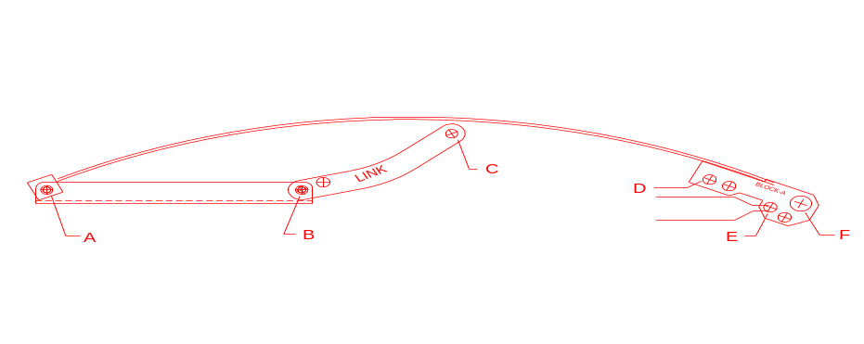
4. ASSEMBLING THE REBUILT TENSIONER.

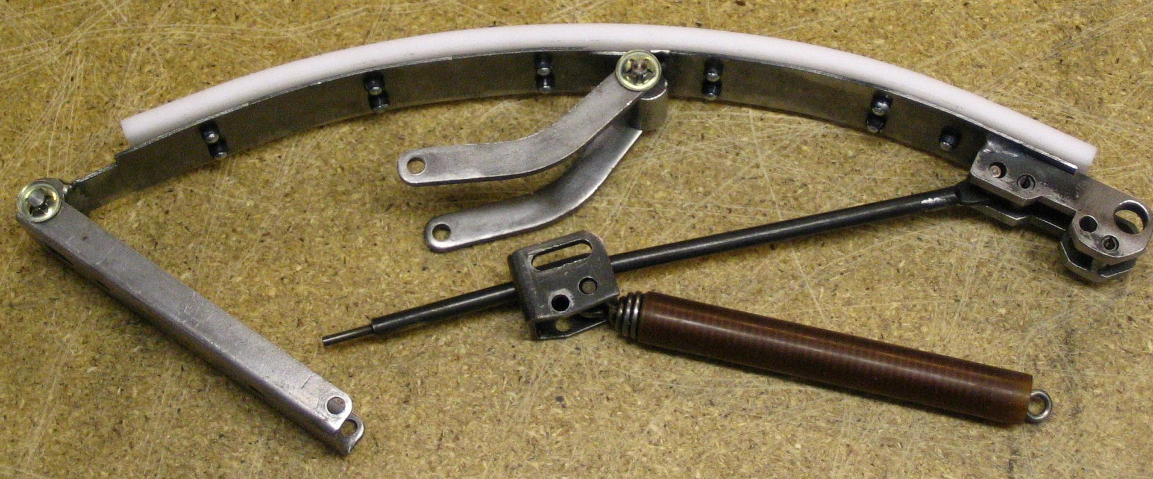
Figure 1

4.1. Figure 1 shows the general arrangement of the parts when the retrofit kit is being assembled.
NOTE: The latching rod has a slight bend, this is probably a design feature. In Figure 1 the rod bends down slightly, and it may not latch if fitted any other way.
Place the pins A, B and C in position to locate the various pressed metal parts and the steel blade. Pin B is 1mm longer than pins A and C.
The pins must be inserted from the engine block side of the tensioner assembly.
It might be easiest to insert pins in the sequence A, B then C.

NOTE: This assembly is not symmetrical, note how the two bent arms are positioned relative to pins B and C as shown in figure 2.
DO NOT set the pins in place with the push on fixes at this stage.
The latching rod and spring are not yet secured with pins D and E.

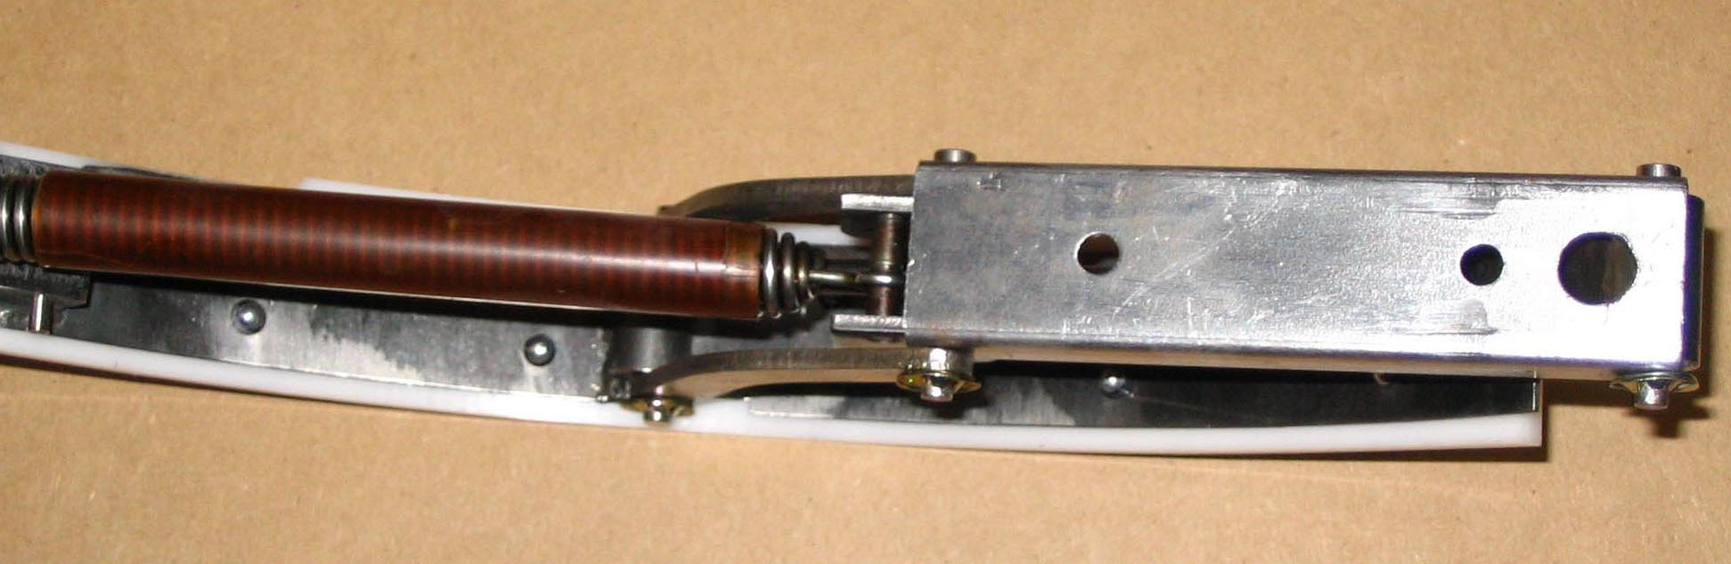
Figure 2

4.2. Check the assembly is correct and all parts will move freely.
In some cases it may be necessary to grind some metal from the pressed parts so there is enough free movement in the whole assembly.

When you are satisfied that all the items can move as they should, press one push on fix to each pin. There are spares with the kit just in case of any mistakes.
These fixes will easily resist any tendency of the pins to drift out of their respective bores.
If you want to be doubly sure there are enough fixes to double up.
4.3. Insert pin D to secure the latching rod. Read this section carefully first.
Pin D is recovered from the original tensioner.
This pin is an interference fit in the end of the rod. However, the pin must float freely in the oversize hole in the steel block. The original design has a slot, and this is most likely to allow a slight movement of the latching rod as the engine cools, otherwise a high stress may be induced in the tensioner which normally does not allow any relaxation of the chain tension.

Note the bend in the rod, and make sure it is oriented as mentioned in 4.1.

It can take quite an impact to drive the pin into the end of the rod. Take care to support the rod so that the welding of the steel block to the spring steel is not damaged.
Another consideration is that the pin must not be able to come adrift from the steel block. On my original tensioner the pin was long enough that if it was centred in the rod end it could not come adrift. Check this before inserting the pin.
If in doubt add small washers or spacers inside the two halves of the block while driving in the pin, so that it will not move far enough to come adrift.

4.4. Check that the latching rod is correctly fitted and make sure:
a) The rod latches if the spring is tensioned, and will not allow the tensioner to relax tension.
b) The rod unlatches when the screwdriver slot is turned.

4.5. There may be some variations in the original pin E which secures the spring. One pin that was recovered had a fairly pronounced groove in the middle that engages in the eyelet on the end of the spring. Another pin had only a very slight groove.
In the original tensioner the pin is an interference fit into the plastic moulding. The pin diameter is 4.55mm for most of its length, but stepped down to 4.30 near its ends.
The overall length on my sample pins was 18.6mm.

If the pin has a reasonable groove, once the spring eyelet engages the groove it will have sufficient tension not to move relative to the pin. Then the pin need not be an interference fit in the steel block provided it is long enough that the pin can not come adrift from the two halves of the steel block.
It is probably not easy to find a drill or reamer suitable to make the hole in the steel block just right for an interference fit.

The steel block has a hole drilled undersize at 4.0mm or 5/32” for pin E, to allow for variation in the original pin. In the two retrofit kits I made up the pin E hole was drilled out to 3/16”. Once the pin was fitted it was long enough not to be in danger of coming adrift.

It is most important to check the pin you have recovered to make sure it has sufficient groove to securely locate the spring eyelet, and that it is long enough to be safe when inserted in the steel block.
Other options are:
a) Secure the pin in the steel block with Loctite.
b) Replace the pin with a roll pin, typically 3/16” X 3/4”. This does not require a groove in the roll pin since the roll pin is secured in the steel block.

4.6. Making a simple slotted jig with a piece of steel or aluminium will help to locate the spring in position, as shown in figure 3.

This jig is held in a vice. The end of the spring is held in the slot as shown in figure 4.
( There was no latching rod fitted when this ‘photo was taken ).
Don’t forget the nylon sleeve over the spring, if you still have it. It was reported to be there so as to minimise vibration noise in the spring.

I found that leaning my body on the pin A end of the assembly ( on the left of this ‘photo ) and holding the steel block with my left hand allowed me to insert the pin with my right hand.
Two people would make the job easier, of course.

Figure 5 shows how it looks when finished.
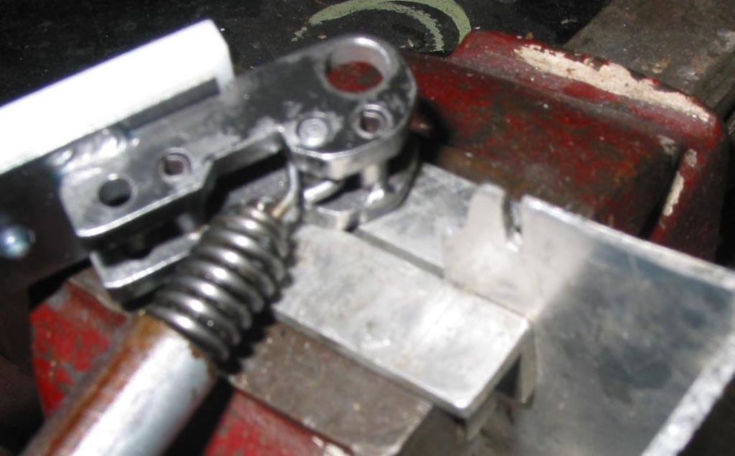
Figure 3

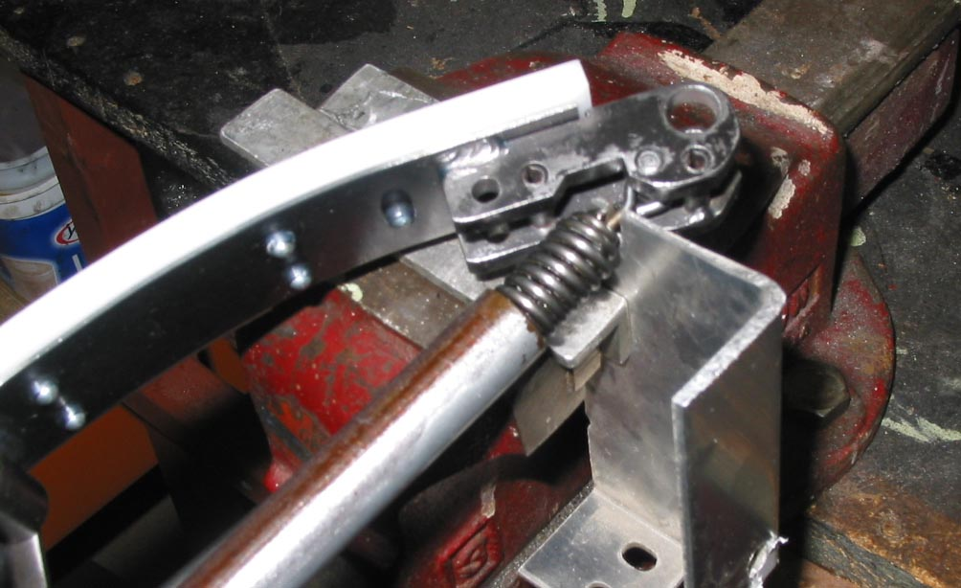
Figure 4

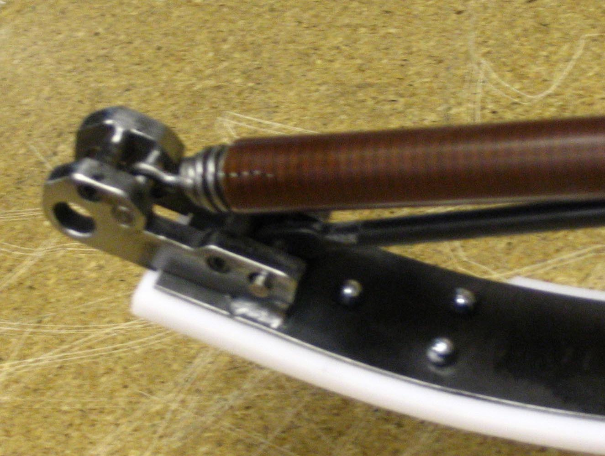
Figure 5
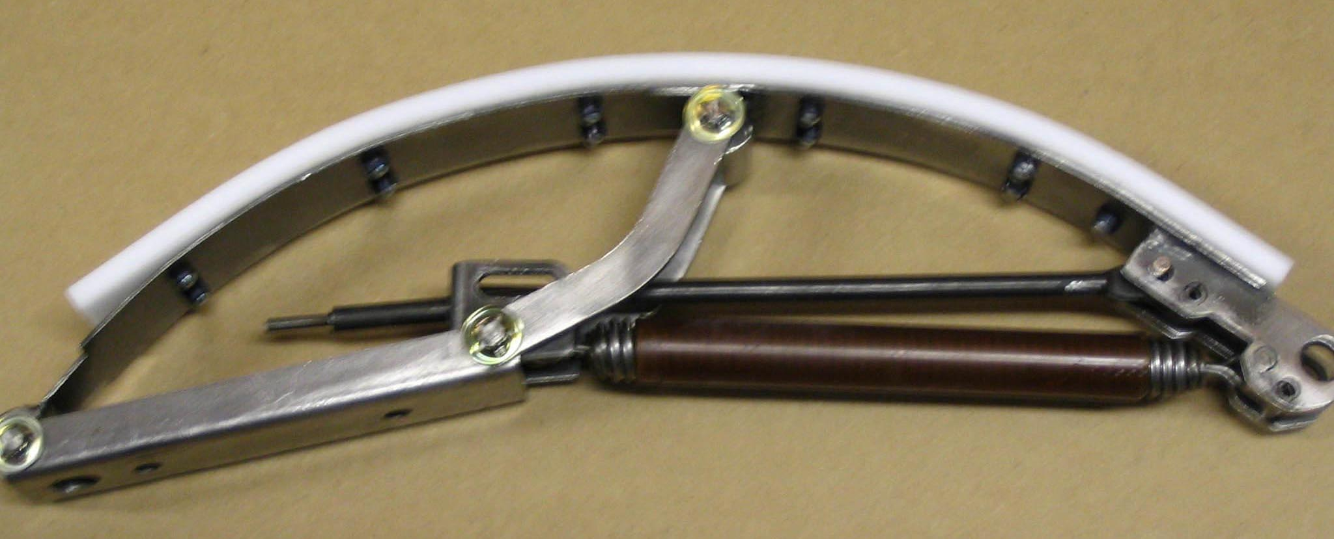
Figure 6

4.7. Figure 6 shows the finished assembly. I check the ends of those pop rivets to make sure the mandrel ends ( the little round steel things ) will not drop out.
You might want to check again.

Place the assembly on a bench, flatten it and make sure you can latch it, then unlatch it.
Lightly oil all the steel parts to prevent corrosion.

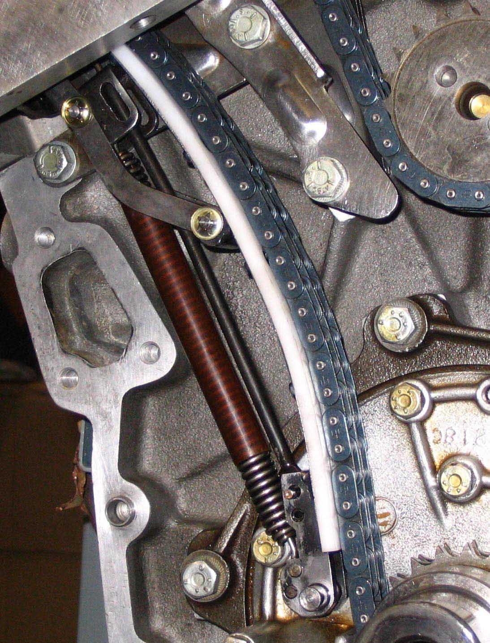
Figure 7

4.8. Figure 7 shows the new tensioner fitted. In this case the heads have been dropped onto the block with cardboard spacers simulating the head gasket, and the camshafts, chain and sprockets fitted just to check the run of the chain. Only a few nuts are needed on the head and camshaft studs for this exercise.

The retrofit tensioner does not flatten as much as the original when latched, so there is a little more effort required to fit a sprocket into position on the end of the camshaft.

4.9. In normal engine rebuilding the heads would not be fitted when the tensioner is fitted.
Next the timing cover would be fitted to the block, and then the heads on the block.

However, there is an advantage to jury rigging the heads as mentioned in 4.8.
The position of the chain dampener guides can be checked. Although there is a setting jig described in the ROM, it is most likely only required in the factory when assembling V12s, since they would not waste time jury rigging the heads.

I have adjusted the dampener guides on my pre HE engine so they just kiss the chain when the chain is fully tensioned. It has done 20,000km since and now and again buzzed to nearly 6,000RPM. I never worry about the chain.
I will do the same to the HE engine shown in the figure 7.

4.10. NEXT TIME . . . . . You do not want to risk breaking a tensioner.

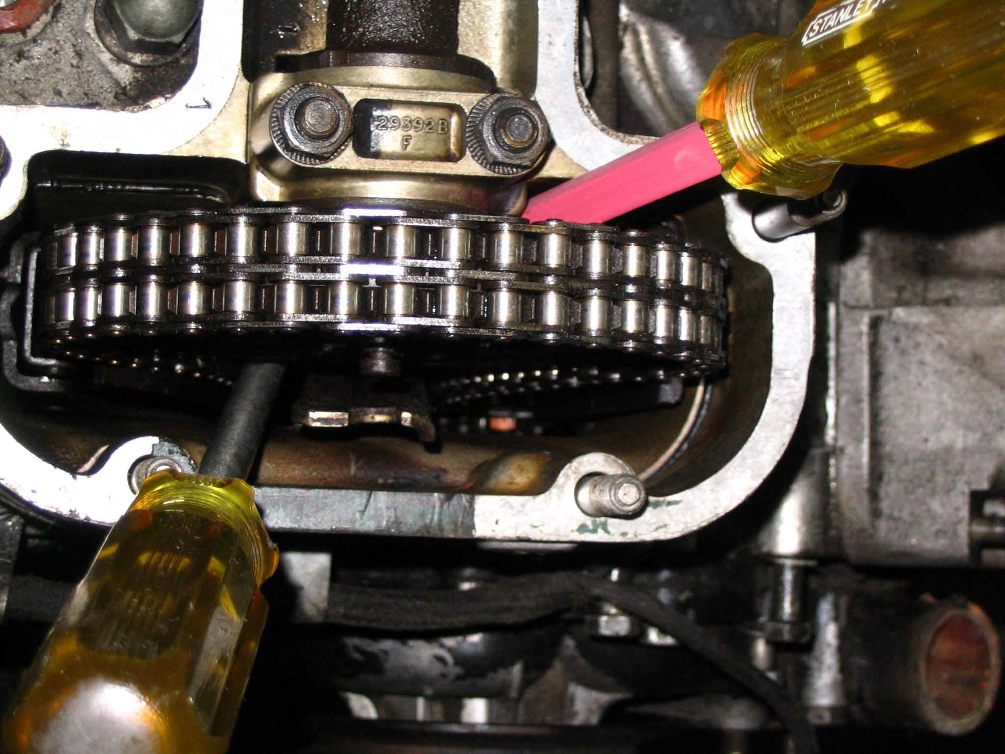
Figure 8

Most original tensioners are stressed around the lower pin bore, pin F shown on page 1, during the retraction process shown in the ROM.
The ROM recommends a tool which pulls up hard on a hole in the top end of the metal part of the original tensioner. This in turn exerts a lot of force on the lower pin bore and many tensioners snap at this point.

Both the original all plastic tensioner, and the retrofit type, can be retracted by the following method using two large screwdrivers as shown in figure 8.

If you look at figure 9 you can see the end of the red blade screwdriver in the middle of the tensioner. It uses one of the chain dampener spacers as a fulcrum. The spacer in question is under the bolt head about 15mm below the lower face of the head

Figure 9 shows an early prototype of the retrofit tensioner in my rebuilt HE engine. At that stage the latch was not fitted.

I have tried this screwdriver method on an old 1975 pre HE V12, shown in figure 8, which was out of the car and therefore a little easier to work on. It appeared to retract the original tensioner in about 5 minutes work without breaking it.

In fact you need two screwdrivers, one on both sides of the cam sprocket. With these two you can work the tensioner flat and latch it as a one man operation. This is much less likely to damage the original or retrofit tensioner.
The red blade screwdriver is used to lever the tensioner downwards, and the other screwdriver jams it in place allowing the red blade to be moved to a new position.

At the same time you need a screwdriver in the slot shown just below the head in figure 7.
The slot must be turned to unlatch the tensioner. Apply pressure from the red blade screwdriver, then turn the slot in the latch and the tensioner will move down.
If the red blade screwdriver runs out of adjustment, use the other screwdriver to jam the tensioner, and then reposition the red blade one.
The procedure is repeated until the latch fits over the reduced diameter at the end of the rod, and restrains the tensioner.

You can see the mechanism of the latch in figure 6.

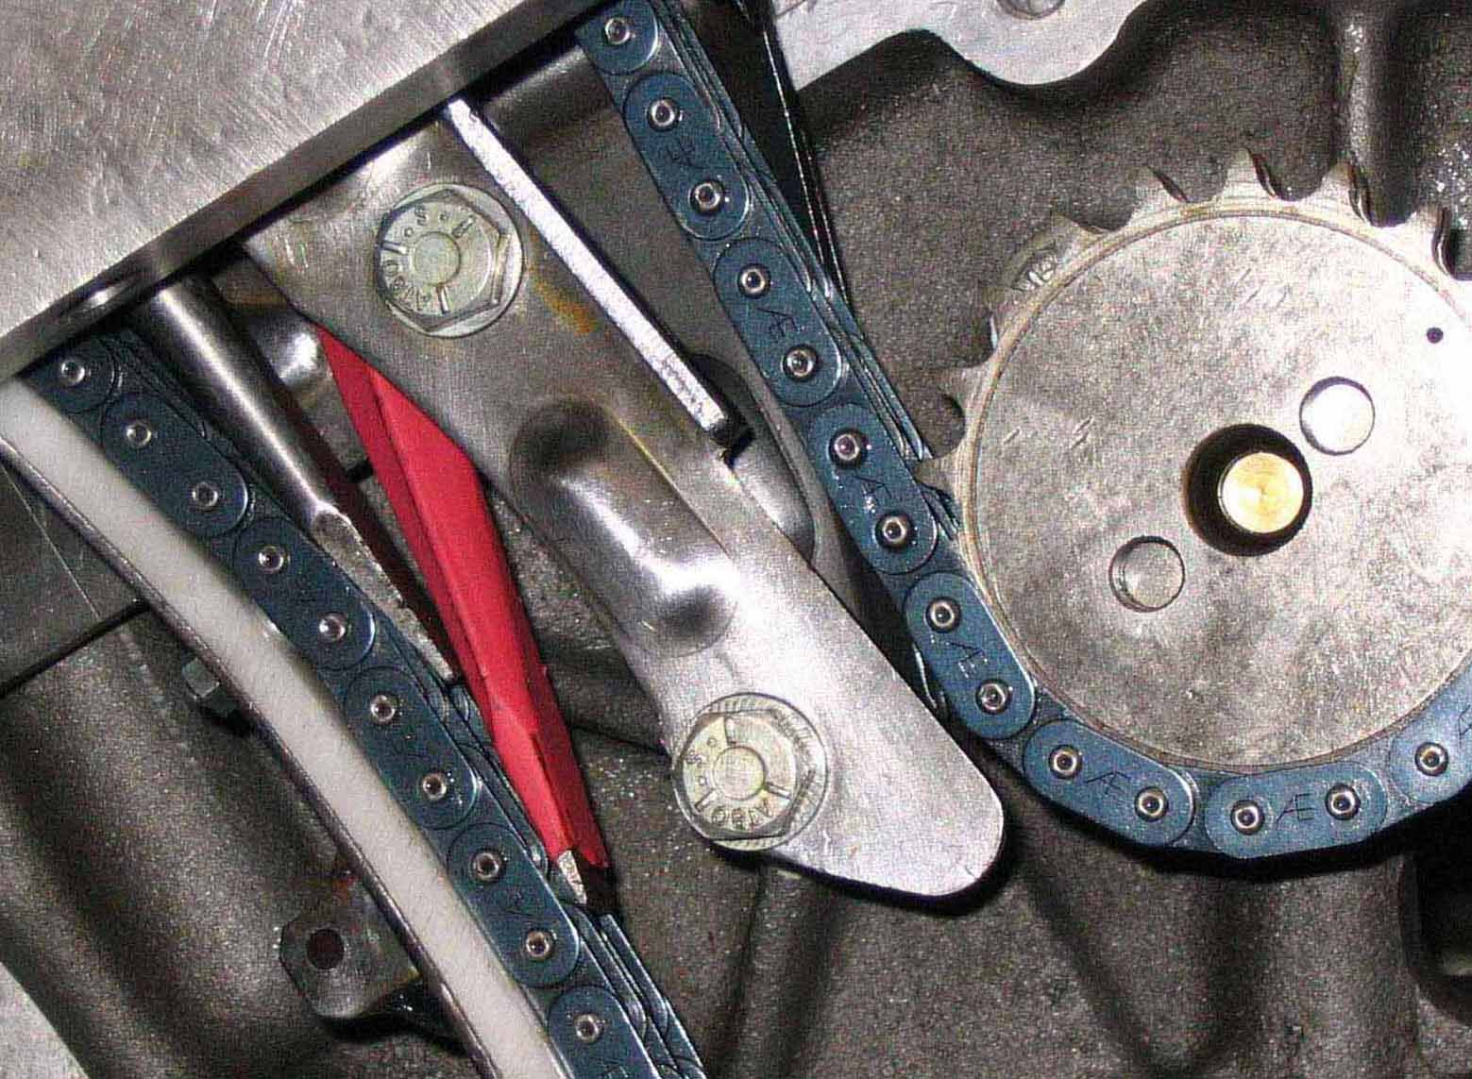
Figure 9

You might want to make sure the edge of the screwdriver is not sharp enough to damage the chain.

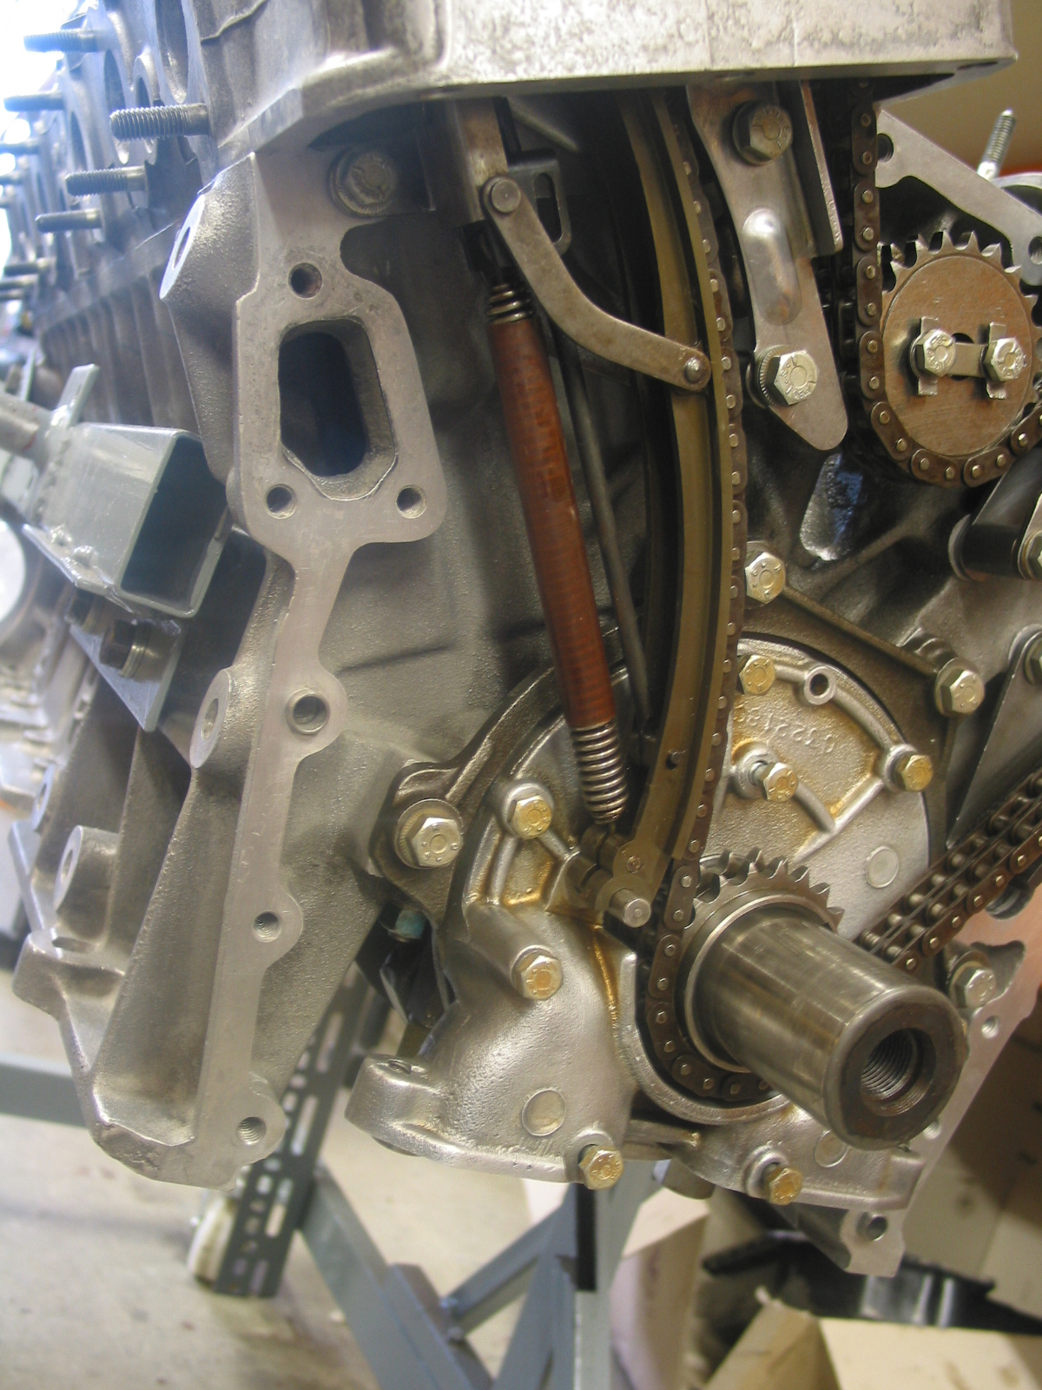
Figure 10

Figure 10 shows the HE engine with an old original tensioner fitted. This tensioner is in fact damaged, the lower pin bore is broken.

